**GP6108**

**Pistolet venturi**

Inverser la pcs n°3 pour changer

le sens du flux d’air

(Aspiration ou soufflage)

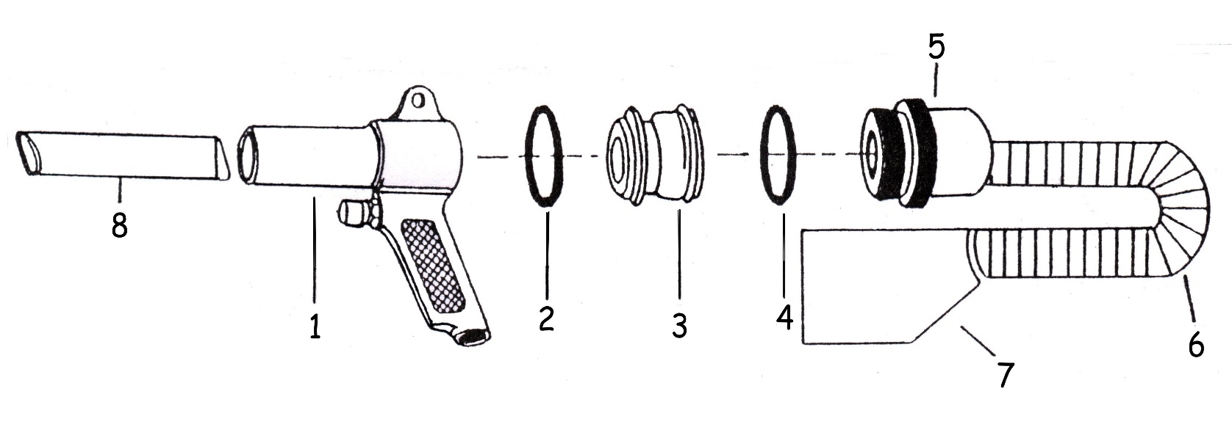

|  |  |  |  |
| --- | --- | --- | --- |
| Rep | Réf Art | DESCRIPTION | Qté |
| 1 | GP6108-01 | Corp | 1 |
| 2 | GP6108-02 | Joint | 1 |
| 3 | GP6108-03 | Insert-inverseur de flux | 1 |
| 4 | GP6108-04 | Joint | 1 |
| 5 | GP6108-05 | Raccord tuyau | 1 |
| 6 | GP6108-06 | Tuyau | 1 |
| 7 | GP6108-07 | Sac | 1 |
| 8 | GP6108-08 | Tube | 1 |