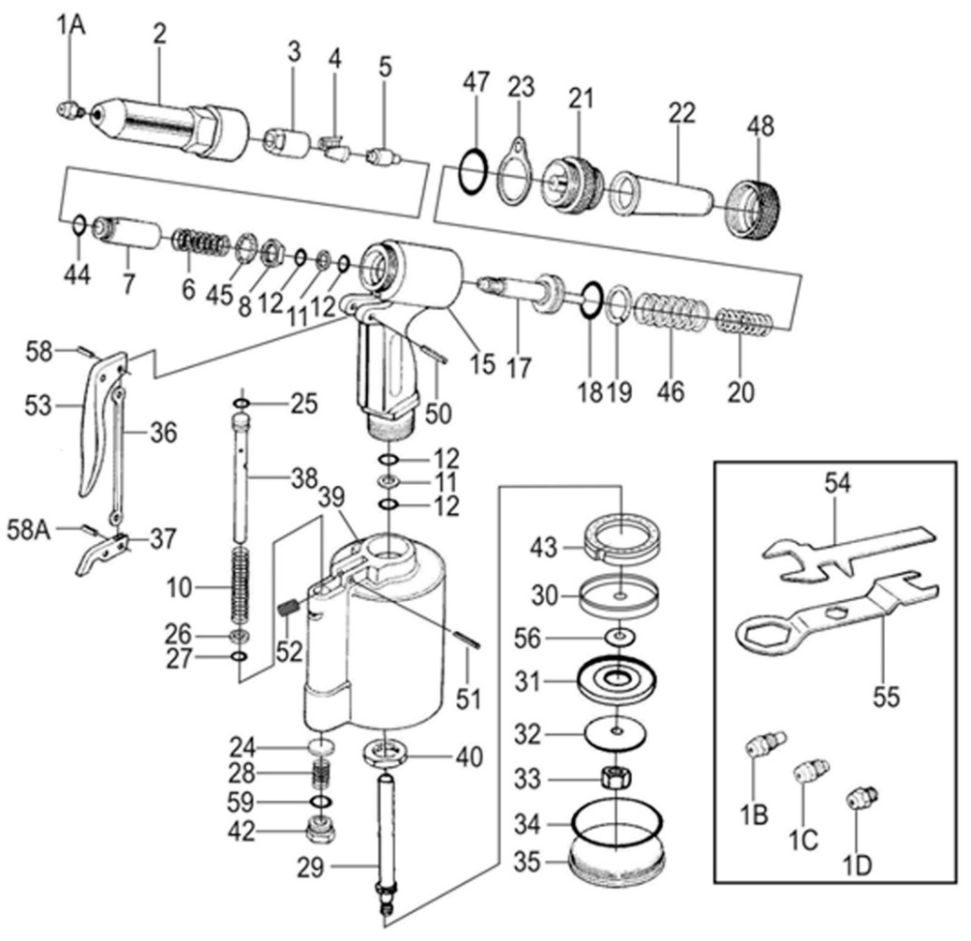

**GP5791**

**Riveteuse**

**2,4 à 4,8**

Réglage course

Quelques soit la taille de buse

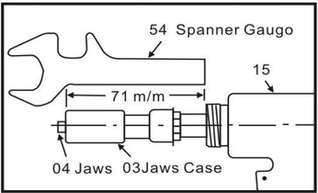

|  |  |  |  |  |  |  |  |
| --- | --- | --- | --- | --- | --- | --- | --- |
| **Rep** | **Réf** | **Description** | **Qté** | **Rep** | **Réf** | **Description** | **Qté** |
| 1A | GP5791-01A | Buse 4,8 | 1 | 30 | GP5791-30 | Rondelle tampon | 1 |
| 1B | GP5791-01B | Buse 4 | 1 | 31 | GP5791-31 | Rondelle piston cuve | 1 |
| 1C | GP5791-01C | Buse 3,2 | 1 | 32 | GP5791-32 | Rondelle | 1 |
| 1D | GP5791-01D | Buse 2,4 | 1 | 33 | GP5791-33 | Ecrou | 1 |
| 2 | GP5791-02 | Tête chromé | 1 | 34 | GP5791-34 | Joint | 1 |
| 3 | GP5791-03 | Porte mors avt | 1 | 35 | GP5791-35 | Capot | 1 |
| 4 | GP5791-04 | Mors (5x10) | 2 | 36 | GP5791-36 | Tige | 1 |
| 5 | GP5791-05 | Poussoir | 1 | 37 | GP5791-37 | Levier | 1 |
| 6 | GP5791-06 | Ressort | 1 | 38 | GP5791-38 | Tube | 1 |
| 7 | GP5791-07 | Porte mors arr | 1 | 39 | GP5791-39 | Cuve | 1 |
| 8 | GP5791-08 | Ecrou | 1 | 40 | GP5791-40 | Ecrou fond cuve | 1 |
| 10 | GP5791-10 | Ressort | 1 | 42 | GP5791-42 | Ecrou buté | 1 |
| 11 | GP5791-11 | Joint | 2 | 43 | GP5791-43 | Tampon buté | 1 |
| 12 | GP5791-12 | Joint | 4 | 44 | GP5791-44 | Joint | 1 |
| 15 | GP5791-15 | Poignée | 1 | 45 | GP5791-45 | Rondelle | 1 |
| 17 | GP5791-17 | Piston de tête | 1 | 46 | GP5791-46 | Ressort | 1 |
| 18 | GP5791-18 | Joint | 1 | 47 | GP5791-47 | Joint | 1 |
| 19 | GP5791-19 | Joint | 1 | 48 | GP5791-48 | Ecrou | 1 |
| 20 | GP5791-20 | Ressort | 1 | 50 | GP5791-50 | Goupille | 1 |
| 21 | GP5791-21 | Ecrou bague | 1 | 51 | GP5791-51 | Goupille | 1 |
| 22 | GP5791-22 | Récupérateur queue de rivet | 1 | 52 | GP5791-52 | Vis | 1 |
| 23 | GP5791-23 | Bague accroche | 1 | 53 | GP5791-53 | Gâchette | 1 |
| 24 | GP5791-24 | Rondelle | 1 | 54 | GP5791-54 | Clé | 1 |
| 25 | GP5791-25 | Joint | 1 | 55 | GP5791-55 | Clé | 1 |
| 26 | GP5791-26 | Rondelle buté | 1 | 56 | GP5791-56 | Rondelle /Joint | 1 |
| 27 | GP5791-27 | Joint | 1 | 58 | GP5791-58 | Goupille | 1 |
| 28 | GP5791-28 | Ressort | 1 | 58A | GP5791-58A | Goupille | 1 |
| 29 | GP5791-29 | Tige | 1 | 59 | GP5791-59 | Joint | 1 |