**GP5681**

**Grignoteuse**

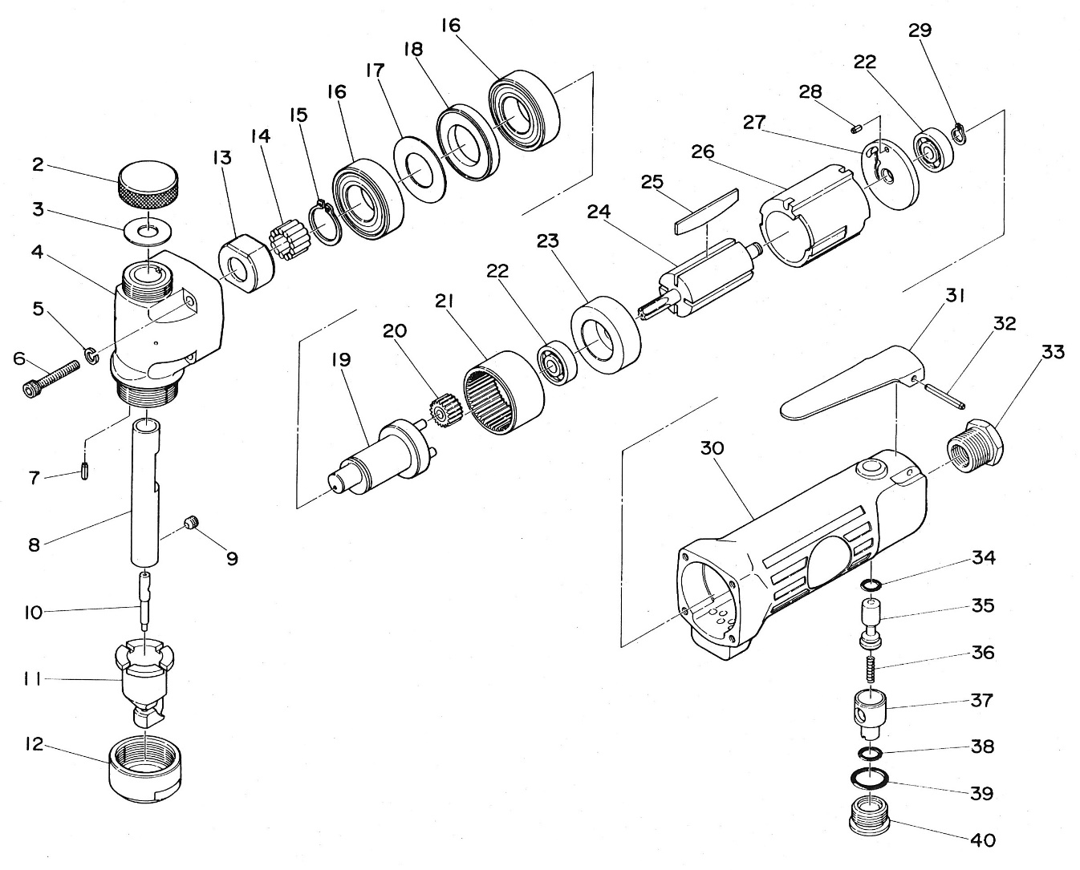

|  |  |  |  |  |  |  |  |
| --- | --- | --- | --- | --- | --- | --- | --- |
| Rep | Réf Art | DESCRIPTION | Qté | Rep | Réf Art | DESCRIPTION | Qté |
| 2 | GP5681-02 | Ecrou de graissage | 1 | 22 | 626-2RS | Roulement 626 | 2 |
| 3 | GP5681-03 | Joint | 1 | 23 | GP5681-23 | Flasque avt | 1 |
| 4 | GP5681-04 | Tête | 1 | 24 | GP5681-24 | Rotor | 1 |
| 5 | GP5681-05 | Rondelle | 4 | 25 | GP5681-25 | Palette | 4 |
| 6 | GP5681-06 | Vis | 4 | 26 | GP5681-26 | Chemise | 1 |
| 7 | GP5681-07 | Goupille | 1 | 27 | GP5681-27 | Flasque arr | 1 |
| 8 | GP5681-08 | Porte poinçon | 1 | 28 | GP5681-28 | Goupille | 1 |
| 9 | GP5681-09 | Vis | 1 | 29 | GP5681-29 | Circlips | 1 |
| 10 | GP5681-10 | Poinçon | 1 | 30 | GP5681-30 | Corps | 1 |
| 11 | GP5681-11 | Matrice | 1 | 31 | GP5681-31 | Gâchette | 1 |
| 12 | GP5681-12 | Ecrou | 1 | 32 | GP5681-32 | Goupille | 1 |
| 13 | GP5681-13 | Cam | 1 | 33 | GP5681-33 | Raccord | 1 |
| 14 | GP5681-14 | Aiguille | 13 | 34 | GP5681-34 | Joint | 1 |
| 15 | GP5681-15 | Circlips | 1 | 35 | GP5681-35 | Axe gâchette | 1 |
| 16 | 6003-2RS | Roulement 6003z | 2 | 36 | GP5681-36 | Ressort | 1 |
| 17 | GP5681-17 | Rondelle | 1 | 37 | GP5681-37 | Variateur | 1 |
| 18 | GP5681-18 | Rondelle | 1 | 38 | GP5681-38 | Joint | 1 |
| 19 | GP5681-19 | Arbre porte satellite | 1 | 39 | GP5681-39 | Joint | 1 |
| 20 | GP5681-20 | Satellite | 3 | 40 | GP5681-40 | Ecrou | 1 |
| 21 | GP5681-21 | Couronne | 1 |  |  |  |  |