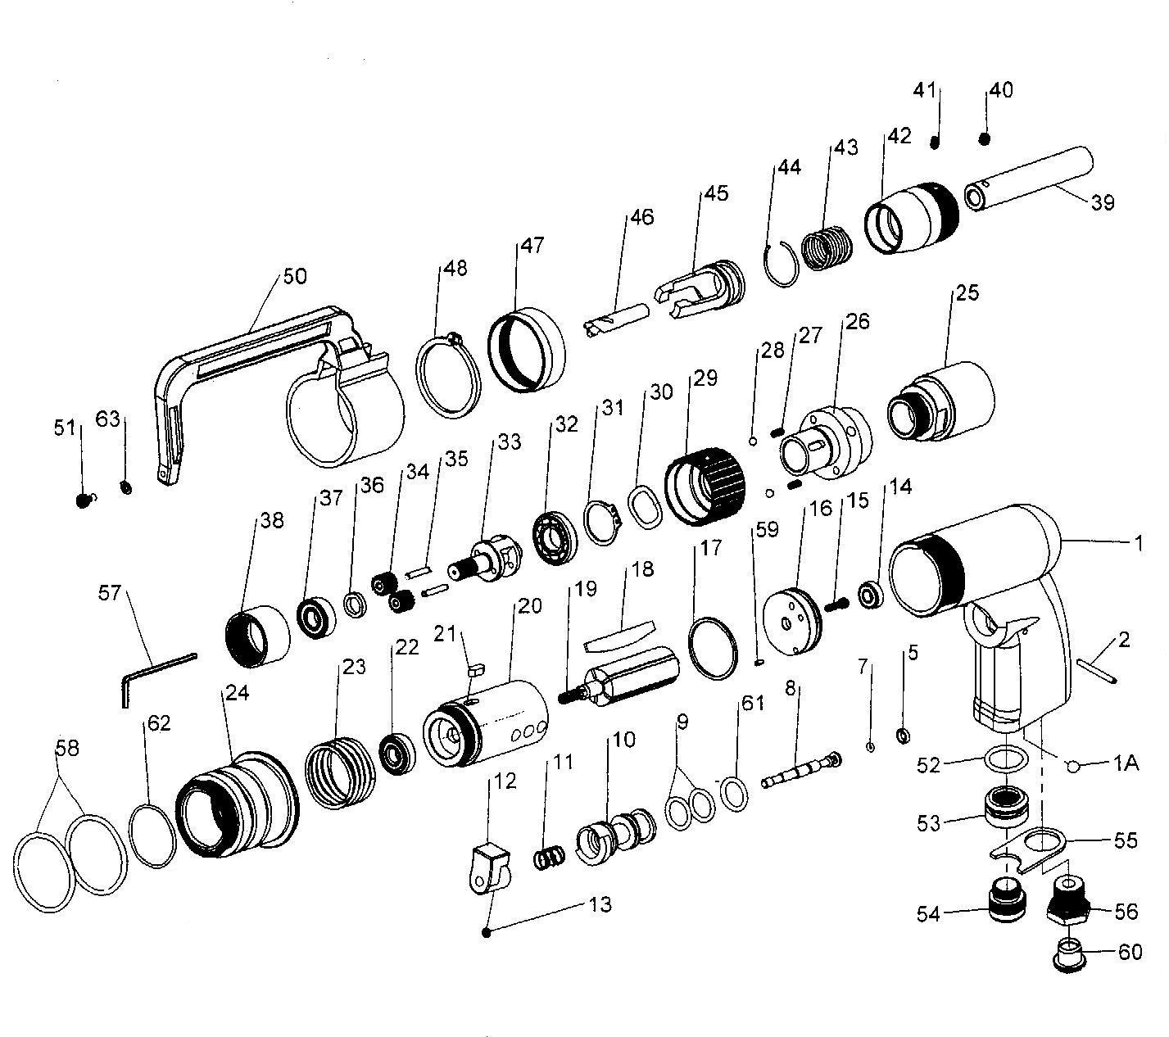

**GP5652**

**Dépointeuse**

|  |  |  |  |  |  |  |  |
| --- | --- | --- | --- | --- | --- | --- | --- |
| Rep | Référence. | DESCRIPTION | QTE | Rep | Référence. | DESCRIPTION | QTE |
| 1 | GP5652-1 | Corps | 1 | 33 | GP5652-33 | Porte satellite | 1 |
| 1A | GP5652-1A | Bille | 1 | 34 | GP5652-34 | Pignon | 2 |
| 2 | GP5652-2 | Goupille | 1 | 35 | GP5652-35 | Axe | 2 |
| 5 | GP5652-5 | Joint | 1 | 36 | GP5652-36 | Rondelle | 1 |
| 7 | GP5652-7 | Joint | 1 | 37 | R6-2RS | Roulement | 1 |
| 8 | GP5652-8 | Axe | 1 | 38 | GP5652-38 | Couronne | 1 |
| 9 | GP5652-9 | Joint | 2 | 39 | GP5652-39 | Porte foret | 1 |
| 10 | GP5652-10 | Chemise | 1 | 40 | GP5652-40 | Vis | 1 |
| 11 | GP5652-11 | Ressort | 1 | 41 | GP5652-41 | Vis | 1 |
| 12 | GP5652-12 | Gâchette | 1 | 42 | GP5652-42 | Attachement | 1 |
| 13 | GP5652-13 | Vis | 1 | 43 | GP5652-43 | Ressort | 1 |
| 14 | 696-2RS | Roulement 696zz | 1 | 44 | GP5652-44 | Clips | 1 |
| 15 | GP5652-15 | Vis | 1 | 45 | GP5652-45 | Bute foret | 1 |
| 16 | GP5652-16 | Flasque arr | 1 | 46 |  | Foret | 1 |
| 17 | GP5652-17 | Joint | 1 | 47 | GP5652-47 | Bague | 1 |
| 18 | GP5652-18 | Palette | 5 | 48 | GP5652-48 | Circlips | 1 |
| 19 | GP5652-19 | Rotor | 1 | 50 | GP5652-50 | Bras | 1 |
| 20 | GP5652-20 | Cylindre | 1 | 51 | GP5652-51 | Vis | 1 |
| 21 | GP5652-21 | Clavette | 1 | 52 | GP5652-52 | Joint | 1 |
| 22 | 608-2RS | Roulement 608 | 1 | 53 | GP5652-53 | Ecrou silencieux | 1 |
| 23 | GP5652-23 | Ressort | 1 | 54 | GP5652-54 | Silencieux | 1 |
| 24 | GP5652-24 | Bague |  | 55 | GP5652-55 | Plaque | 1 |
| 25 | GP5652-25 | Carter pignon | 1 | 56 | GP5652-56 | Raccord | 1 |
| 26 | GP5652-26 | Carter | 1 | 57 | GP5652-57 | Clé 2.5mm | 1 |
| 27 | GP5652-27 | Ressort | 2 | 58 | GP5652-58 | Joint | 2 |
| 28 | GP5652-28 | Bille | 2 | 59 | GP5652-59 | Goupille | 1 |
| 29 | GP5652-29 | Bague réglage | 1 | 60 | GP5652-60 | Bouchon | 1 |
| 30 | GP5652-30 | Rondelle élastique | 1 | 61 | GP5652-61 | Joint | 1 |
| 31 | GP5652-31 | Circlips | 1 | 62 | GP5652-62 | Joint | 1 |
| 32 | R8-2RS | Roulement R8 | 1 | 63 | GP5652-63 | Rondelle | 1 |