



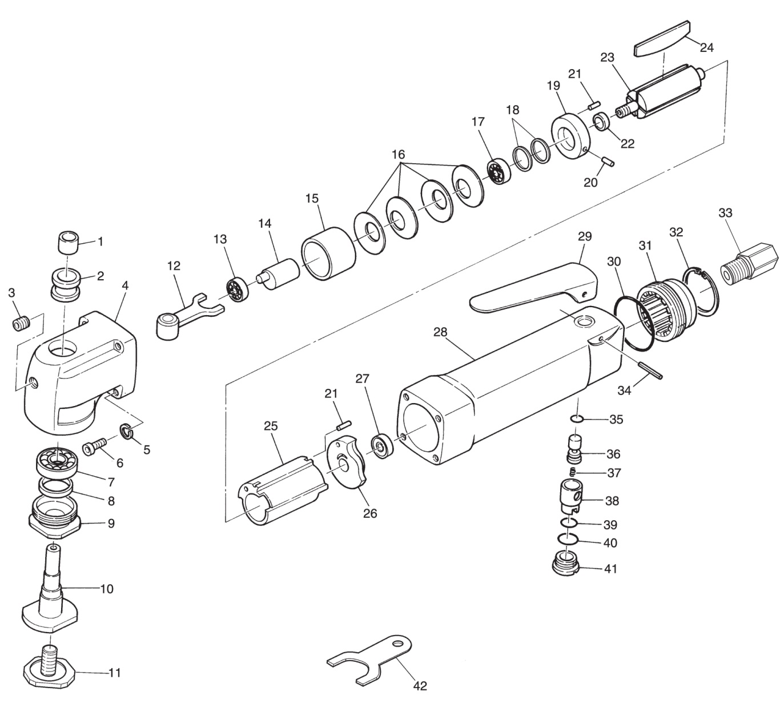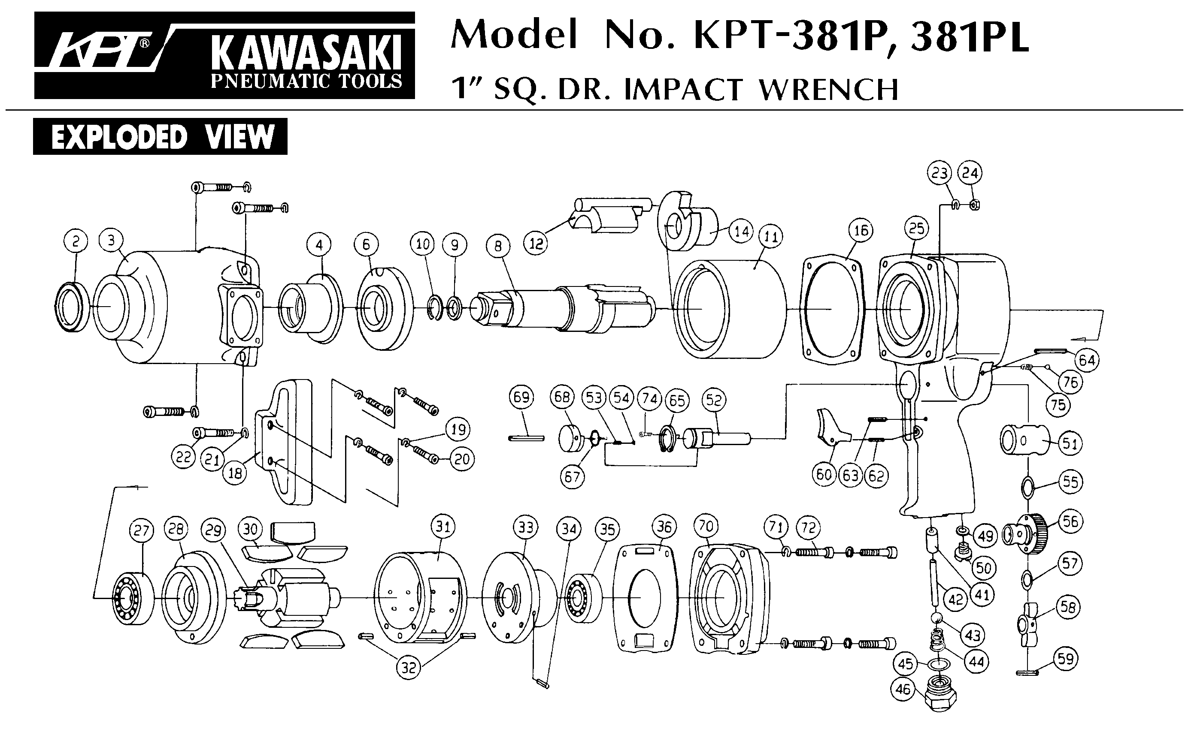





**GP5634**

**Couteau pare-brise**

|  |  |  |  |  |  |  |  |
| --- | --- | --- | --- | --- | --- | --- | --- |
| REP | INDEX No. | DESCRIPTION | QTE | REP | INDEX No. | DESCRIPTION | QTE |
| 1 | GP5634N-1 | Roulement aiguille | 1 | 23 | GP5634N-23 | Rotor | 1 |
| 2 | GP5634N-2 | Chambre roulement | 1 | 24 | GP5634N-24 | Palette | 1 |
| 3 | GP5634N-3 | Vis | 1 | 25 | GP5634N-25 | Chemise moteur | 1 |
| 4 | GP5634N-4 | Carter tête | 1 | 26 | GP5634N-26 | Flasque arr | 1 |
| 5 | GP5634N-5 | Rondelle | 4 | 27 | 626-2RS | Roulement 626 | 1 |
| 6 | GP5634N-6 | Vis | 4 | 28 | GP5634N-28 | Corps | 1 |
| 7 | EE-3 | Roulement EE3 | 1 | 29 | GP5634N-29 | Gâchette | 1 |
| 8 | GP5634N-8 | Joint | 1 | 30 | GP5634N-30 | Joint | 1 |
| 9 | GP5634N-9 | Ecrou axe tête | 1 | 31 | GP5634N-31 | Silencieux | 1 |
| 10 | GP5634N-10 | Axe couteau | 1 | 32 | GP5634N-32 | Circlips | 1 |
| 11 | GP5634N-11 | Ecrou lame | 1 | 33 | GP5634N-33 | Raccord air | 1 |
| 12 | GP5634N-12 | Fourchette | 1 | 34 | GP5634N-34 | Goupille | 1 |
| 13 | 607-2RS | Roulement 607 | 1 | 35 | GP5634N-35 | Joint | 1 |
| 14 | GP5634N-14 | Axe excentrique | 1 | 36 | GP5634N-36 | Axe gâchette | 1 |
| 15 | GP5634N-15 | Entretoise | 1 | 37 | GP5634N-37 | Ressort | 1 |
| 16 | GP5634N-16 | Rondelle élastique | 4 | 38 | GP5634N-38 | Variateur | 1 |
| 17 | 6000-2RS | Roulement 6000zz | 1 | 39 | GP5634N-39 | Joint | 1 |
| 18 | GP5634N-18 | Rondelle calage | 1 | 40 | GP5634N-40 | Joint | 1 |
| 19 | GP5634N-19 | Flasque Avt | 1 | 41 | GP5634N-41 | Ecrou | 1 |
| 20 | GP5634N-20 | Goupille | 1 | 42 | GP5634N-42 | Clé serrage lame | 2 |
| 21 | GP5634N-21 | Goupille | 2 |  |  |  |  |
| 22 | GP5634N-22 | Entretoise | 1 |  |  |  |  |

**Manche Atlantique Equipements** -27 parc d’activité du Chalet - 22250 BroonsTél 02 96 84 65 59 - Fax 02 96 84 77 75

**WWW.MAE-FR.COM**