

**GP5630**

**Poinçonneuse soyeuse**

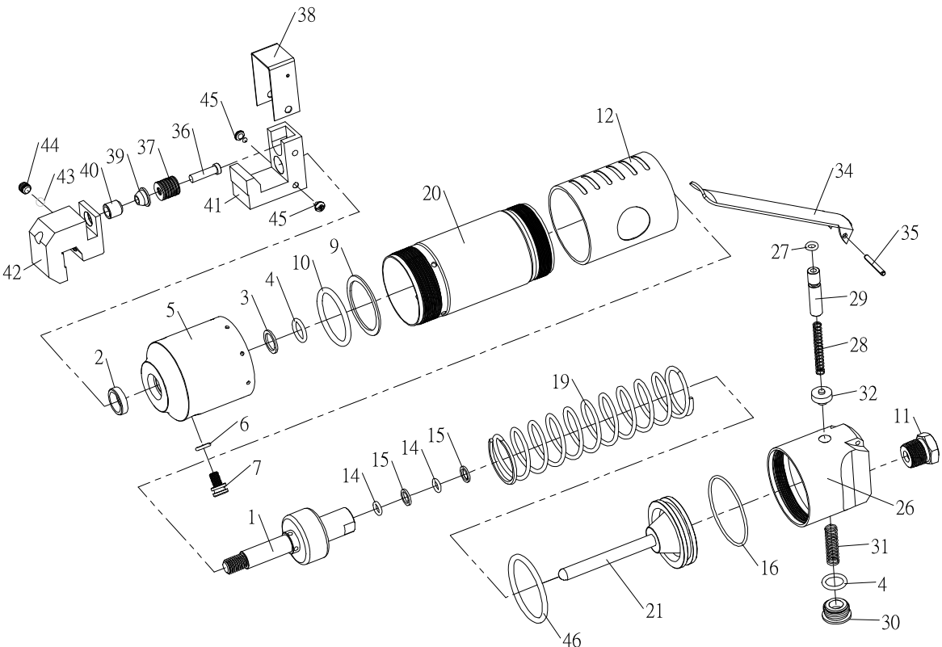

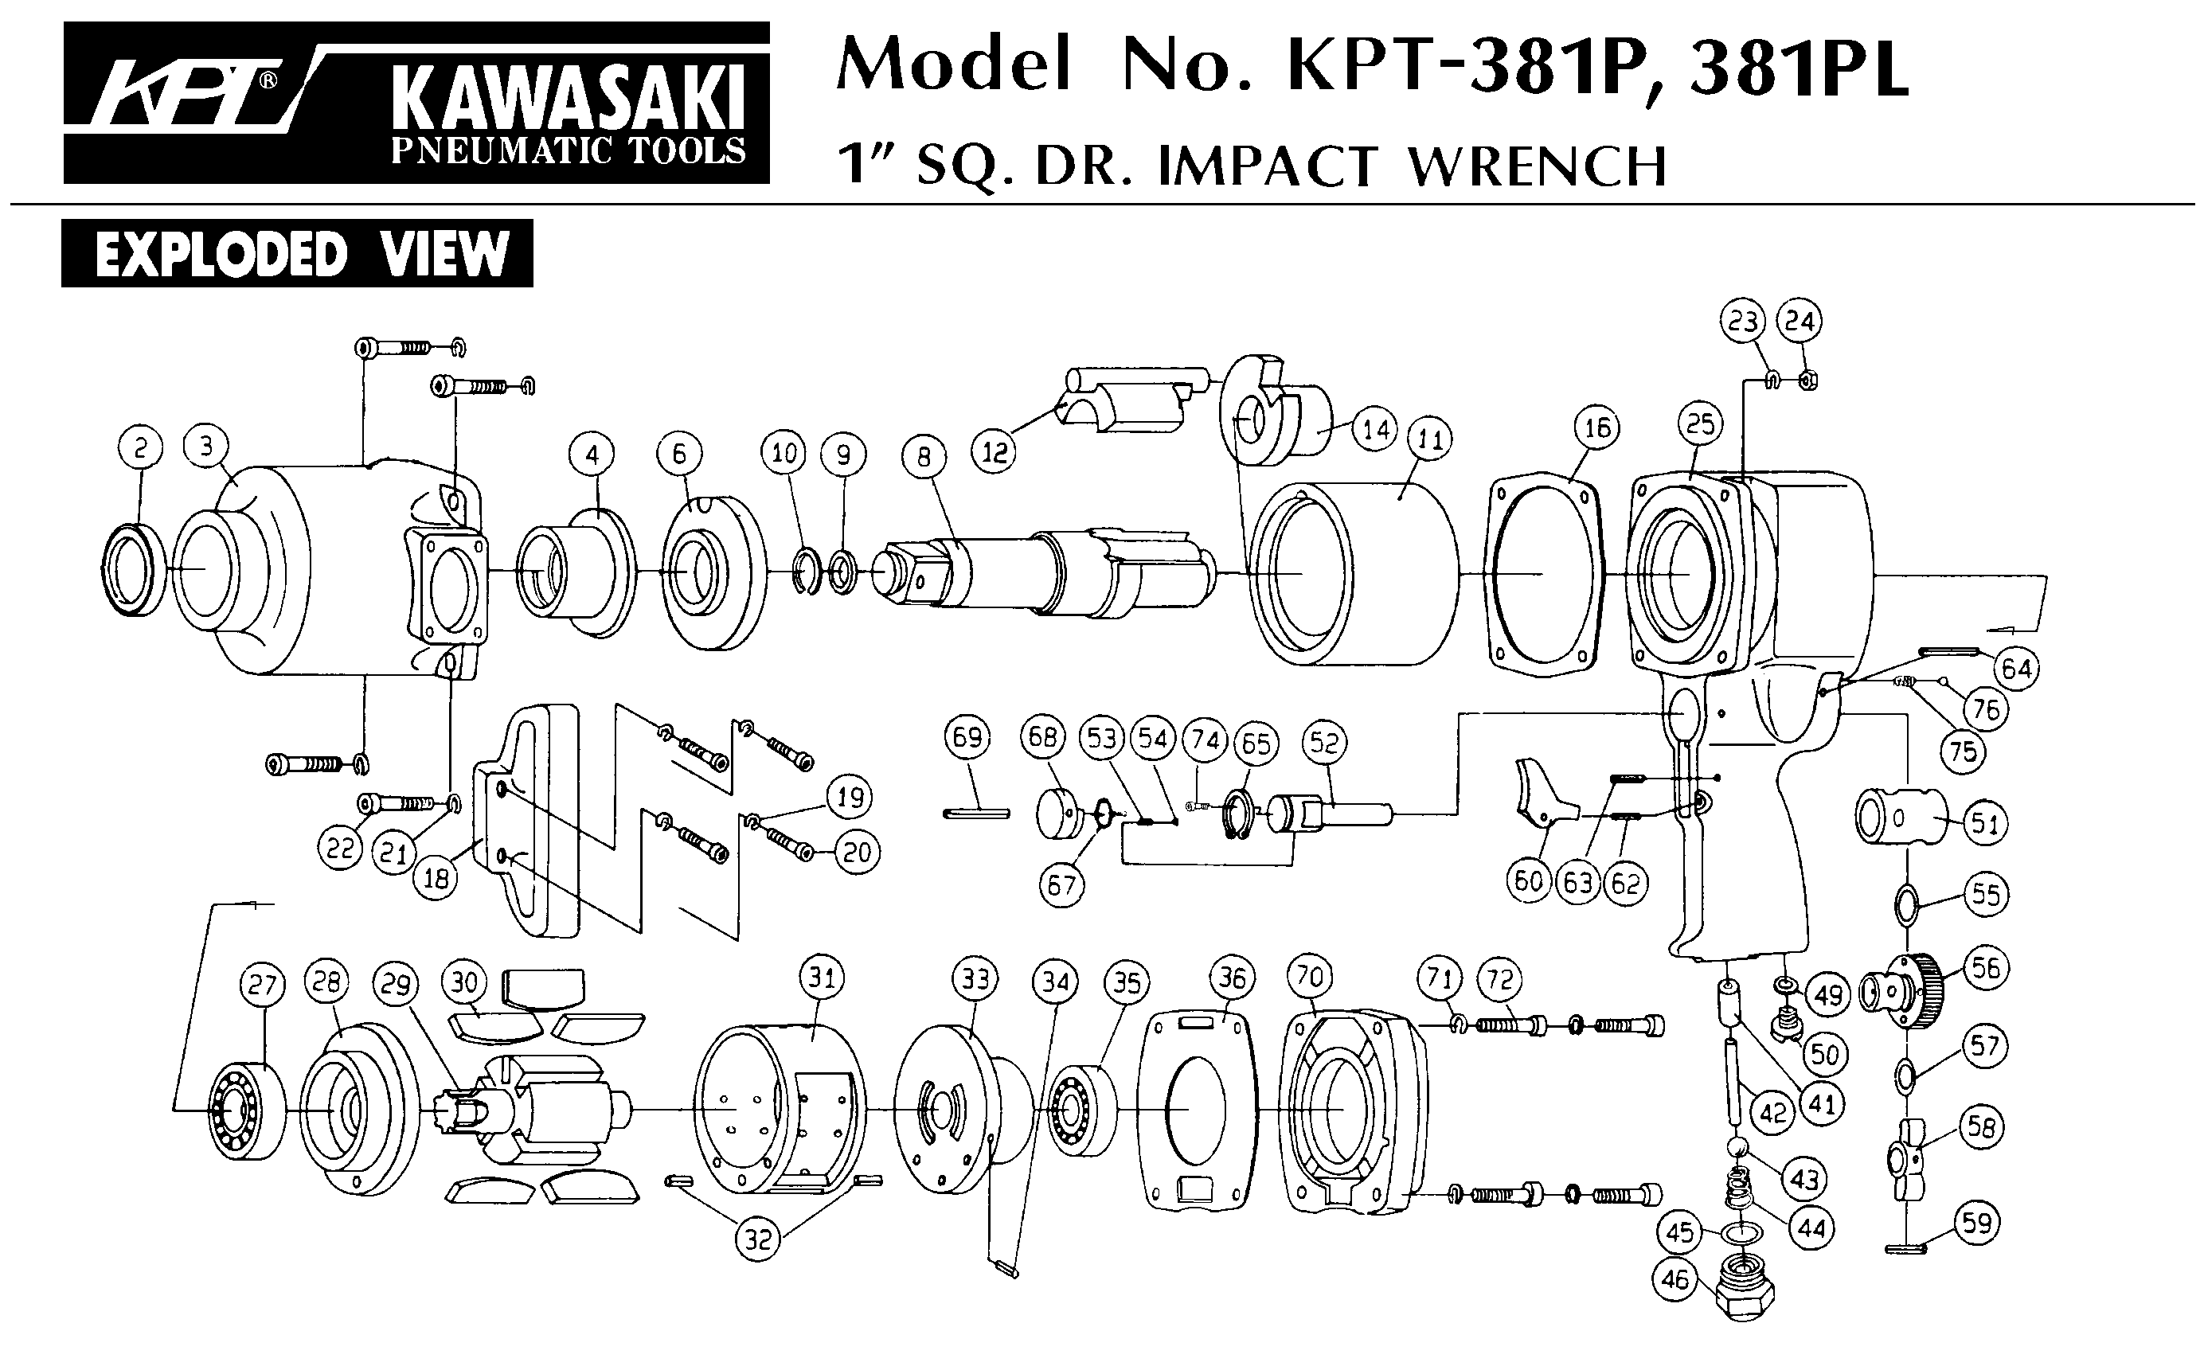





|  |  |  |  |  |  |  |  |  |
| --- | --- | --- | --- | --- | --- | --- | --- | --- |
| Rep | Ref. n° | Description | Qté |  | Rep | Ref. n° | Description | Qté |
| 1 | GP5630-01 | Piston | 1 |  | 28 | GP5630-28 | Ressort | 1 |
| 2 | GP5630-02 | Joint | 1 |  | 29 | GP5630-29 | Axe valve | 1 |
| 3 | GP5630-03 | Support joint | 1 |  | 30 | GP5630-30 | Ecrou | 1 |
| 4 | GP5630-04 | Joint | 2 |  | 31 | GP5630-31 | Ressort | 1 |
| 5 | GP5630-05 | Carter | 1 |  | 32 | GP5630-32 | Valve | 1 |
| 6 | GP5630-06 | Joint | 1 |  | 34 | GP5630-34 | Gâchette | 1 |
| 7 | GP5630-07 | Vis | 1 |  | 35 | GP5630-35 | Goupille | 1 |
| 9 | GP5630-09 | Support joint | 1 |  | 36 | GP5630-36 | Poinçon | 1 |
| 10 | GP5630-10 | Joint | 1 |  | 37 | GP5630-37 | Rondelle | 13 |
| 11 | GP5630-11 | Raccord | 1 |  | 38 | GP5630-38 | Cache | 1 |
| 12 | GP5630-12 | Grip | 1 |  | 39 | GP5630-39 | Guide | 1 |
| 14 | GP5630-14 | Joint | 2 |  | 40 | GP5630-40 | Guide | 1 |
| 15 | GP5630-15 | Support joint | 2 |  | 41 | GP5630-41 | Marteau | 1 |
| 16 | GP5630-16 | Joint | 1 |  | 42 | GP5630-42 | Tête | 1 |
| 19 | GP5630-19 | Ressort | 1 |  | 43 | GP5630-43 | Joint | 1 |
| 20 | GP5630-20 | Cylindre | 1 |  | 44 | GP5630-44 | Vis | 1 |
| 21 | GP5630-21 | Piston | 1 |  | 45 | GP5630-45 | Vis | 2 |
| 26 | GP5630-26 | Corps valve | 1 |  | 46 | GP5630-46 | Joint | 1 |
| 27 | GP5630-27 | Joint | 1 |  |  |  |  |  |

Avril 2019