



**GP5612**

**Scie Sabre**

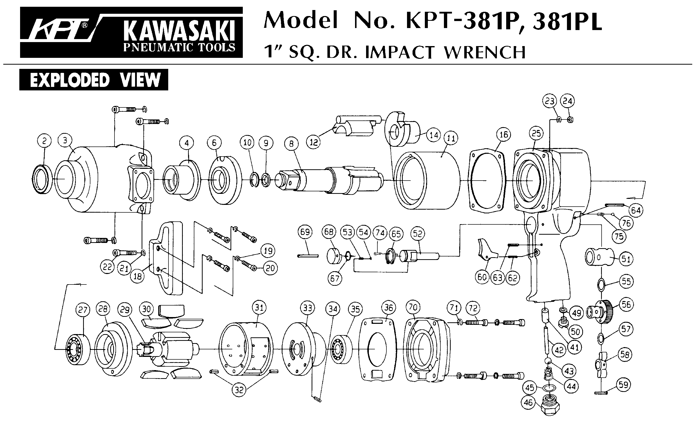





|  |  |  |  |  |  |  |  |
| --- | --- | --- | --- | --- | --- | --- | --- |
| Rep | Réf | Description | Qté | Rep | Réf | Description | Qté |
| 1 | GP5612-01 | Ecrou | 1 | 26 | GP5612-26 | Capot lame | 1 |
| 2 | GP5612-02 | Joint | 1 | 27 | GP5612-27 | Vis | 2 |
| 3 | GP5612-03 | Joint | 1 | 28 | GP5612-28 | Corps | 1 |
| 4 | GP5612-04 | Variateur | 1 | 28A | GP5612-28A | Gaine protection | 1 |
| 5 | GP5612-05 | Ressort | 1 | 29 | GP5612-29 | Piston | 1 |
| 6 | GP5612-06 | Axe -valve | 1 | 30 | GP5612-30 | Vis | 2 |
| 7A | GP5612-07A | Joint | 1 | 31 | GP5612-31 | Clé 2 mm | 1 |
| 7B | GP5612-07B | Joint | 1 | 32 | GP5612-32 | Plaque | 1 |
| 8 | GP5612-08 | Insert | 1 | 33 | GP5612-33 | Mandrin lame | 1 |
| 9 | GP5612-09 | Raccord | 1 | 34 | GP5612-34 | Guide lame | 1 |
| 10 | GP5612-10 | Vis | 4 | 35 | RA31324 | Lame | 1 |
| 11 | GP5612-11 | Rondelle | 4 | 36 | GP5612-36 | Clé 4mm | 1 |
| 12 | GP5612-12 | Goupille | 1 | 38 | GP5612-38 | Vis capot | 2 |
| 13 | GP5612-13 | Gâchette | 1 | 39 | GP5612-39 | Plaque | 1 |
| 15 | GP5612-15 | Chemise | 1 | 40 | GP5612-40 | Bride | 2 |
| 16 | GP5612-16 | Entretoise | 1 | 41 | GP5612-41 | Plaque | 1 |
| 17 | GP5612-17 | Chemise | 1 | 42 | GP5612-42 | Joint amortisseur avt | 1 |
| 18 | GP5612-18 | Valve | 1 | 43 | GP5612-43 | Joint amortisseur Arr | 1 |
| 19 | GP5612-19 | Joint | 1 | 44 | GP5612-44 | Goupille | 2 |
| 20 | GP5612-20 | Ecrou | 1 | 45 | GP5612-45 | Ressort | 1 |
| 21 | GP5612-21 | Ecrou | 2 | 46 | GP5612-46 | Joint | 1 |
| 22 | GP5612-22 | Joint | 1 | 47 | GP5612-47 | Joint | 1 |
| 23 | GP5612-23 | Bloc valve | 1 | 48 | GP5612-48 | Joint | 1 |
| 24 | GP5612-24 | Vis | 2 | 49 | GP5612-49 | Vis | 1 |
| 25 | GP5612-25 | Entretoise | 2 |  |  |  | 1 |