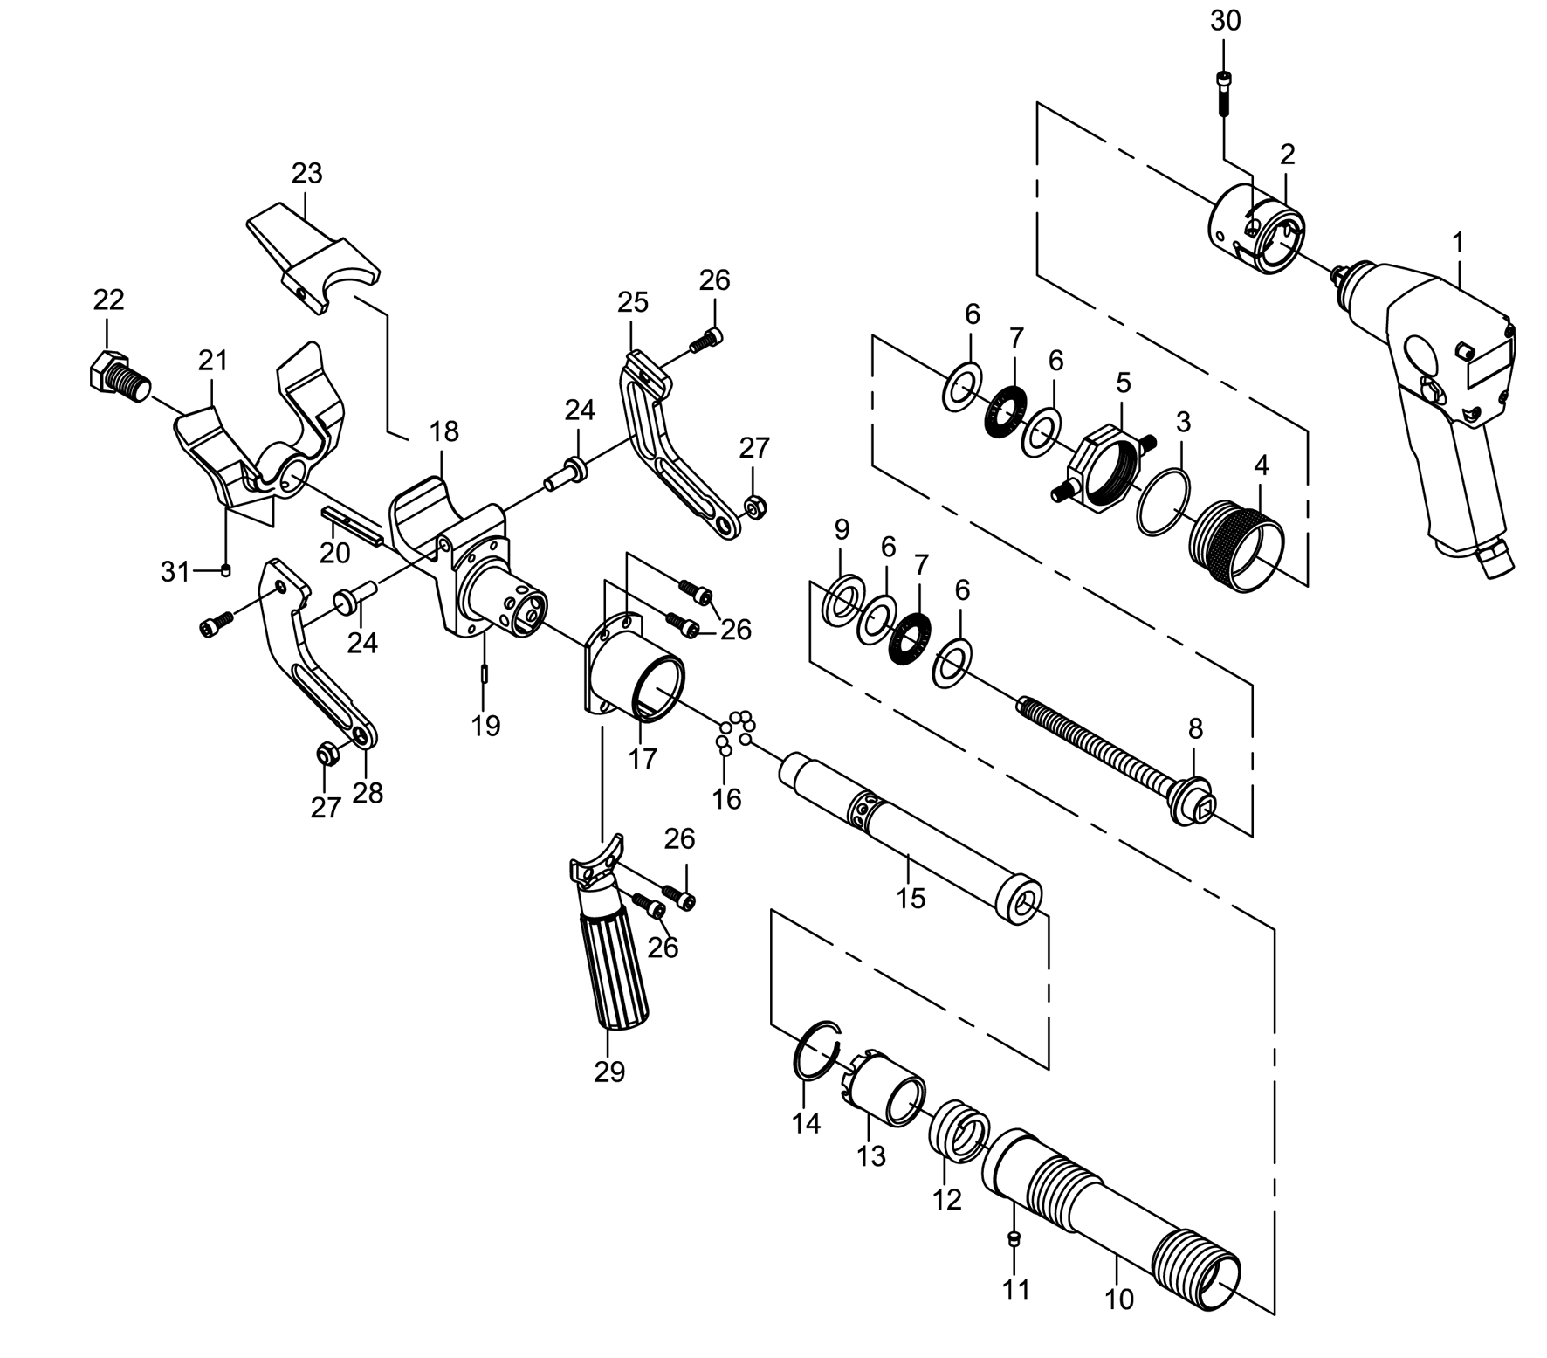

GP5510
Détalonneur de pneu

Réf | Rep | Désignation | Qté | Réf | Rep | Désignation | Qté
GP5510-01 | 1 | Clé entrainement | 1 | GP5510-17 | 17 | Carter connexion | 1
GP5510-02 | 2 | Connecteur | 1 | GP5510-18 | 18 | Appuie | 1
GP5510-03 | 3 | Joint | 1 | GP5510-19 | 19 | Goupille | 1
GP5510-04 | 4 | Ecrou serrage | 1 | GP5510-20 | 20 | Clavette | 1
GP5510-05 | 5 | Vis réglage | 1 | GP5510-21 | 21 | Bras de poussé | 1
GP5510-06 | 6 | Rondelle | 4 | GP5510-22 | 22 | Vis | 1
GP5510-07 | 7 | Roulement aiguille | 2 | GP5510-23 | 23 | Mâchoire supérieur | 1
GP5510-08 | 8 | Vis | 1 | GP5510-24 | 24 | Axe rouleau (X2) | 1
GP5510-09 | 9 | Rondelle | 1 | GP5510KITA | 25 | Bras de maintien droite | 1
GP5510-10 | 10 | Tube adaptateur | 1 | GP5510KITA | 28 | Bras de maintien gauche | 1
GP5510-11 | 11 | Goupille | 1 | GP5510-26 | 26 | Vis | 6
GP5510-12 | 12 | Ressort | 1 | GP5510-27 | 27 | Ecrou | 2
GP5510-13 | 13 | Cage à bille | 1 | GP5510-29 | 29 | Poignée | 1
GP5510-14 | 14 | Circlips | 1 | GP5510-30 | 30 | Vis | 2
GP5510-15 | 15 | Tube - broche | 1 | GP5510-31 | 31 | Vis | 1
GP5510-16 | 16 | Bille | 7

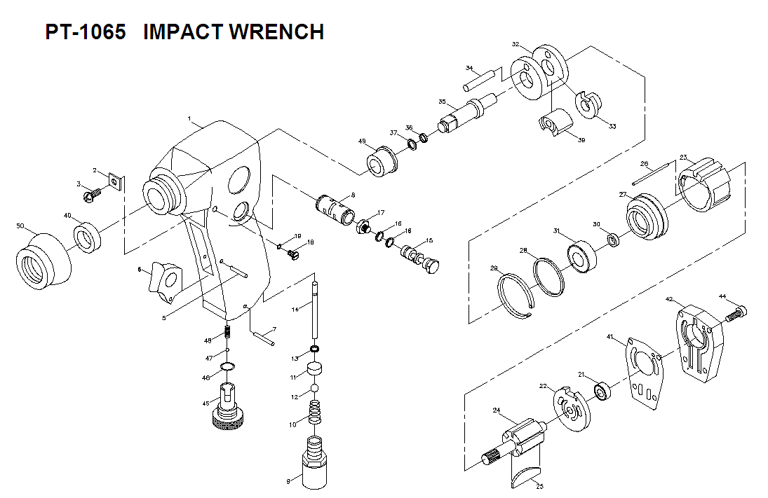

Rep | Ref | Désignation | Qté | Rep | Ref | Désignation | Qté
1 | GP5510K-01 | Carter moteur | 1 | 26 | GP5510K-26 | Goupille | 1
2 | GP5510K-02 | Déflecteur | 1 | 27 | GP5510K-27 | Flasque avt | 1
3 | GP5510K-03 | Vis | 1 | 28 | GP5510K-28 | Joint | 1
5 | GP5510K-05 | Goupille | 1 | 29 | GP5510K-29 | Circlips | 1
6 | GP5510K-06 | Gâchette | 1 | 30 | GP5510K-30 | Joint spy | 1
7 | GP5510K-07 | Goupille | 1 | 31 | GP5510K-31 | Roulement 77R6 | 1
8 | GP5510K-08 | Chambre inverseur | 1 | 32 | GP5510K-32 | Cage de frappe | 1
9 | GP5510K-09 | Raccord | 1 | 33 | GP5510K-33 | Came | 1
10 | GP5510K-10 | Ressort | 1 | 34 | GP5510K-34 | Axe marteau | 1
11 | GP5510K-11 | Siege bille | 1 | 35 | GP5510K-35 | Broche 3/8 | 1
12 | GP5510K-12 | Bille | 1 | 36 | GP5510K-36 | Joint | 1
13 | GP5510K-13 | Joint | 1 | 37 | GP5510K-37 | Circlips | 1
14 | GP5510K-14 | Axe valve | 1 | 39 | GP5510K-39 | Marteau | 1
15 | GP5510K-15 | Bouton inverseur | 1 | 40 | GP5510K-40 | Joint spy | 1
16 | GP5510K-16 | Joint | 2 | 41 | GP5510K-41 | Joint | 1
17 | GP5510K-17 | Vis | 1 | 42 | GP5510K-42 | Carter Arr | 1
18 | GP5510K-18 | Vis | 1 | 44 | GP5510K-44 | Vis | 4
19 | GP5510K-19 | Joint | 1 | 45 | GP5510K-45 | Régulateur | 1
21 | 626-2RS | Roulement 626 | 1 | 46 | GP5510K-46 | Joint | 1
22 | GP5510K-22 | Flasque Arr | 1 | 47 | GP5510K-47 | Bille | 1
23 | GP5510K-23 | Chemise | 1 | 48 | GP5510K-48 | Ressort | 1
24 | GP5510K-24 | Rotor | 1 | 49 | GP5510K-49 | Entretoise | 1
25 | GP5510K-25 | Palette | 6 | 50 | GP5510K-50 | Caoutchouc | 1

