



GP5225H
Burineur hexagonal

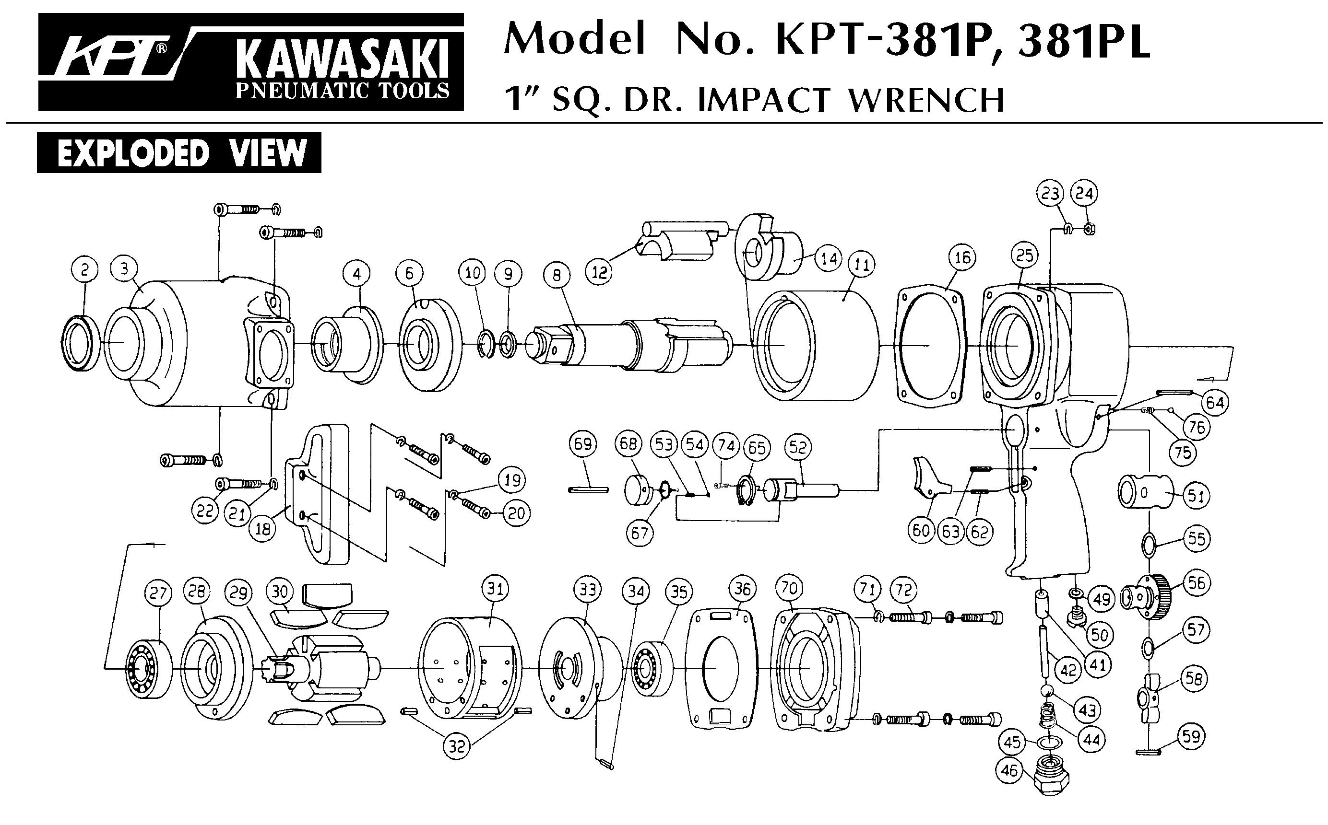
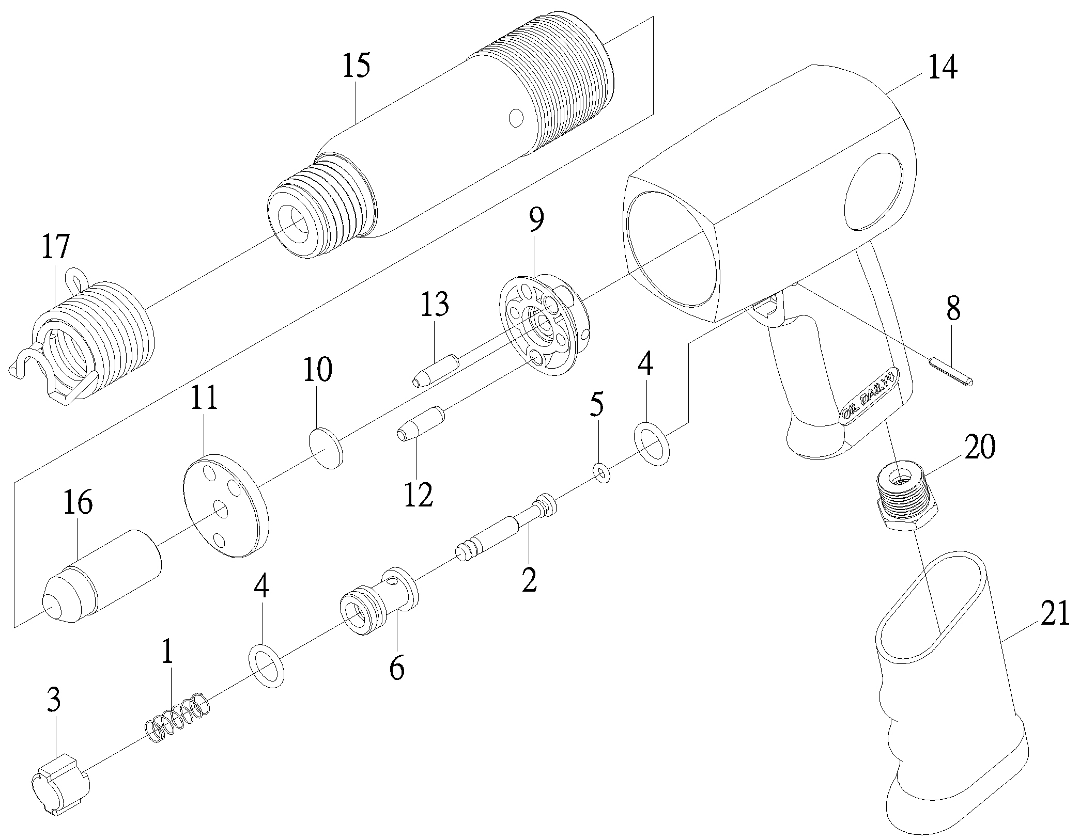

Rep | Réf pièce | DESCRIPTION | QTE | Rep | Réf pièce. | DESCRIPTION | QTE
1 | GP5225H-1 | Ressort | 1 | 11 | GP5225H-11 | Flasque AVT | 1
2 | GP5225H-2 | Axe valve | 1 | 12 | GP5225H-12 | Gros axe | 1
3 | GP5225H-3 | Gâchette | 1 | 13 | GP5225H-13 | Petit axe | 1
4 | GP5225H-4 | Joint | 2 | 14 | GP5225H-14 | Corps | 1
5 | GP5225H-5 | Joint | 1 | 15 | GP5225H-15 | Cylindre sortie 11mm | 1
6 | GP5225H-6 | Guide axe valve | 1 | 16 | GP5225H-16 | Piston | 1
8 | GP5225H-8 | Goupille | 1 | 17 | GP5225H-17 | Ressort | 1
9 | GP5225H-9 | Flasque AR | 1 | 20 | GP5225H-20 | Raccord | 1
10 | GP5225H-10 | Rondelle | 1 | 21 | GP5225H-21 | Grip | 1

Manche Atlantique Equipements -27 parc d’activité du Chalet - 22250 Broons
Tél 02 96 84 65 59 - Fax 02 96 84 77 75
WWW.MAE-FR.COM

