



**GP4811**

**Ponceuse à bande**

**10x330**

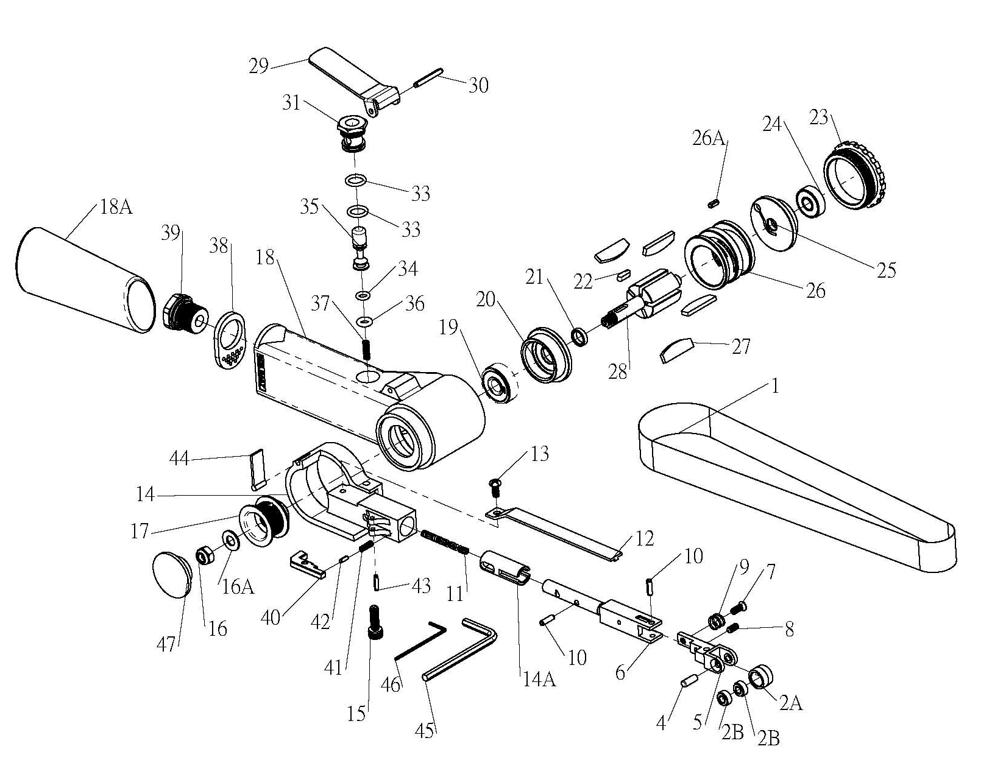

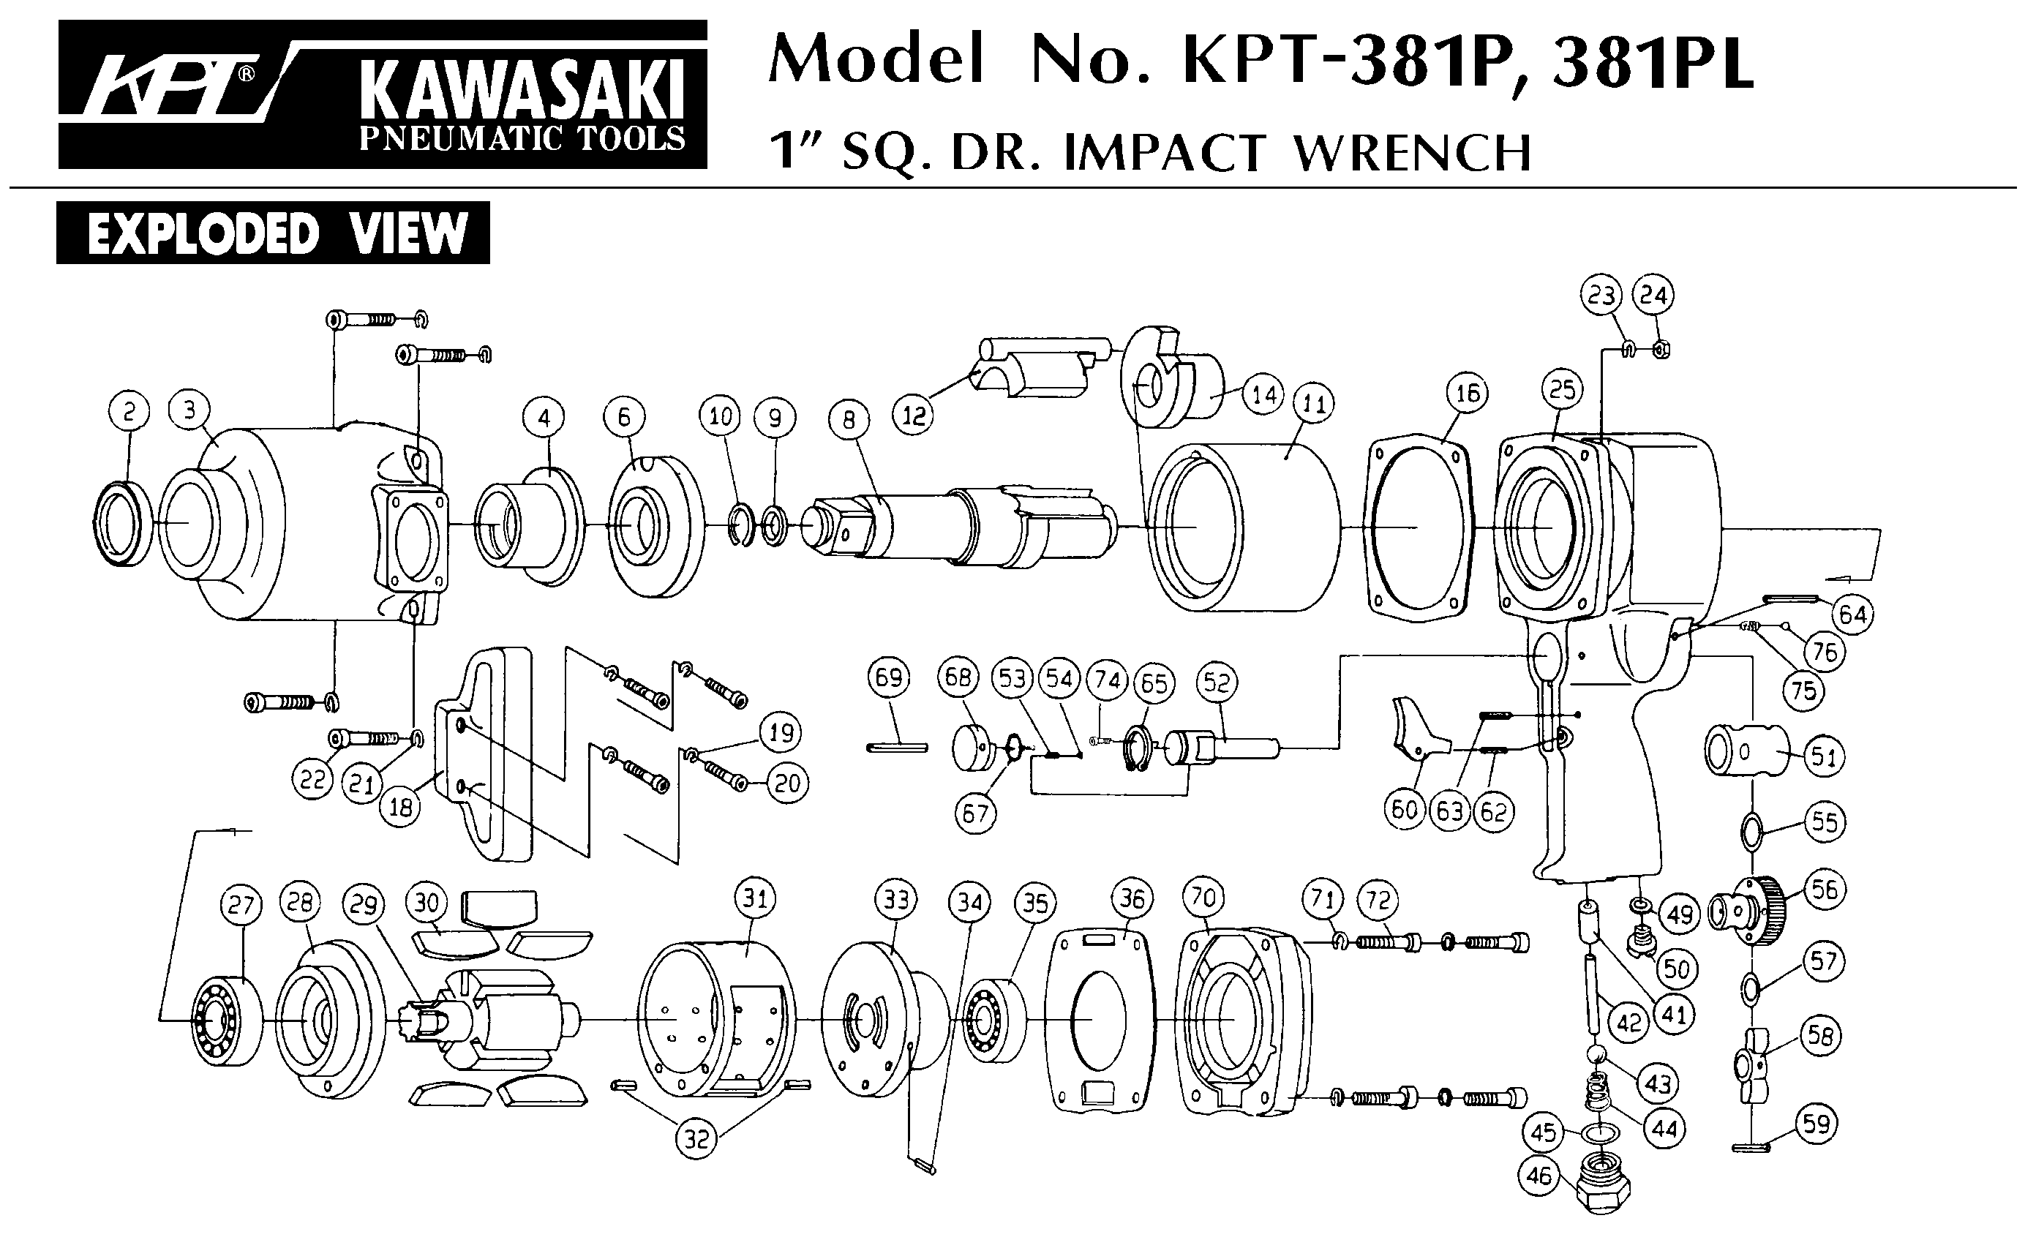





|  |  |  |  |  |  |  |  |
| --- | --- | --- | --- | --- | --- | --- | --- |
| Rep | Réf | Description | Qté | Rep | Réf | Description | Qté |
| 1 | GP4811-1 | Bande | 1 | 23 | GP4811-23 | Capot moteur | 1 |
| 2 | GP4811-2 | Poulie complète | 1 | 24 | 607-2RS | Roulement 607 | 1 |
| 2A |  | Poulie (voir GP4811-2) | 1 | 25 | GP4811-25 | Flasque arr | 1 |
| 2B |  | Roulement 684 (voir GP4811-2) | 2 | 26 | GP4811-26 | Cylindre | 1 |
| 4 | GP4811-4 | Axe | 1 | 26A | GP4811-26A | Goupille | 1 |
| 5 | GP4811-5 | Porte poulie | 1 | 27 | GP4811-27 | Palette | 1 |
| 6 | GP4811-6 | Bras | 1 | 28 | GP4811-28 | Rotor | 5 |
| 7 | GP4811-7 | Vis | 1 | 29 | GP4811-29 | Gâchette | 1 |
| 8 | GP4811-8 | Vis | 1 | 30 | GP4811-30 | Goupille | 1 |
| 9 | GP4811-9 | Ressort | 1 | 31 | GP4811-31 | Chemise | 1 |
| 10 | GP4811-10 | Goupille | 1 | 33 | GP4811-33 | Joint | 1 |
| 11 | GP4811-11 | Ressort | 1 | 34 | GP4811-34 | Joint | 1 |
| 12 | GP4811-12 | Support bande | 1 | 35 | GP4811-35 | Axe valve | 1 |
| 13 | GP4811-13 | Vis | 1 | 36 | GP4811-36 | Joint | 1 |
| 14 | GP4811-14 | Carter bande | 1 | 37 | GP4811-37 | Ressort | 1 |
| 14A | GP4811-14A | Support bras | 1 | 38 | GP4811-38 | Silencieux | 1 |
| 15 | GP4811-15 | Vis | 1 | 39 | GP4811-39 | Raccord | 1 |
| 16 | GP4811-16 | Ecrou | 1 | 40 | GP4811-40 | Pate de blocage bras | 1 |
| 16A | GP4811-16A | Rondelle | 1 | 41 | GP4811-41 | Ressort | 1 |
| 17 | GP4811-17 | Poulie moteur | 1 | 42 | GP4811-42 | Goupille | 1 |
| 18 | GP4811-18 | Corps moteur | 1 | 43 | GP4811-43 | Goupille | 1 |
| 18A | GP4811-18A | Manchon caoutchouc | 1 | 44 | GP4811-44 | Bavette | 1 |
| 19 | 628-2RS | Roulement R628 | 1 | 45 | GP4811-45 | Clé | 1 |
| 20 | GP4811-20 | Flasque avt | 1 | 46 | GP4811-46 | Clé | 1 |
| 21 | GP4811-21 | Entretoise | 1 | 47 | GP4811-47 | Bouchon | 1 |
| 22 | GP4811-22 | Clavette | 1 |  |  |  |  |