

**GP4724**

**Surfaceur Ø150**

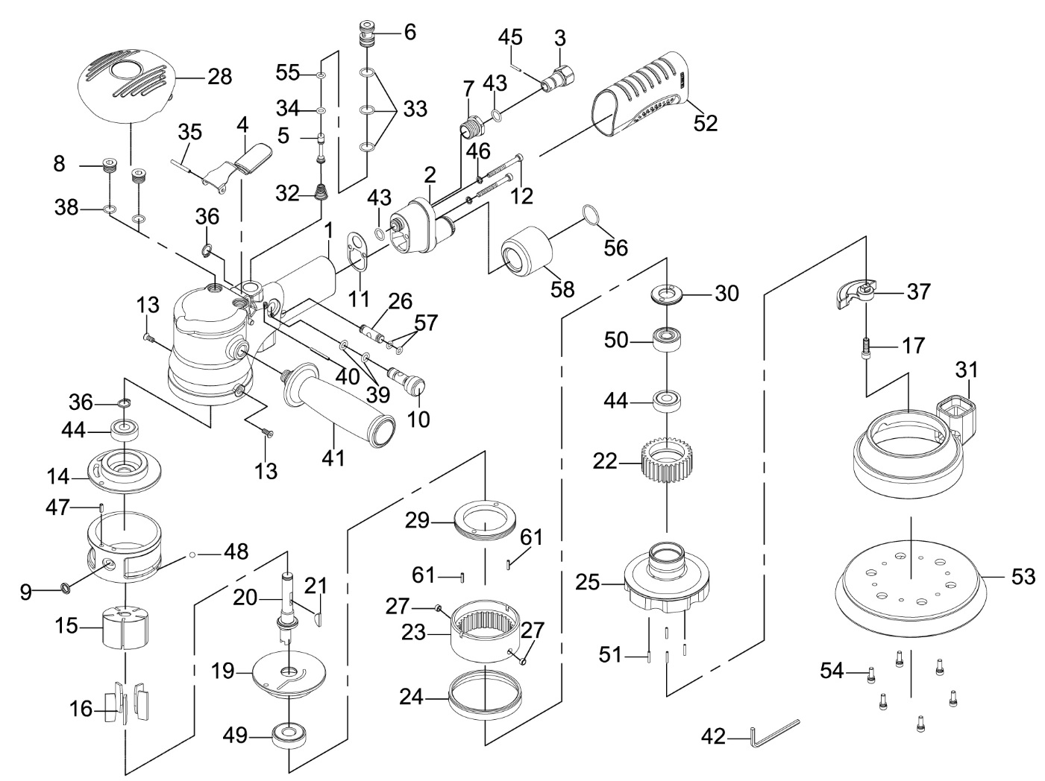

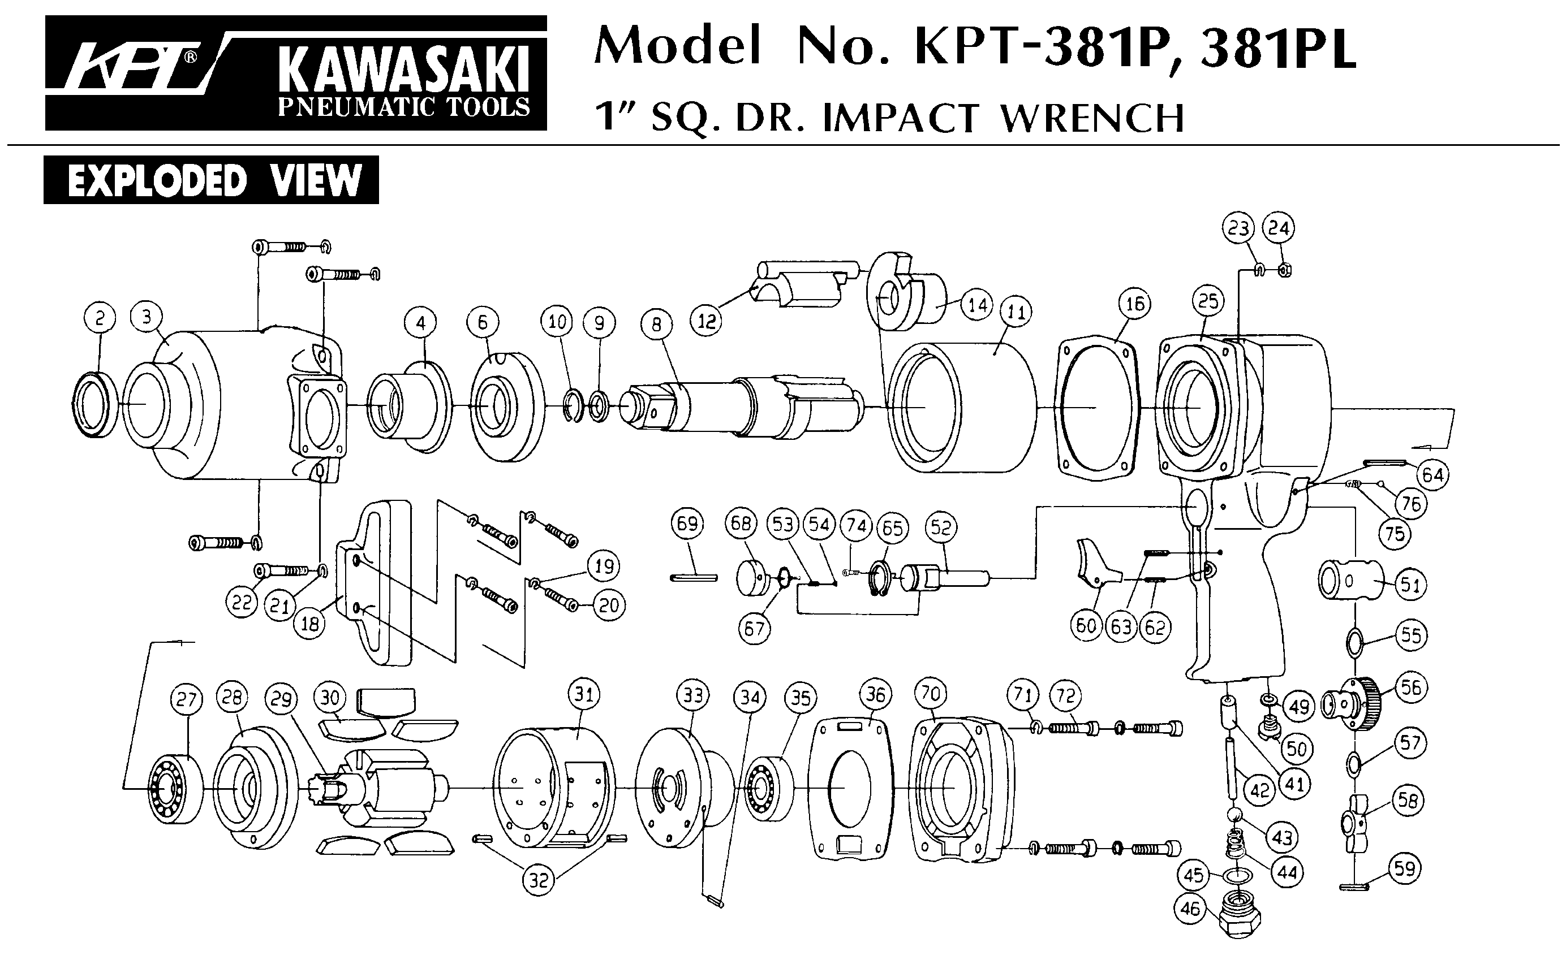





|  |  |  |  |  |  |  |  |
| --- | --- | --- | --- | --- | --- | --- | --- |
| ref. | Rep | Désignation | Qté | Ref. | Rep | Désignation | Qté |
| GP4734-1 | 1 | Corps | 1 | GP4734-28 | 28 | Grip | 1 |
| GP4734KITA | 2 | Carter raccord | 1 | GP4724KITD | 22 | Couronne | 1 |
| 3 | Raccord tournant | 1 | 23 | Couronne | 1 |
| 7 | Vis | 1 | 27 | Entretoise Acier | 2 |
| 43 | Joint | 2 | 30 | Ecrou coupelle plateau | 1 |
| 45 | Goupille | 1 | 44 | Roulement 6000ZZ couronne | 1 |
| 56 | Joint | 1 | 50 | Roulement 5000RS | 1 |
| 58 | Sortie poussière | 1 | 51 | Axe | 4 |
| GP4734-4 | 4 | Gâchette | 1 | 61 | Axe | 2 |
| GP4734-5 | 5 | Joint | 1 | GP4734-29 | 29 | Ecrou moteur | 1 |
| GP4734-6 | 6 | Valve | 1 | GP4734-30 | 30 | Ecrou coupelle plateau | 1 |
| GP4734-8 | 8 | Vis | 2 | GP4724-31 | 31 | Jupe | 1 |
| GP4734-9 | 9 | Joint | 1 | GP4734-32 | 32 | Ressort | 1 |
| GP4734KITB | 10 | Régulateur | 1 | GP4734-33 | 33 | Joint chambre | 3 |
| 36 | Circlips | 1 | GP4734-34 | 34 | Joint axe | 1 |
| 39 | Joint | 2 | GP4734-35 | 35 | Goupille | 1 |
| GP4734-11 | 11 | Joint | 1 | GP4724-37 | 37 | Balancier | 1 |
| GP4734-12 | 12 | Vis carter raccord | 2 | GP4734-38 | 38 | Joint | 2 |
| GP4734-13 | 13 | Vis | 2 | GP4734-40 | 40 | Axe | 1 |
| GP4734-14 | 14 | Flasque arr | 1 | GP4734-41 | 41 | Poignée latérale | 1 |
| GP4734KITC | 15 | Rotor | 1 | GP4724-42 | 42 | Clé 6 pans | 1 |
| 16 | Palettes | 5 | GP4734-46 | 46 | Rondelle | 2 |
| 21 | Clavette | 1 | GP4734-47 | 47 | Goupille | 1 |
| 36 | Circlips | 1 | GP4734-48 | 48 | Bille | 1 |
| 44 | Roulement 6000ZZ moteur | 1 | GP4734-51 | 51 | Axe | 4 |
| 49 | Roulement 6201zz moteur | 1 | GP4734-52 | 52 | Grip corps | 1 |
| GP4734-17 | 17 | Vis | 1 | GP4724-53 | 53 | Plateau | 1 |
| GP4734-18 | 18 | Chemise | 1 | GP4724-54 | 54 | Vis | 5 |
| GP4734-19 | 19 | Flasque avt | 1 | GP4734-56 | 55 | Joint | 1 |
| GP4734-20 | 20 | Arbre | 1 | GP4734-57 | 56 | Joint | 1 |
| GP4734-24 | 24 | Joint feutre | 1 | GP4734-58 | 57 | Joint | 2 |
| GP4724-25 | 25 | Coupelle plateau | 1 |  |  |  |  |
| GP4734-26 | 26 | Axe valve | 1 |  |  |  |  |

**Manche Atlantique Equipements** -27 parc d’activité du Chalet - 22250 BroonsTél 02 96 84 65 59 - Fax 02 96 84 77 75

**WWW.MAE-FR.COM**