

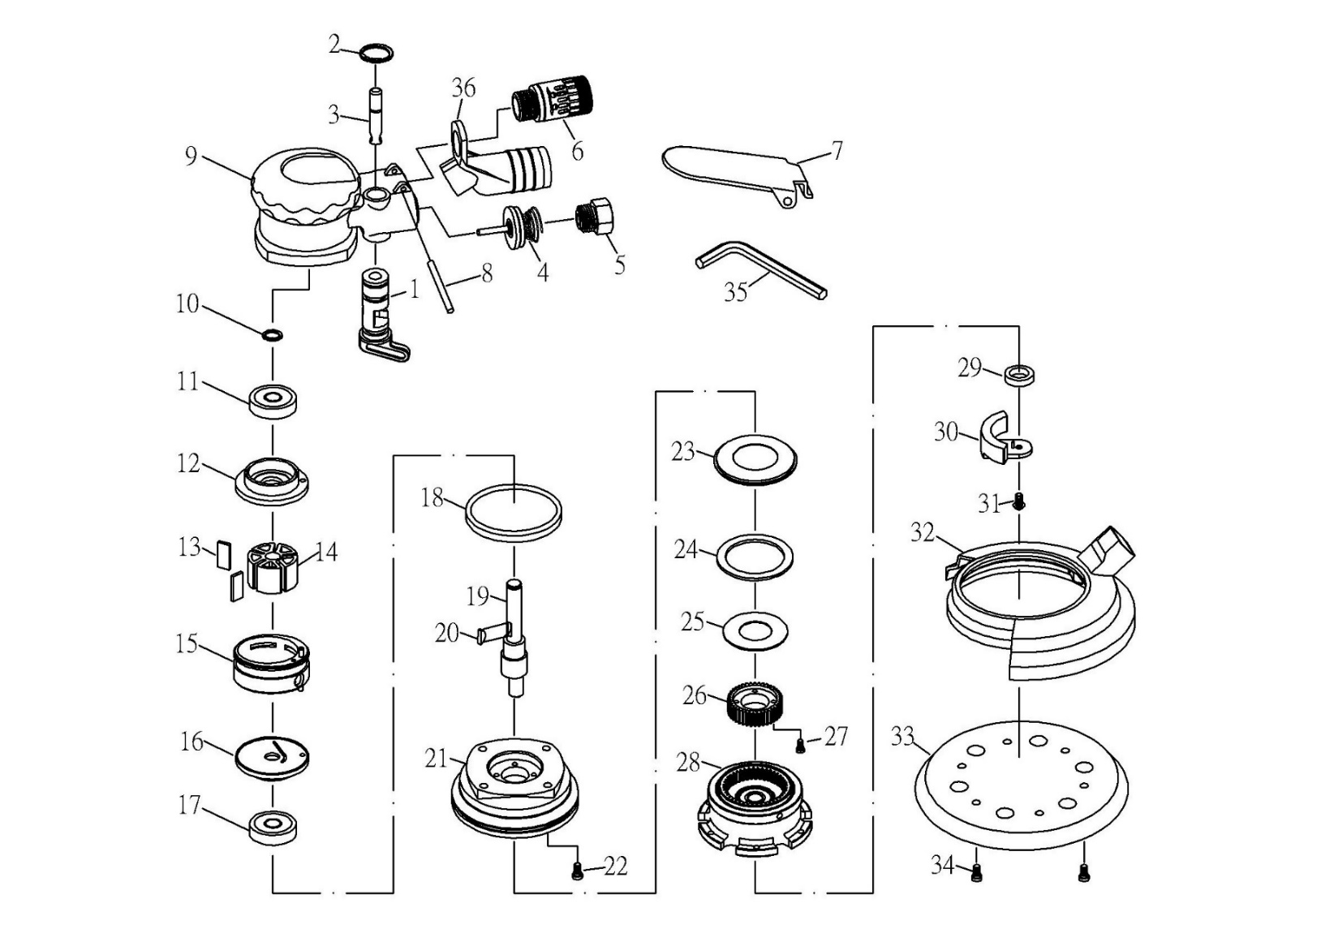

**GP4717**

**Surfaceur Ø150**

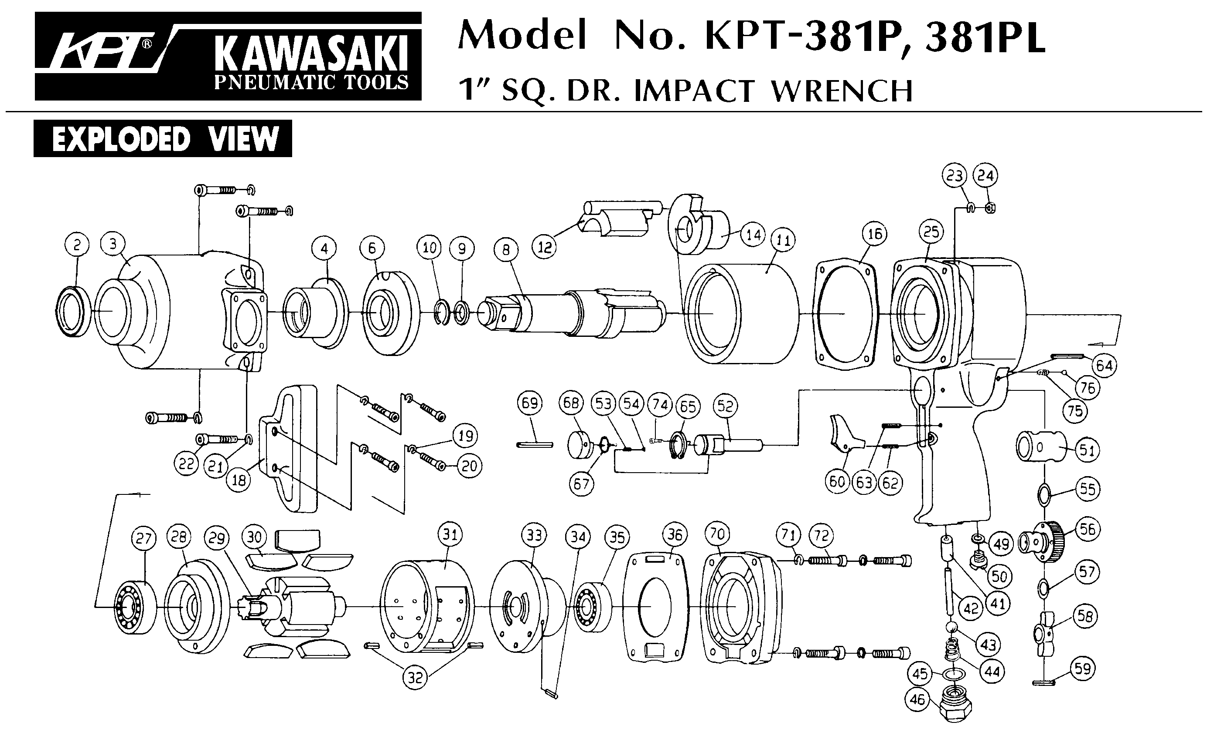





|  |  |  |  |  |  |  |  |
| --- | --- | --- | --- | --- | --- | --- | --- |
| Rep | Réf | Désignation | Qté | Rep | Réf | Désignation | Qté |
| 1 | GP4717-1 | Variateur + joint | 1 | 19 | GP4717-29 | Arbre moteur | 1 |
| 2 | GP4717-3 | Circlips | 1 | 20 | GP4717-28 | Clavette | 1 |
| 3 | GP4717-5 | Axe valve + joint | 1 | 21 | GP4717-30 | Carter pignon | 1 |
| 4 | GP4717-8 | Axe valve + joint + ressort | 1 | 22 | GP4717-54 | Vis M5x10 | 4 |
| 5 | GP4717-10 | Raccord | 1 | 23 | GP4717-31 | Rondelle protection | 1 |
| 6 | GP4717-11 | Silencieux complet | 1 | 24 | GP4717-32 | Rondelle feutre | 1 |
| 7 | GP4717-15 | Gâchette | 1 | 25 | GP4717-55 | Rondelle papier | 1 |
| 8 | GP4717-16 | Goupille | 1 | 26 | GP4717-33 | Pignon | 1 |
| 9 | GP4717-17 | Corps | 1 | 27 | GP4717-34 | Vis M3x10 | 4 |
| 10 | GP4717-19 | Circlips | 1 | 28 | GP4717-38 | Support plateau + couronne (ex) | 1 |
| 11 | 6000-2RS | Roulement 6000 | 1 | 29 | GP4717-40 | BUSHING | 1 |
| 12 | GP4717-21 | Flasque Arrière | 1 | 30 | GP4717-41 | Masselotte complète | 1 |
| 13 | GP4717-22 | Palette | 5 | 31 | GP4717-43 | Vis M4x10 | 1 |
| 14 | GP4717-23 | Rotor | 1 | 32 | GP4717-52 | Jupe | 1 |
| 15 | GP4717-24 | Chemise | 1 | 33 | A157385 | Plateau Ø150 | 1 |
| 16 | GP4717-26 | Flasque avt | 1 | 34 | GP4717-46 | Vis | 6 |
| 17 | 6002-2RS | Roulement 6002 | 1 | 35 | GP4717-47 | Clé hex 3mm | 1 |
| 18 | GP4717-53 | Joint | 1 | 36 | GP4717-51 | Adaptateur poussière | 1 |

**Manche Atlantique Equipements** -27 parc d’activité du Chalet - 22250 BroonsTél 02 96 84 65 59 - Fax 02 96 84 77 75

**WWW.MAE-FR.COM**