

**GP4507**

**Ponceuse orbitale Ø50**

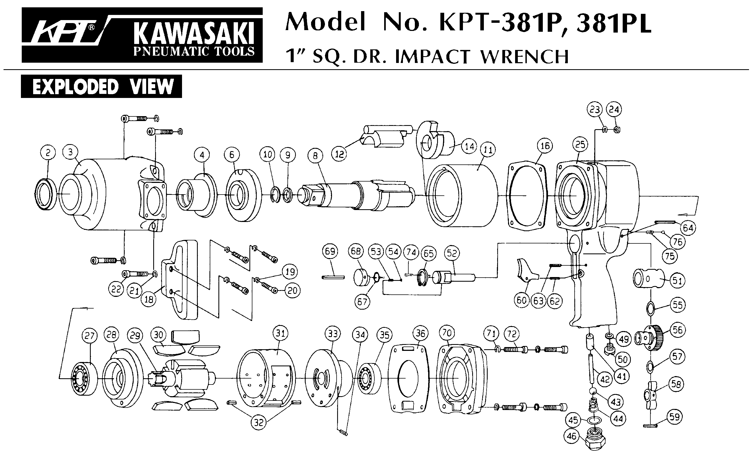





|  |  |  |  |  |  |  |  |
| --- | --- | --- | --- | --- | --- | --- | --- |
| Rep | Réf | Désignation | Qté | Rep | Réf | Désignation | Qté |
| 1 | GP4507-1 | Carter renvoi d’angle | 1 | 23 | GP4507-23 | Rotor | 1 |
| 2 | GP4507-2 | Graisseur | 1 | 24 | GP4507-24 | Palette | 4 |
| 3 | R4 | Roulement R4 | 1 | 25 | GP4507-25 | Chemise | 1 |
| 4 | GP4507-4 | Pignon | 1 | 26 | GP4507-26 | Flasque Arr | 1 |
| 5 | 608-2RS | Roulement 608 | 1 | 27 | 696-2RS | Roulement 696 | 1 |
| 6 | GP4507-6 | Arbre tête | 1 | 28 | GP4507-28 | Protection corps | 1 |
| 7 | GP4507-7 | Clavette | 1 | 29 | GP4507-29 | Corps | 1 |
| 8 | GP4507-8 | Bague serrage | 1 | 30 | GP4507-30 | Valve | 1 |
| 9 | GP4507-9 | Collier serrage | 1 | 31 | GP4507-31 | Joint | 1 |
| 10 | GP4507-10 | Jupe de protection | 1 | 32 | GP4507-32 | Ressort | 1 |
| 11 | GP4507-11 | Balancier | 1 | 33 | GP4507-33 | Variateur | 1 |
| 12 | GP4507-12 | Orbital + fixation plateau | 1 | 34 | GP4507-34 | Joint | 1 |
| 13 | GP4507-13 | Circlips | 1 | 35 | GP4507-35 | Joint | 1 |
| 14 | GP4507-14 | Ecrou de serrage | 1 | 36 | GP4507-36 | Ecrou | 1 |
| 15 | GP4507-15 | Bague de réglage | 1 | 37 | GP4507-37 | Gâchette | 1 |
| 16 | GP4507-16 | Pignon | 1 | 38 | GP4507-38 | Goupille | 1 |
| 17 | 608-2RS | Roulement 608 | 1 | 39 | GP4507-39 | Silencieux | 1 |
| 18 | GP4507-18 | Rondelle calage | 1 | 40 | GP4507-40 | Joint | 1 |
| 19 | GP4507-19 | Flasque Avt | 1 | 41 | GP4507-41 | Circlips | 1 |
| 20 | GP4507-20 | Goupille | 1 | 42 | GP4507-42 | Raccord | 1 |
| 21 | GP4507-21 | Entretoise | 1 | 47 | GP4507-47 | Clé 11x17 | 1 |
| 22 | GP4507-22 | Goupille | 2 | 48 | GP4507-48 | Limitateur | 1 |