

**GP4506**

**Ponceuse pistolet Ø 75**

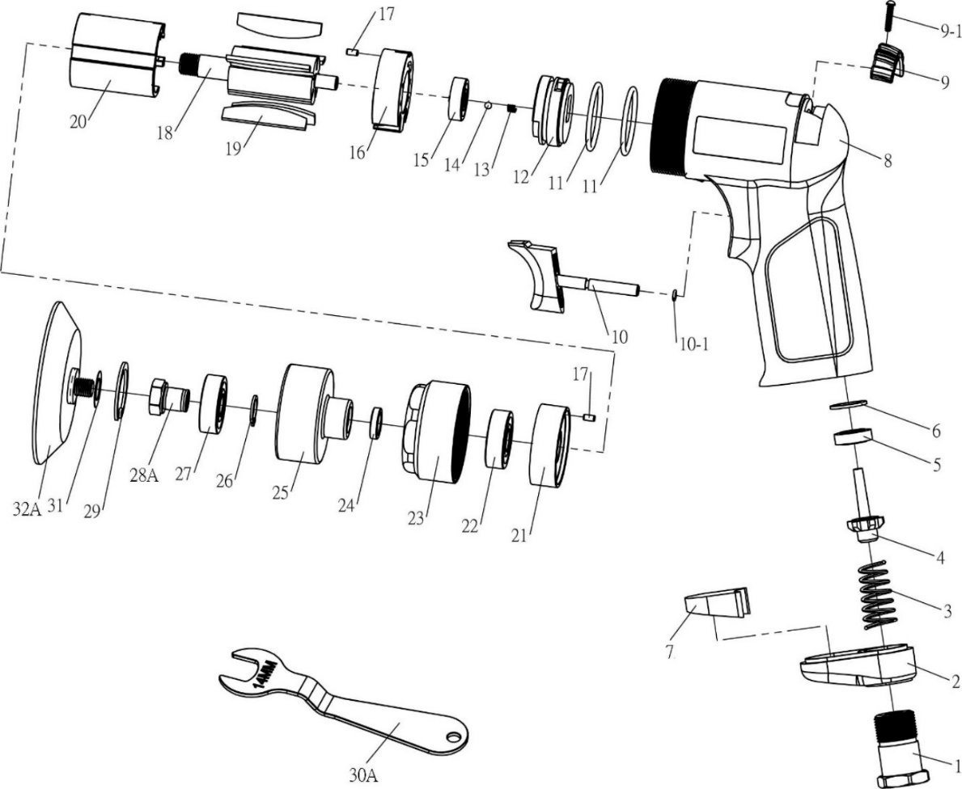

|  |  |  |  |  |  |  |  |  |
| --- | --- | --- | --- | --- | --- | --- | --- | --- |
| **No.** | **Parts No.** | **Description** | **Q'ty** |  | **No.** | **Parts No.** | **Description** | **Q'ty** |
| 1 | GP4506-01 | Raccord | 1 |  | 16 | GP4506-16 | Flasque Arr | 1 |
| 2 | GP4506-02 | Déflecteur | 1 |  | 17 | GP4506-17 | Goupille | 2 |
| 3 | GP4506-03 | Ressort | 1 |  | 18 | GP4506-18 | Rotor | 1 |
| 4 | GP4506-04 | Valve | 1 |  | 19 | GP4506-19 | Palette | 5 |
| 5 | GP4506-05 | Joint valve | 1 |  | 20 | GP4506-20 | Cylindrer | 1 |
| 6 | GP4506-06 | Rondelle | 1 |  | 21 | GP4506-21 | Flasque Avt | 1 |
| 7 | GP4506-07 | Silencieux | 1 |  | 22 | 6000-2RS | Roulement 6000 | 1 |
| 8 | GP4506-08 | Corps composite | 1 |  | 23 | GP4506-23 | Carter Avt | 1 |
| 9 | GP4506-09 | Bouton variateur | 1 |  | 24 | GP4506-24 | Entretoise | 1 |
| 9-1 | GP4506-09-1 | Vis (Φ2.3x12L) | 1 |  | 25 | GP4506-25 | Excentrique | 1 |
| 10 | GP4506-10 | Gâchette | 1 |  | 26 | GP4506-26 | Circlips | 1 |
| 10-1 | GP4506-10-1 | Joint (3x1) | 1 |  | 27 | 6000-2RS | Roulement 6000 | 1 |
| 11 | GP4506-11 | Joint (27x2) | 2 |  | 28A | GP4506-28A | Arbre fixation | 1 |
| 12 | GP4506-12 | Valve variateur | 1 |  | 29 | GP4506-29 | Circlips | 1 |
| 13 | GP4506-13 | Ressort | 1 |  | 30A | GP4506-30A | Clé (14mm) | 1 |
| 14 | GP4506-14 | Bille | 1 |  | 31 | GP4506-31 | Rondelle | 1 |
| 15 | 626-2RS | Roulement | 1 |  | 32A | GP3710-31A | plateau Ø75 | 1 |

**Manche Atlantique Equipements** -27 parc d’activité du Chalet - 22250 BroonsTél 02 96 84 65 59 - Fax 02 96 84 77 75

**WWW.MAE-FR.COM**