

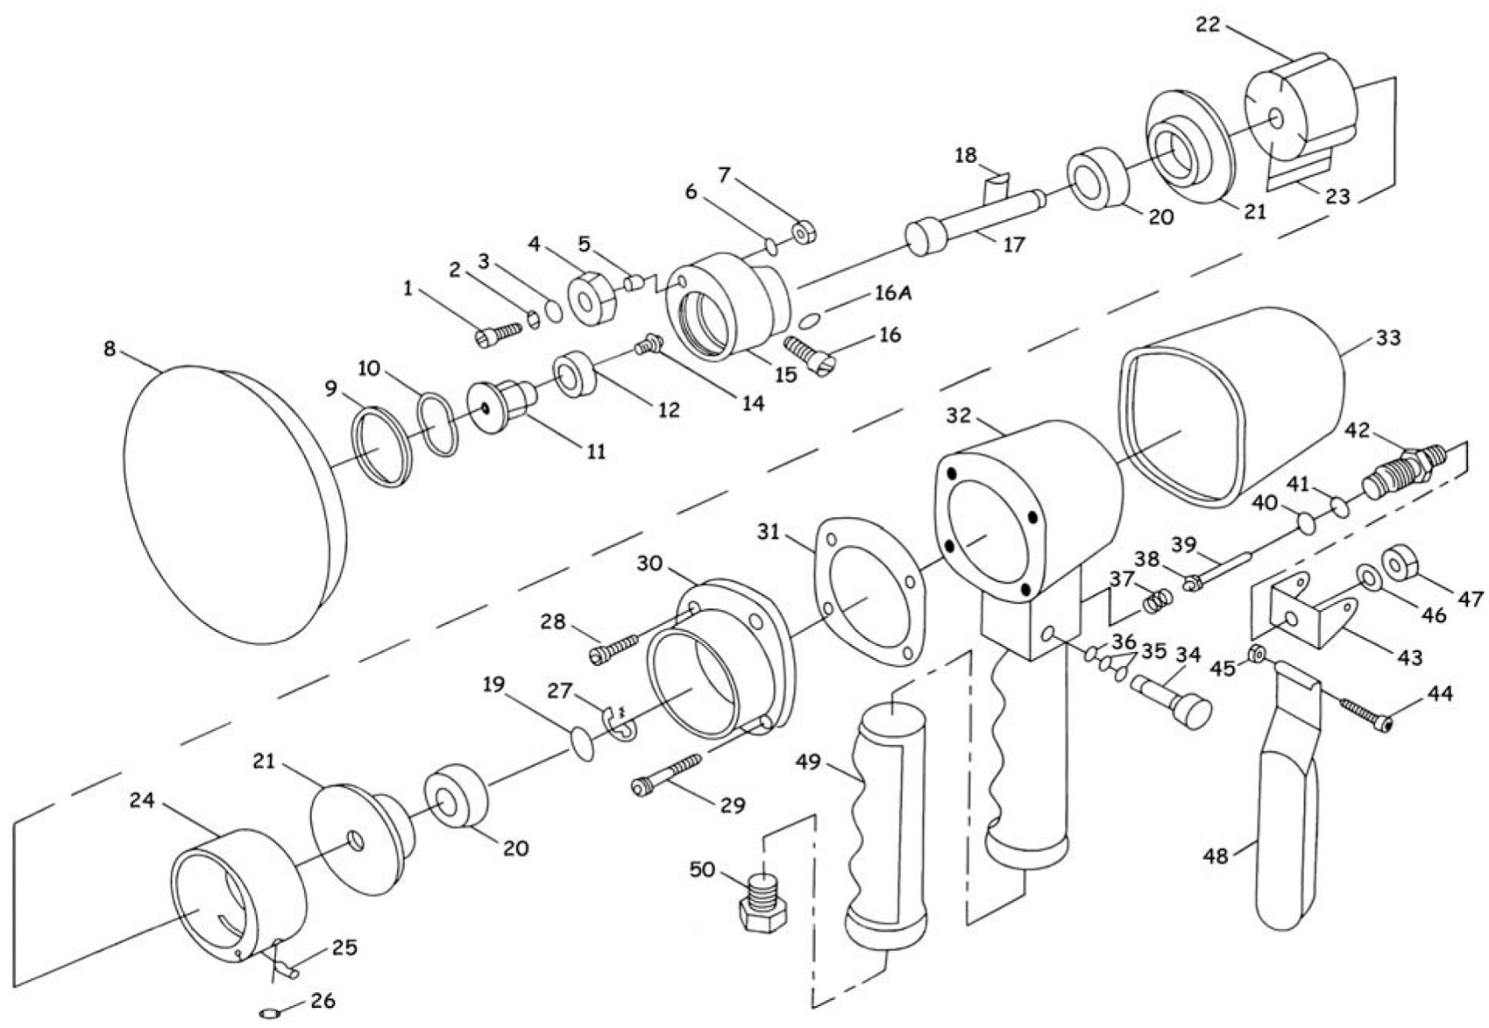

**GP4390**

**Ponceuse Ø150**

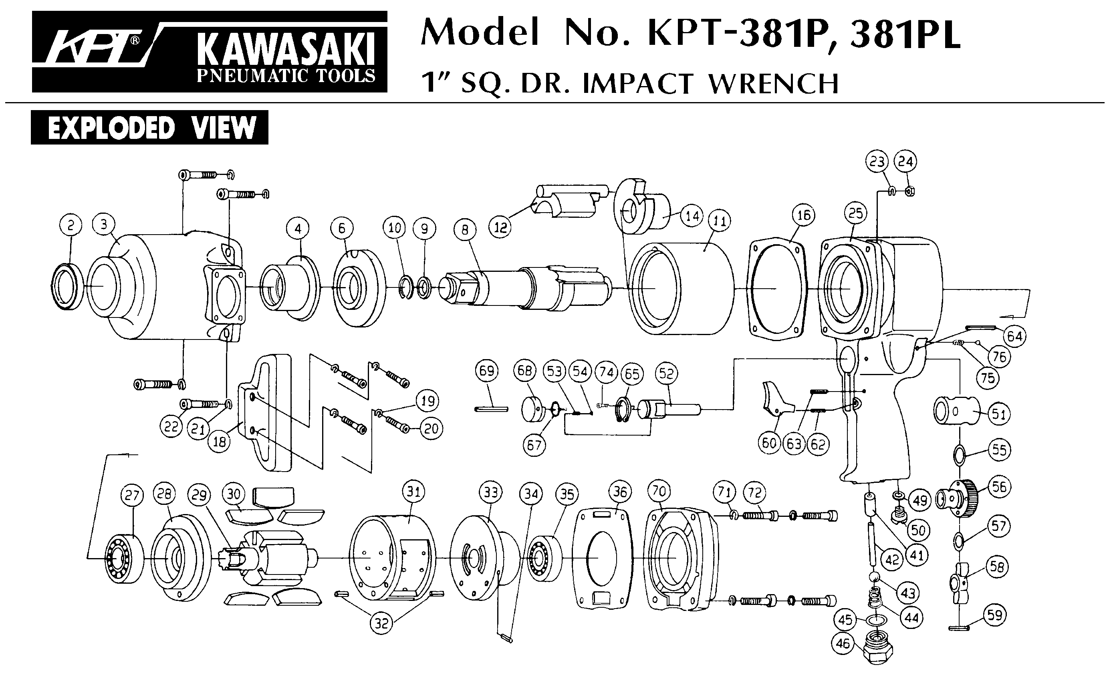



|  |  |  |  |  |  |  |  |
| --- | --- | --- | --- | --- | --- | --- | --- |
| Rep | Réf | Désignation | Qté | Rep | Réf | Désignation | Qté |
| 1 | GP4390-01 | Vis | 1 | 26 | GP4390-26 | Joint | 1 |
| 2 | GP4390-02 | Rondelle | 1 | 27 | GP4390-27 | Circlips | 1 |
| 3 | GP4390-03 | Joint | 1 | 28 | GP4390-28 | Vis | 2 |
| 4 | GP4390-04 | Masselotte | 1 | 29 | GP4390-29 | Vis | 2 |
| 5 | GP4390-05 | Entretoise | 1 | 30 | GP4390-30 | Capot moteur | 1 |
| 6 | GP4390-06 | Rondelle | 1 | 31 | GP4390-31 | Joint | 1 |
| 7 | GP4390-07 | Ecrou | 1 | 32 | GP4390-32 | Corps moteur | 1 |
| 8 | GP4390-08 | Plateau | 1 | 33 | GP4390-33 | Protection corps | 1 |
| 9 | GP4390-09 | Circlips | 1 | 34 | GP4390-34 | Variateur | 1 |
| 10 | GP4390-10 | Rondelle | 1 | 35 | GP4390-35 | Joint | 1 |
| 11 | GP4390-11 | Arbre orbitale | 1 | 36 | GP4390-36 | Joint | 1 |
| 12 | 6201-2RS | Roulement 6201 | 1 | 37 | GP4390-37 | Ressort | 1 |
| 14 | GP4390-14 | Vis | 1 | 38 | GP4390-38 | Valve | 1 |
| 15 | GP4390-15 | Balancier orbital | 1 | 39 | GP4390-39 | Axe | 1 |
| 16 | GP4390-16 | Vis | 4 | 40 | GP4390-40 | Joint | 1 |
| 16A | GP4390-16A | Rondelle | 1 | 41 | GP4390-41 | Joint | 1 |
| 17 | GP4390-17 | Arbre moteur | 1 | 42 | GP4390-42 | Chemise gâchette | 1 |
| 18 | GP4390-18 | Clavette | 1 | 43 | GP4390-43 | Support gâchette | 1 |
| 19 | GP4390-19 | Rondelle | 1 | 44 | GP4390-44 | Vis | 1 |
| 20 | 6200-2RS | Roulement 6200 | 2 | 45 | GP4390-45 | Ecrou | 1 |
| 21 | GP4390-21 | Flasque moteur | 2 | 46 | GP4390-46 | Rondelle | 1 |
| 22 | GP4390-22 | Rotor | 1 | 47 | GP4390-47 | Ecrou | 1 |
| 23 | GP4390-23 | Palette | 4 | 48 | GP4390-48 | Gâchette | 1 |
| 24 | GP4390-24 | Chemise | 1 | 49 | GP4390-49 | Gaine poignée | 1 |
| 25 | GP4390-25 | Goupille | 1 | 50 | GP4390-50 | Raccord | 1 |



**Manche Atlantique Equipements** -27 parc d’activité du Chalet - 22250 BroonsTél 02 96 84 65 59 - Fax 02 96 84 77 75

**WWW.MAE-FR.COM**