

**GP3831**

**Lustreuse Ø200**

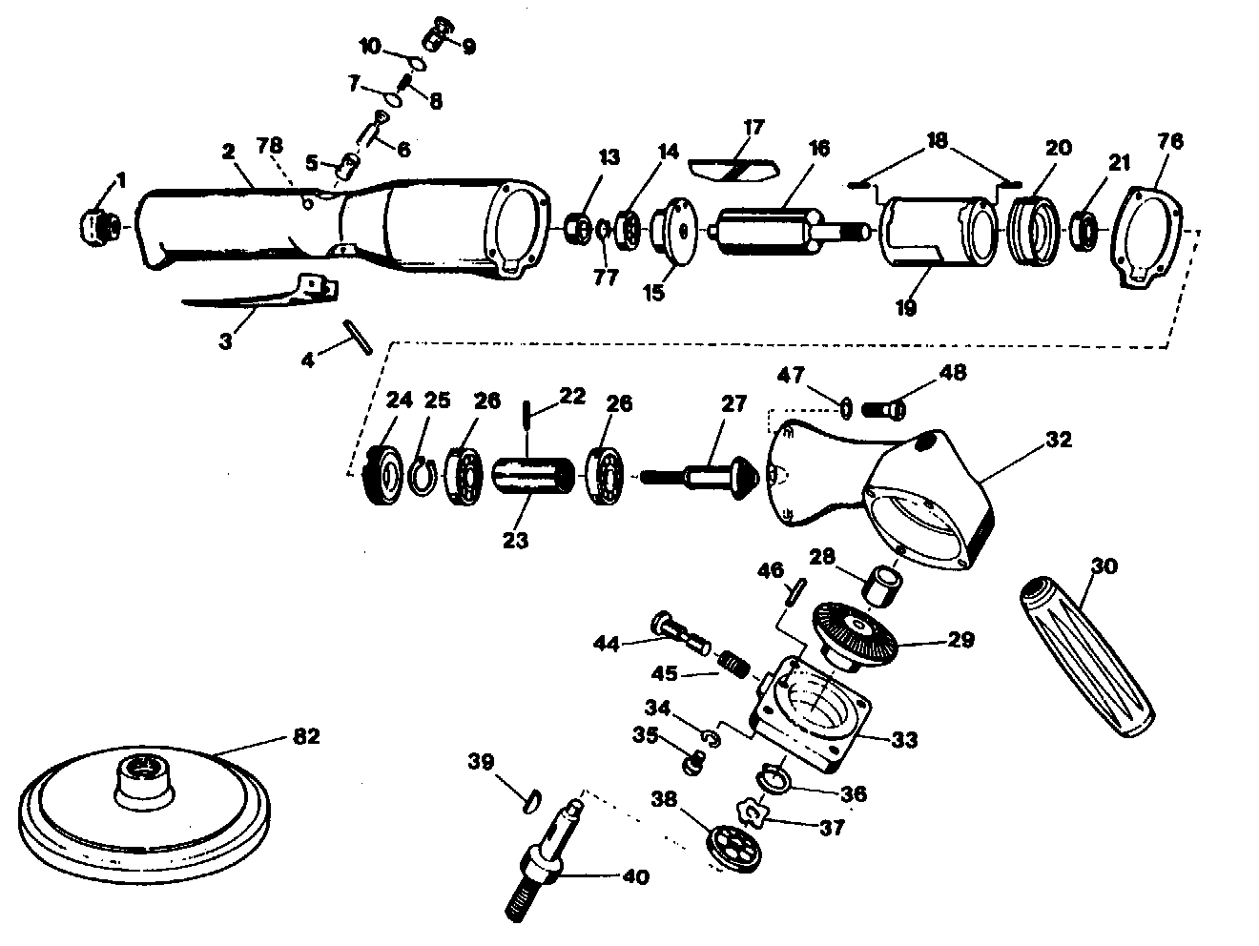

|  |  |  |  |  |  |  |  |
| --- | --- | --- | --- | --- | --- | --- | --- |
| rep | ref. | DESIGNATION | QTE | Rep | Réf. | DESIGNATION | QTE |
| 1 | GP3831-01 | Raccord | 1 | 28 | GP3831-28 | Needle Bearing | 1 |
| 2 | GP3831-02 | Corps moteur Incl:5 | 1 | 29 | GP3831-29 | Couronne | 1 |
| 3 | GP3831-03 | Gâchette | 1 | 30 | GP3831-30 | Poignée latérale | 1 |
| 4 | GP3831-04 | Goupille | 1 | 32 | GP3831-32 | Carter renvoi d ’angle | 1 |
| 5 | GP3831-05 | Insert | 1 | 33 | GP3831-33 | Capot | 1 |
| 6 | GP3831-06 | Valve | 1 | 34 | GP3831-34 | Rondelle | 4 |
| 7 | GP3831-07 | Joint | 1 | 35 | GP3831-35 | Vis | 4 |
| 8 | GP3831-08 | Ressort | 1 | 36 | GP3831-36 | Circlips | 1 |
| 9 | GP3831-09 | Régulateur | 1 | 37 | GP3831-37 | Rondelle | 1 |
| 10 | GP3831-10 | Joint | 1 | 38 | 6302-2RS | Ball Bearing | 1 |
| 13 | GP3831-13 | Cache roulement | 1 | 39 | GP3831-39 | Clavette | 1 |
| 14 | 608-2RS | Roulement 608 | 1 | 40 | GP3831-40 | Arbre 5/8 | 1 |
| 15 | GP3831-15 | Flasque arrière | 1 | 41 | GP3831-41 | Rondelle | 1 |
| 16 | GP3831-16 | Rotor | 1 | 42 | GP3831-42 | Retaining Ring | 1 |
| 17 | GP3831-17 | Palette | 4 | 44 | GP3831-44 | Bouton blocage | 1 |
| 18 | GP3831-18 | Goupille | 2 | 45 | GP3831-45 | Ressort | 1 |
| 19 | GP3831-19 | Chemise | 1 | 46 | GP3831-46 | Goupille | 1 |
| 20 | GP3831-20 | Flasque avt | 1 | 47 | GP3831-47 | Rondelle élstique | 4 |
| 21 | 608-2rs | Roulement 608 | 1 | 48 | GP3831-48 | Vis | 4 |
| 22 | GP3831-22 | Goupille | 1 | 76 | GP3831-76 | Joint plat | 1 |
| 23 | GP3831-23 | Transmission | 1 | 77 | GP3831-77 | Circlips | 1 |
| 24 | GP3831-24 | Clamp Nut | 1 | 78 | GP3831-78 | Goupille | 1 |
| 25 | GP3831-25 | Circlips | 1 | 82 | A156420 | Plateau Ø200 | 1 |
| 26 | 6200-2RS | Roulement 6200 | 2 |  |  |  |  |
| 27 | GP3831-27 | Pignon | 1 |  |  |  |  |