

**GP3730**

**Lustreuse Ø150-180**

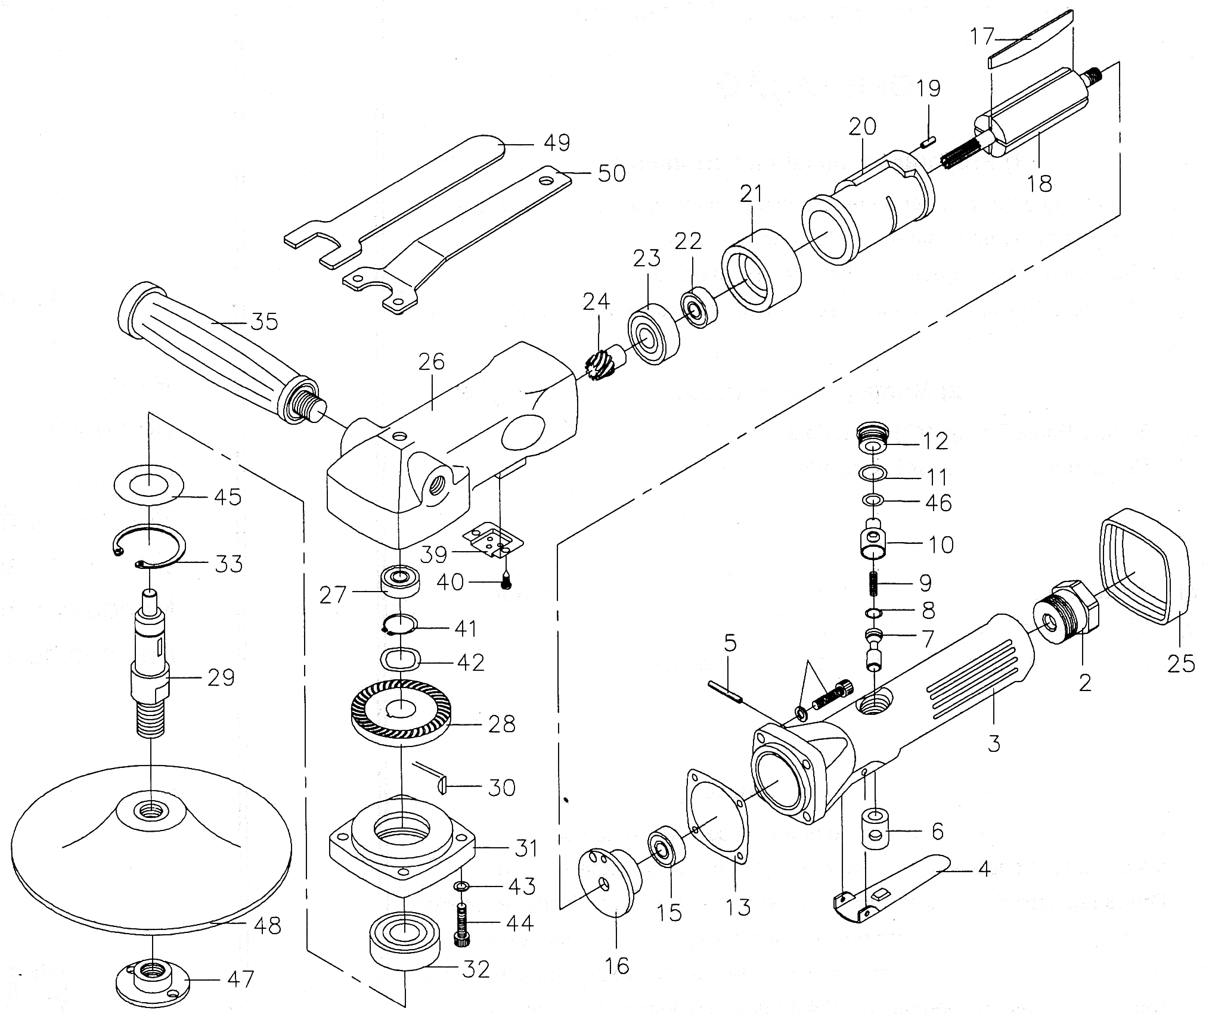



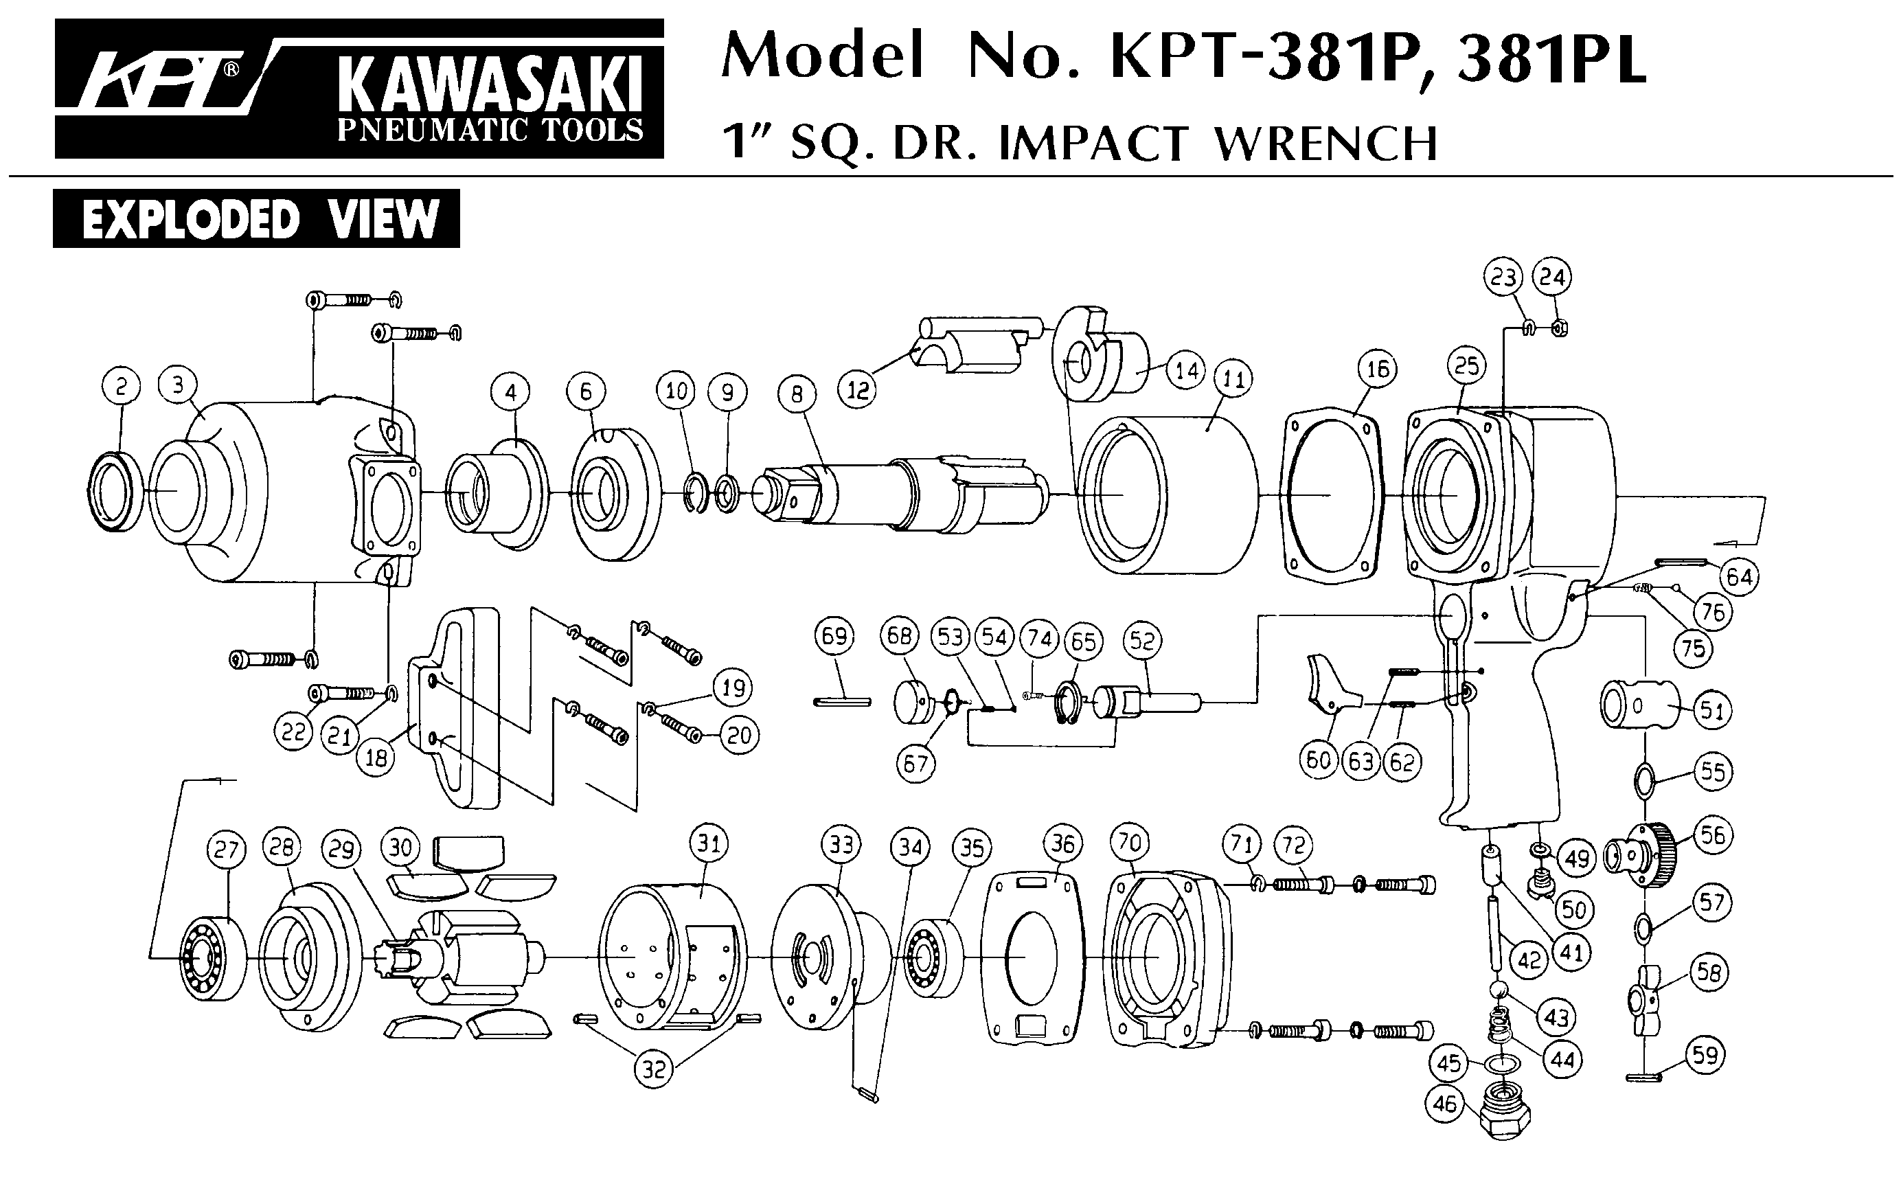



|  |  |  |  |  |  |  |  |
| --- | --- | --- | --- | --- | --- | --- | --- |
| Rep | Ref | DESCRIPTION | Qté | Rep | Ref | DESCRIPTION | Qté |
| 2 | GP3730-02A | Raccord | 1 | 26 | GP3730-26A | Corps avt | 1 |
| 3 | GP3730-03A | Poigné arrière | 1 | 27 | 608-2RS | Roulement 608 | 1 |
| 4 | GP3730-04A | Gâchette | 1 | 28 | GP3730-28A | Couronne lustreuse | 1 |
| 5 | GP3730-05A | Goupille | 1 | 29 | GP3730-29A | Arbre | 1 |
| 6 | GP3730-06A | Insert | 1 | 30 | GP3730-30A | Clavette | 1 |
| 7 | GP3730-07A | Axe | 1 | 31 | GP3730-31A | Capot tête | 1 |
| 8 | GP3730-08A | Joint | 1 | 32 | 6203-2RS | Roulement 6203 | 1 |
| 9 | GP3730-09A | Ressort | 1 | 33 | GP3730-33A | Clips | 1 |
| 10 | GP3730-10A | Variateur | 1 | 35 | GP3730-35A | Poignée | 1 |
| 11 | GP3730-11A | Joint | 1 | 39 | GP3730-39A | Déflecteur | 1 |
| 12 | GP3730-12A | Ecrou | 1 | 40 | GP3730-40A | Vis déflecteur | 2 |
| 13 | GP3730-13A | Joint | 1 | 41 | GP3730-41A | Circlips | 1 |
| 15 | 608-2RS | Roulement 608 | 1 | 42 | GP3730-42A | Rondelle | 1 |
| 16 | GP3730-16A | Flasque arr | 1 | 43 | GP3730-43A | Rondelle | 4 |
| 17 | GP3730-17A | Palette | 4 | 44 | GP3730-44A | Vis | 4 |
| 18 | GP3730-18A | Rotor | 1 | 45 | GP3730-45A | Rondelle élastique | 1 |
| 19 | GP3730-19A | Goupille | 1 | 46 | GP3730-46A | Joint | 1 |
| 20 | GP3730-20A | Chemise | 1 | 47 | GP3730-47A | Ecrou | 1 |
| 21 | GP3730-21A | Flasque avt | 1 | 48 | GP3730-48A | Plateau | 1 |
| 22 | 608-2RS | Roulement 608 | 1 | 49 | GP3730-49A | Clé | 1 |
| 23 | 6201-2RS | Roulement 6201 | 1 | 50 | GP3730-50A | Clé | 1 |
| 24 | GP3730-24A | Pignon lustreuse | 1 | 51 | GP3730-51A | Vis | 4 |
| 25 | GP3730-25A | Protection corps | 1 |  |  |  |  |



|  |  |  |  |  |  |  |  |
| --- | --- | --- | --- | --- | --- | --- | --- |
| Rep | Réf Art | DESCRIPTION | Qté | Rep | Réf Art | DESCRIPTION | Qté |
| 1 | GP3110-01 | Corps régulateur | 1 | 15 | GP3110-15 | Palette | 3 |
| 2 | GP3110-02 | Bague | 1 | 16 | GP3110-16 | Rotor | 1 |
| 3 | GP3110-03 | Vis | 1 | 17 | GP3110-17 | Rondelle | 1 |
| 4 | GP3110-04 | Joint | 1 | 18 | GP3110-18 | Flasque avt | 1 |
| 5 | GP3110-05 | Joint | 2 | 19 | 695-2RS | Roulement 695 | 2 |
| 6 | GP3110-06 | Régulateur | 1 | 20 | GP3110-20 | Ecrou moteur | 1 |
| 7 | GP3110-07 | Goupille | 1 | 20A | GP3110-21 | Porte pince | 1 |
| 8 | GP3110-08 | Entretoise | 1 | 22 | GP3110-22 | Pince | 1 |
| 9 | GP3110-09 | Corps | 1 | 23 | GP3110-23 | Ecrou pince | 1 |
| 10 | GP3110-10 | Cage roulement | 1 | 24 | GP3110-24 | Ecrou | 2 |
| 11 | 693-2RS | Roulement 693 | 1 | 25 | GP3110-25 | Insert | 1 |
| 12 | GP3110-12 | Flasque AR | 1 | 26 | GP3110-26 | Tuyau | 1 |
| 13 | GP3110-13 | Axe | 1 | 27 | GP3110-27 | Gaine silencieux | 1 |
| 14 | GP3110-14 | Chemise | 1 | 28 | GP3110-28 | Clé | 2 |

**Manche Atlantique Equipements** -27 parc d’activité du Chalet - 22250 BroonsTél 02 96 84 65 59 - Fax 02 96 84 77 75

**WWW.MAE-FR.COM**