



**GP3710**

**Lustreuse pistolet**

**Ø75**

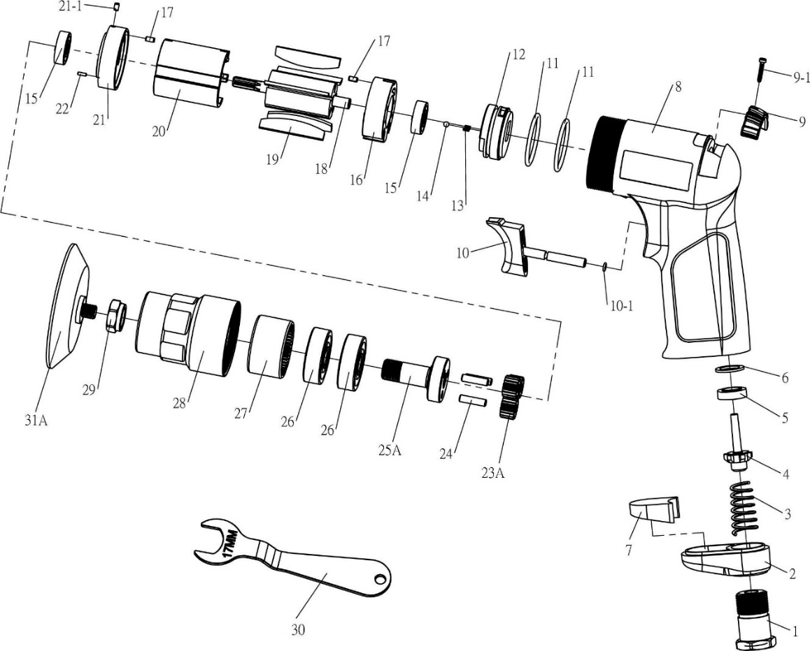

|  |  |  |  |  |  |  |  |  |
| --- | --- | --- | --- | --- | --- | --- | --- | --- |
| **No.** | **Parts No.** | **Description** | **Q'ty** |  | **No.** | **Parts No.** | **Description** | **Q'ty** |
| 1 | GP3710-01 | Raccord | 1 |  | 16 | GP3710-16 | Flasque Arr | 1 |
| 2 | GP3710-02 | Déflecteur | 1 |  | 17 | GP3710-17 | Goupille | 2 |
| 3 | GP3710-03 | Ressort | 1 |  | 18 | GP3710-18 | Rotor | 1 |
| 4 | GP3710-04 | Valve | 1 |  | 19 | GP3710-19 | Palette | 5 |
| 5 | GP3710-05 | Joint valve | 1 |  | 20 | GP3710-20 | Cylindrer | 1 |
| 6 | GP3710-06 | Rondelle | 1 |  | 21 | GP3710-21 | Flasque Avt | 1 |
| 7 | GP3710-07 | Silencieux | 1 |  | 21-1 | GP3710-21-1 | Goupille | 1 |
| 8 | GP3710-08 | Corps composite | 1 |  | 22 | GP3710-22 | Goupille | 1 |
| 9 | GP3710-09 | Bouton variateur | 1 |  | 23A | GP3710-23A | Satellite | 3 |
| 9-1 | GP3710-09-1 | Vis (Φ2.3x12L) | 1 |  | 24 | GP3710-24 | Axe satellite | 3 |
| 10 | GP3710-10 | Gâchette | 1 |  | 25A | GP3710-25A | Porte satellite | 1 |
| 10-1 | GP3710-10-1 | Joint (3x1) | 1 |  | 26 | 6201-2RS | Roulement 6201 | 2 |
| 11 | GP3710-11 | Joint (27x2) | 2 |  | 27 | GP3710-27 | Couronne | 1 |
| 12 | GP3710-12 | Valve variateur | 1 |  | 28 | GP3710-28 | Carter Avt | 1 |
| 13 | GP3710-13 | Ressort | 1 |  | 29 | GP3710-29 | Arbre | 1 |
| 14 | GP3710-14 | Bille | 1 |  | 30 | GP3710-30 | Clé (17mm) | 1 |
| 15 | 626-2RS | Roulement - 626 | 2 |  | 31A | GP3710-31A | Plateau Ø75 | 1 |

**Manche Atlantique Equipements** -27 parc d’activité du Chalet - 22250 BroonsTél 02 96 84 65 59 - Fax 02 96 84 77 75

**WWW.MAE-FR.COM**