

**GP3645**

**Meuleuse d’angle**

**Ø125**

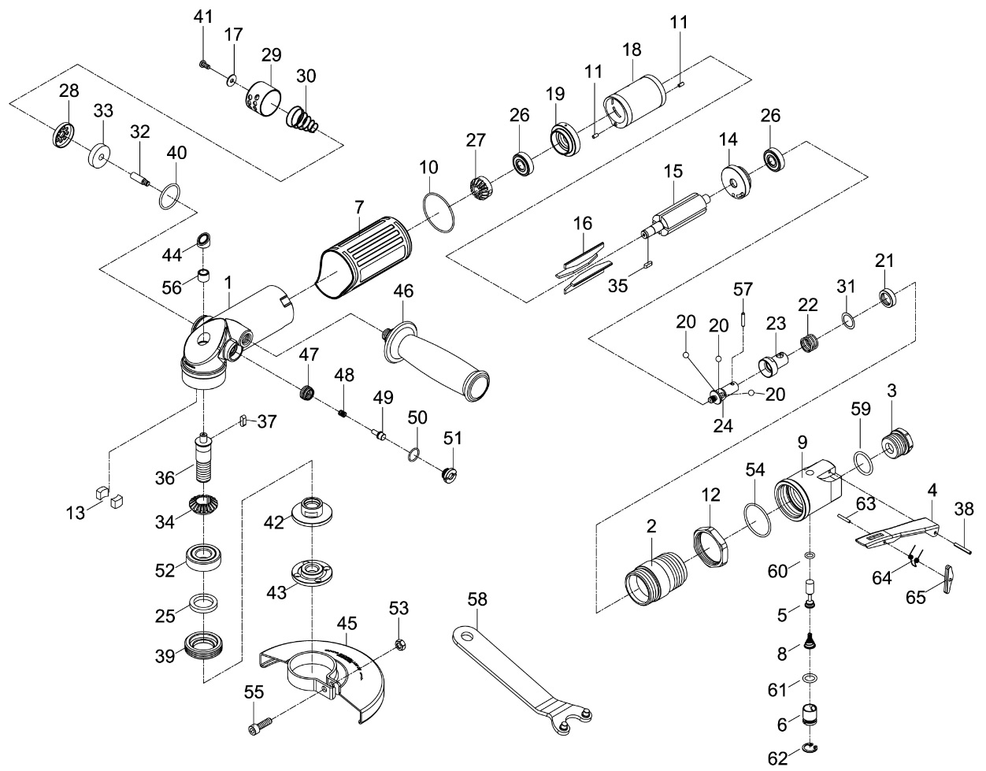

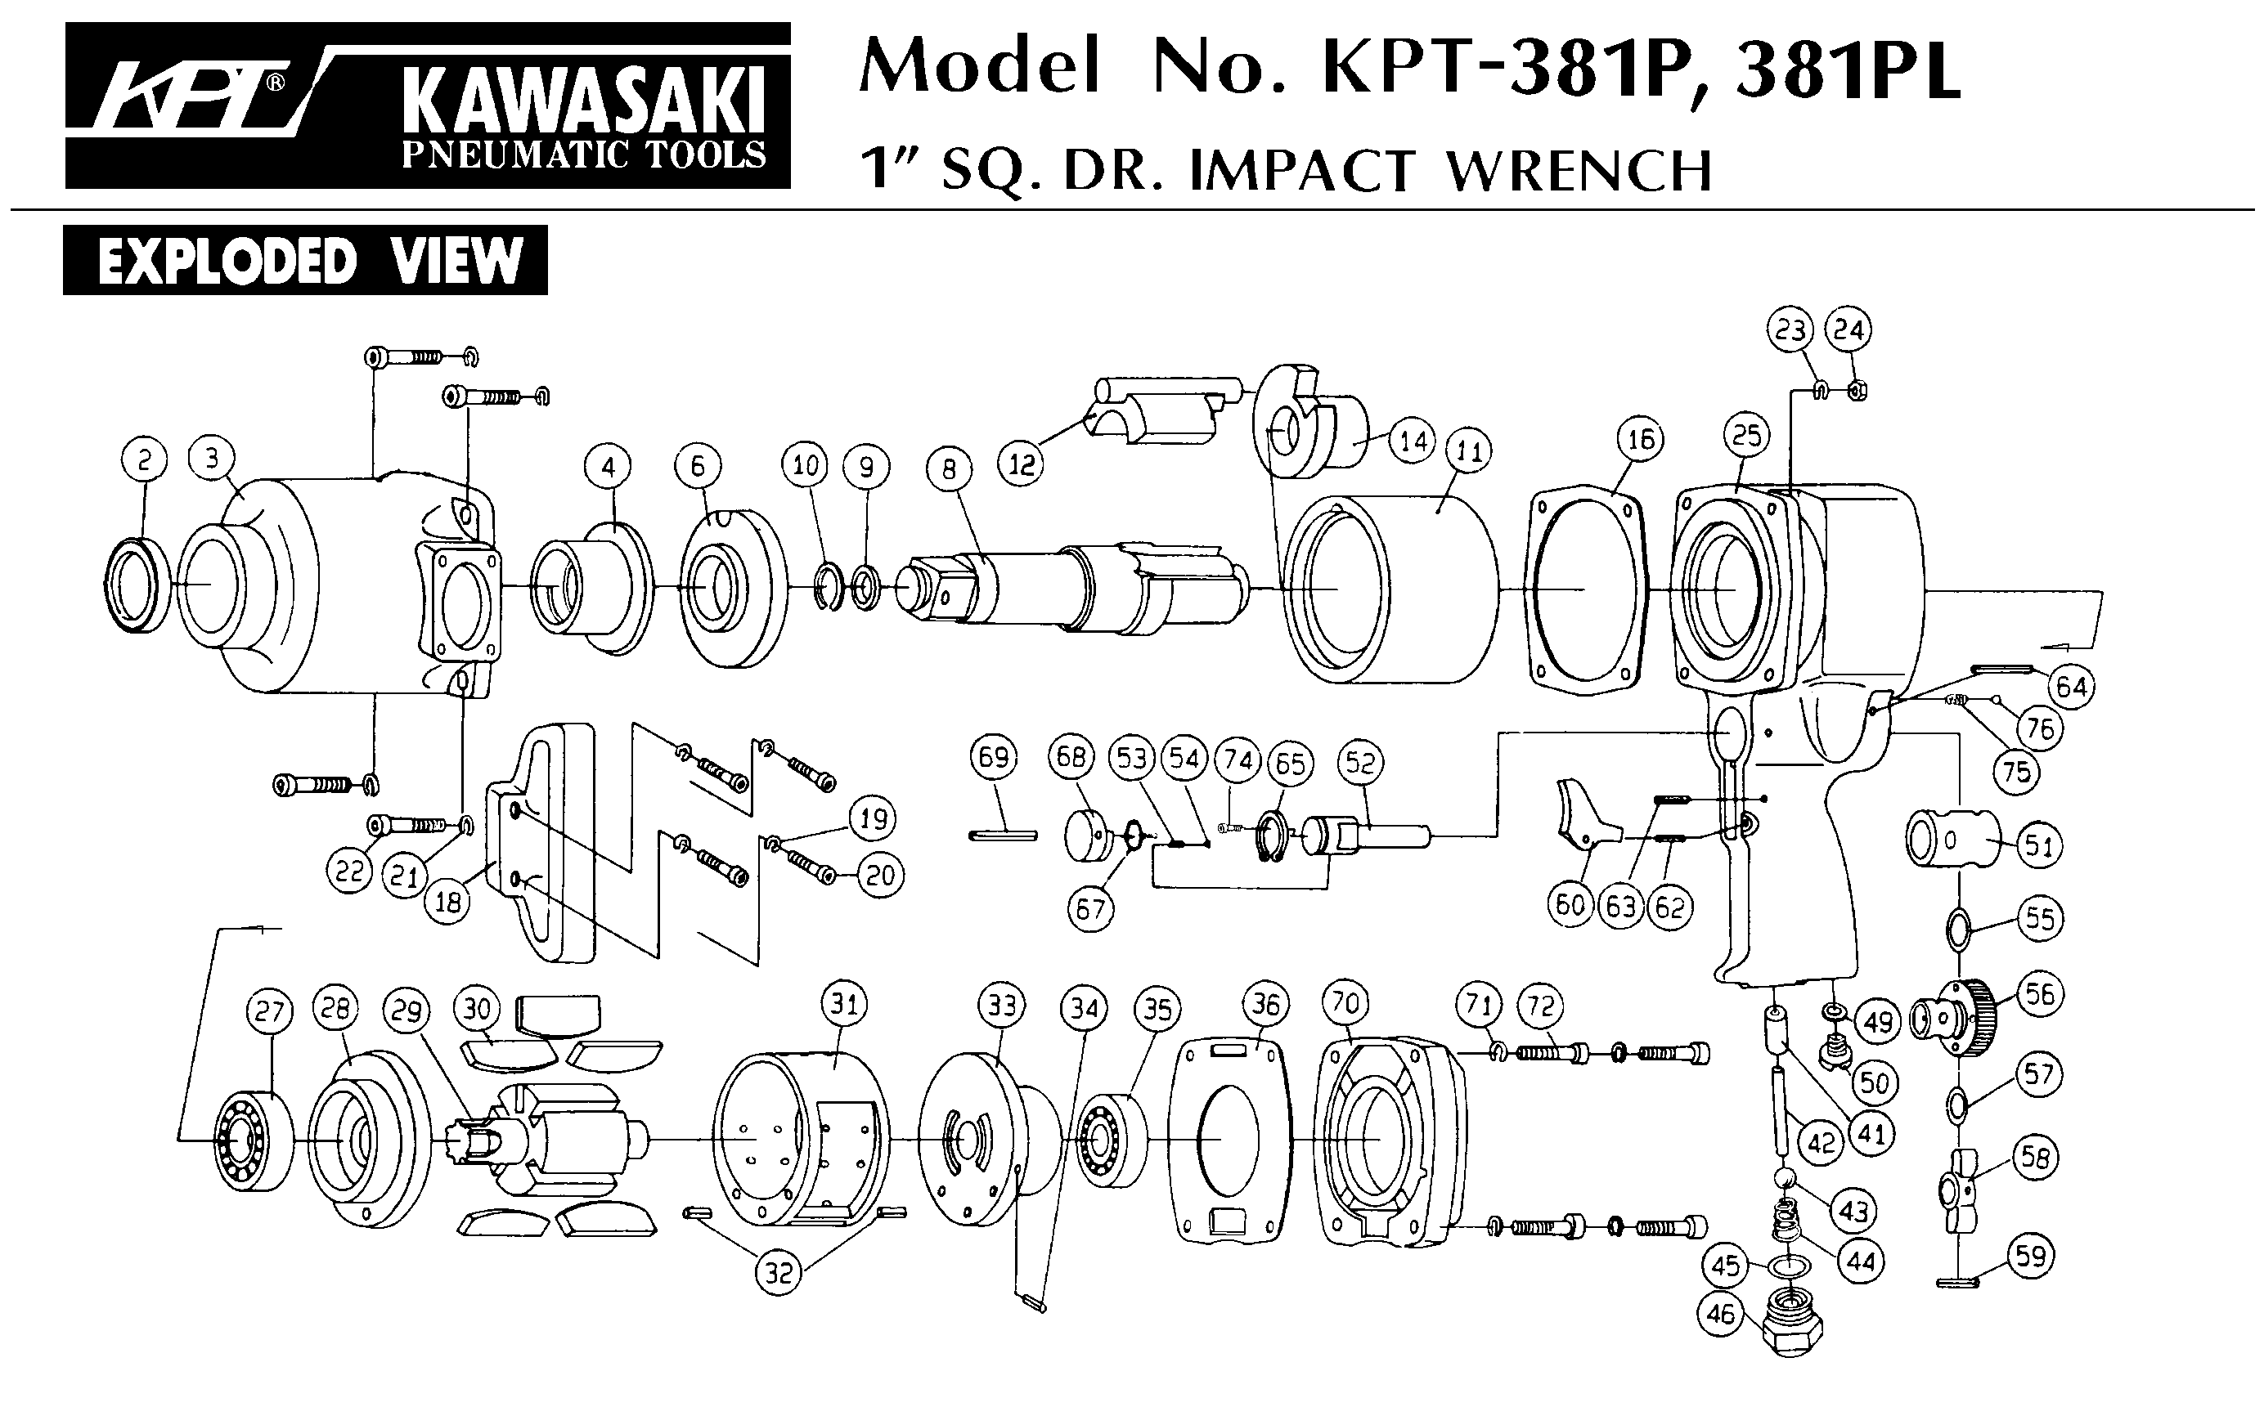





|  |  |  |  |  |  |  |  |
| --- | --- | --- | --- | --- | --- | --- | --- |
| Réf | Rep | Description | Qté | Réf | Rep | Description | Qté |
| GP3645-01 | 1 | Corps | 1 | GP3645-11 | 11 | Goupille (3x6L) | 2 |
| GP3645-02 | 2 | Bague | 1 | GP3645-12 | 12 | Ecrou | 1 |
| GP3645-03 | 3 | Raccord | 1 | GP3645-14 | 14 | Flasque Arr | 1 |
| GP3645KITA | 4 | Gâchette | 1 | GP3645-15 | 15 | Rotor | 1 |
| 63 | Goupille (2.5x16L) | 1 | GP3645-18 | 18 | Chemise Moteur | 1 |
| 64 | Ressort | 1 | GP3645-19 | 19 | Flasque Avt | 1 |
| 65 | Sécurité gâchette | 1 | GP3645-20 | 20 | Bille (7/32) | 3 |
| 38 | Goupille (3x24L) | 1 | GP3645-21 | 21 | Rondelle | 1 |
| GP3645KITB | 5 | Valve | 1 | GP3645-22 | 22 | Ressort | 1 |
| 6 | Chemise valve | 1 | GP3645-23 | 23 | Masse | 1 |
| 8 | Ressort | 1 | GP3645-24 | 24 | Axe masse | 1 |
| 60 | Joint (5.28x1.78) | 1 | GP3645KITF | 27 | Pignon | 1 |
| 61 | Joint (10x2.2) | 1 | 34 | Couronne | 1 |
| 62 | Circlips (RTW-14) | 1 | 35 | Clavette (3x10L) | 1 |
| GP3645-07 | 7 | Gaine protection | 1 | 37 | Clavette (4x8L) | 1 |
| GP3645-09 | 9 | Bloc valve | 1 | GP3645-31 | 31 | Rondelle (0.2mm) | 1 |
| GP3645-10 | 10 | Joint (34.65x1.78) | 1 | GP3645-39 | 39 | Ecrou | 1 |
| GP3645KITC | 13 | Feutre graisseur | 2 | GP3645-42 | 42 | Ecrou (M14X2) | 1 |
| 25 | Feutre graisseur | 1 | GP3645-43 | 43 | Contre écrou (M14X2) | 1 |
| 36 | Arbre M14X2 | 1 | GP3645KITG | 45 | Carter | 1 |
| 44 | Protection | 1 | 53 | Ecrou (M6X1) | 1 |
| 52 | Roulement (6202zz) | 1 | 55 | Vis (M6X20L) | 1 |
| 56 | Roulement aiguille (BK0709) | 1 | GP3645-46 | 46 | Poignée | 1 |
| GP3645KITD | 16 | Palette | 4 | GP3645KITH | 47 | Nul | 1 |
| 26 | Roulement (609ZZ) | 2 | 48 | Ressort | 1 |
| GP3645KITE | 17 | Rondelle | 1 | 49 | Axe | 1 |
| 28 | Valve silencieux | 1 | 50 | Joint (11.4x1.251) | 1 |
| 29 | Couvercle silencieux | 1 | 51 | Bouton | 1 |
| 30 | Ressort | 1 | GP3645-54 | 54 | Joint (33.5x2) | 1 |
| 32 | Vis | 1 | GP3645-57 | 57 | Goupille(3x15.8L) | 1 |
| 33 | Mousse silencieux | 1 | GP3645-58 | 58 | Clé | 1 |
| 40 | Joint (23.52x1.78) | 1 | GP3645-59 | 59 | Joint (19.8x2.4) | 1 |
| 41 | Vis (M4X8L) | 1 |  |  |  |  |

**Manche Atlantique Equipements** -27 parc d’activité du Chalet - 22250 BroonsTél 02 96 84 65 59 - Fax 02 96 84 77 75

**WWW.MAE-FR.COM**