

**GP3626**

**Disqueuse Ø125**

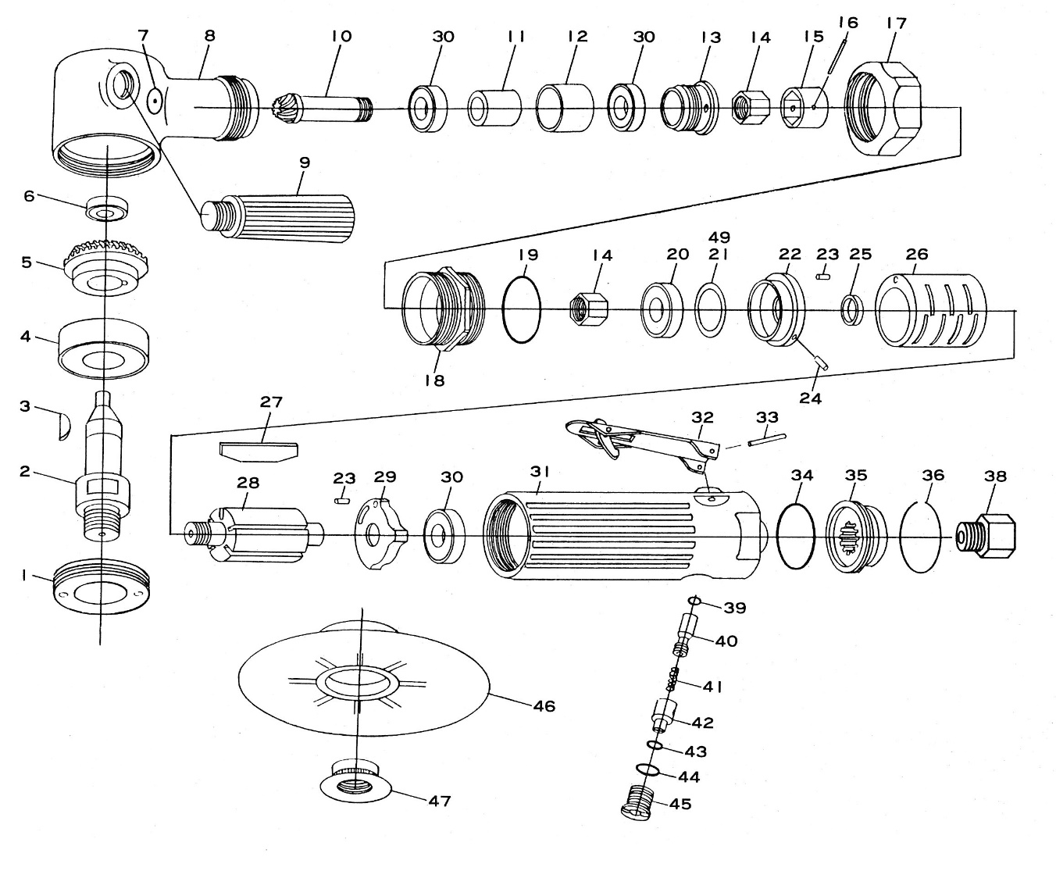

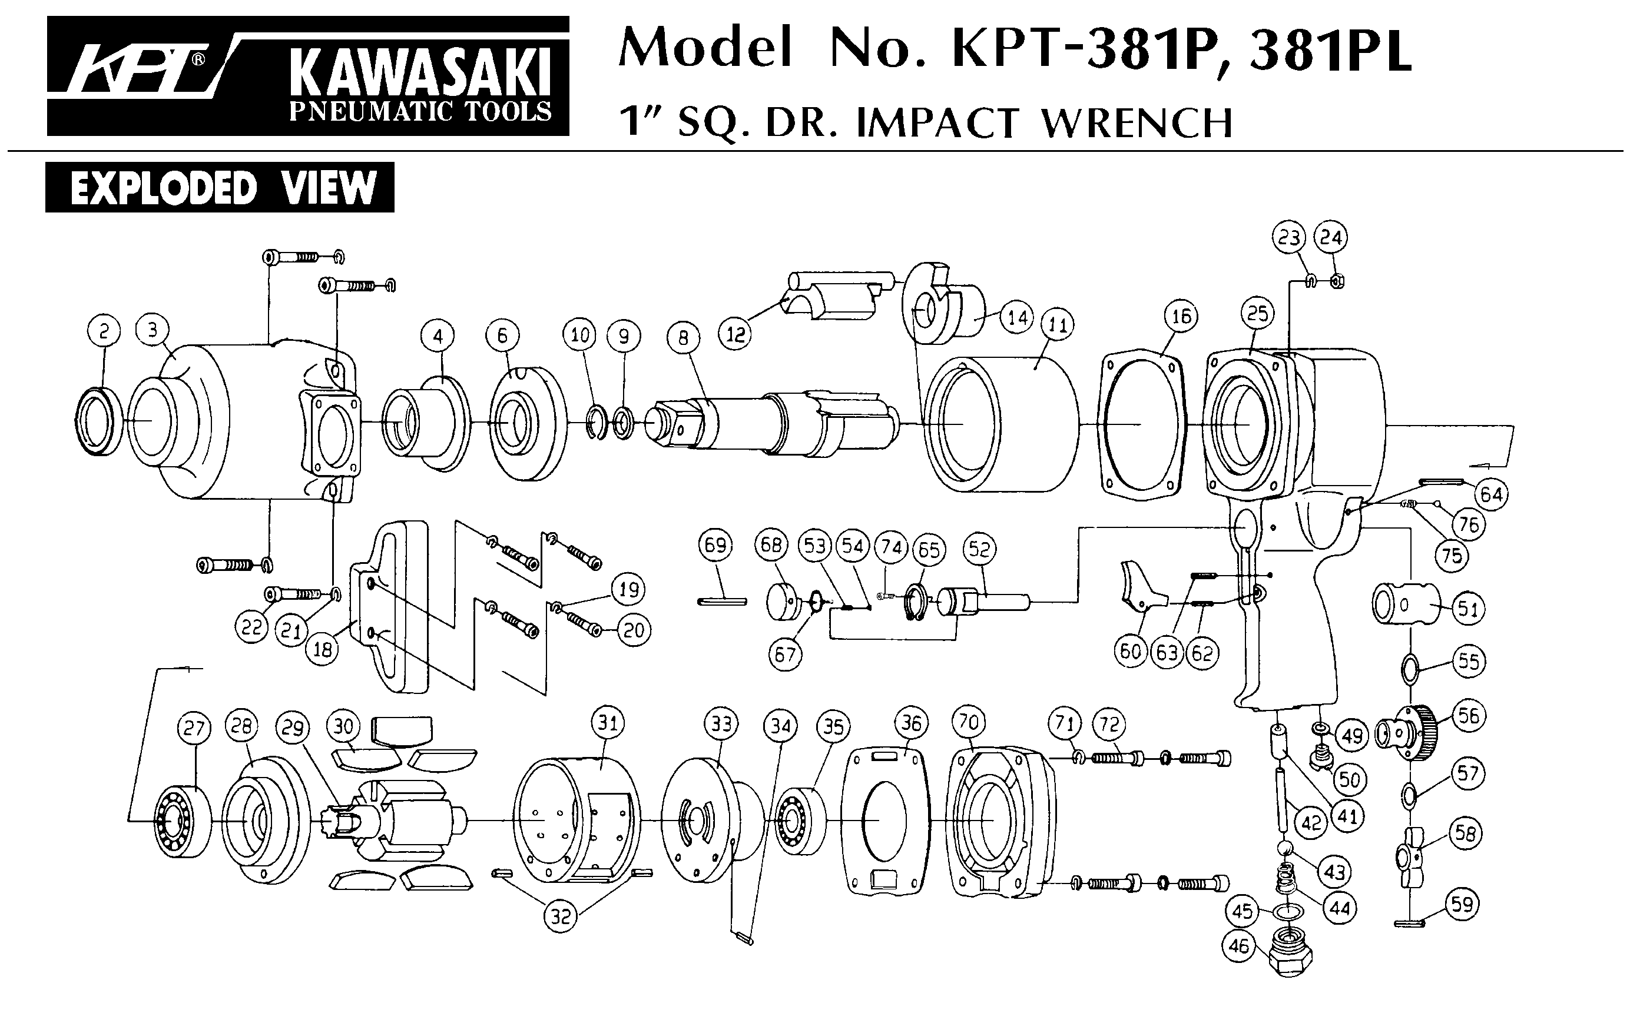





|  |  |  |  |  |  |  |  |
| --- | --- | --- | --- | --- | --- | --- | --- |
| Rep | Réf | Désignation | Qté | Rep | Réf | Désignation | Qté |
| 1 | GP3626-1 | Ecrou | 1 | 24 | GP3626-24 | Goupille | 1 |
| 2 | GP3626-2 | Arbre | 1 | 25 | GP3626-25 | Entretoise | 1 |
| 3 | GP3626-3 | Clavette | 1 | 26 | GP3626-26 | Chemise | 1 |
| 4 | 6203-2RS | Roulement 6203 | 1 | 27 | GP3626-27 | Palette | 5 |
| 5 | GP3626-5 | Couronne | 1 | 28 | GP3626-28 | Rotor | 1 |
| 6 | 626-2RS | Roulement 626 | 1 | 29 | GP3626-29 | Flasque arr | 1 |
| 7 | GP3626-7 | Graisseur | 1 | 30 | EE-3 | Roulement EE3 | 3 |
| 8 | GP3626-8 | Carter tête | 1 | 31 | GP3626-31 | Corps | 1 |
| 9 | GP3626-9 | Poignée | 1 | 32 | GP3626-32 | Gâchette | 1 |
| 10 | GP3626-10 | Pignon | 1 | 33 | GP3626-33 | Goupille | 1 |
| 11 | GP3626-11 | Bague | 1 | 34 | GP3626-34 | Joint | 1 |
| 12 | GP3626-12 | Bague | 1 | 35 | GP3626-35 | Silencieux | 1 |
| 13 | GP3626-13 | Ecrou | 1 | 36 | GP3626-36 | Clips | 1 |
| 14 | GP3626-14 | Entretoise | 1 | 38 | GP3626-38 | Raccord | 1 |
| 15 | GP3626-15 | Entretoise | 2 | 39 | GP3626-39 | Joint | 1 |
| 16 | GP3626-16 | Goupille | 1 | 40 | GP3626-40 | Axe | 1 |
| 17 | GP3626-17 | Ecrou | 1 | 41 | Gp3626-41 | Ressort | 1 |
| 18 | GP3626-18 | Ecrou | 1 | 42 | GP3626-42 | Variateur | 1 |
| 19 | GP3626-19 | Joint | 1 | 43 | GP3626-43 | Joint | 4 |
| 20 | 6000-2RS | Roulement 6000 | 1 | 44 | GP3626-44 | Joint | 4 |
| 21 | GP3626-21 | Rondelle | 1 | 45 | GP3626-45 | Ecrou | 1 |
| 22 | GP3626-22 | Flasque avt | 1 | 46 | GP3626-46 | Plateau | 1 |
| 23 | GP3626-23 | Goupille | 2 | 47 | GP3626-47 | Ecrou | 1 |