

**GP3621**

**Disqueuse Ø180**

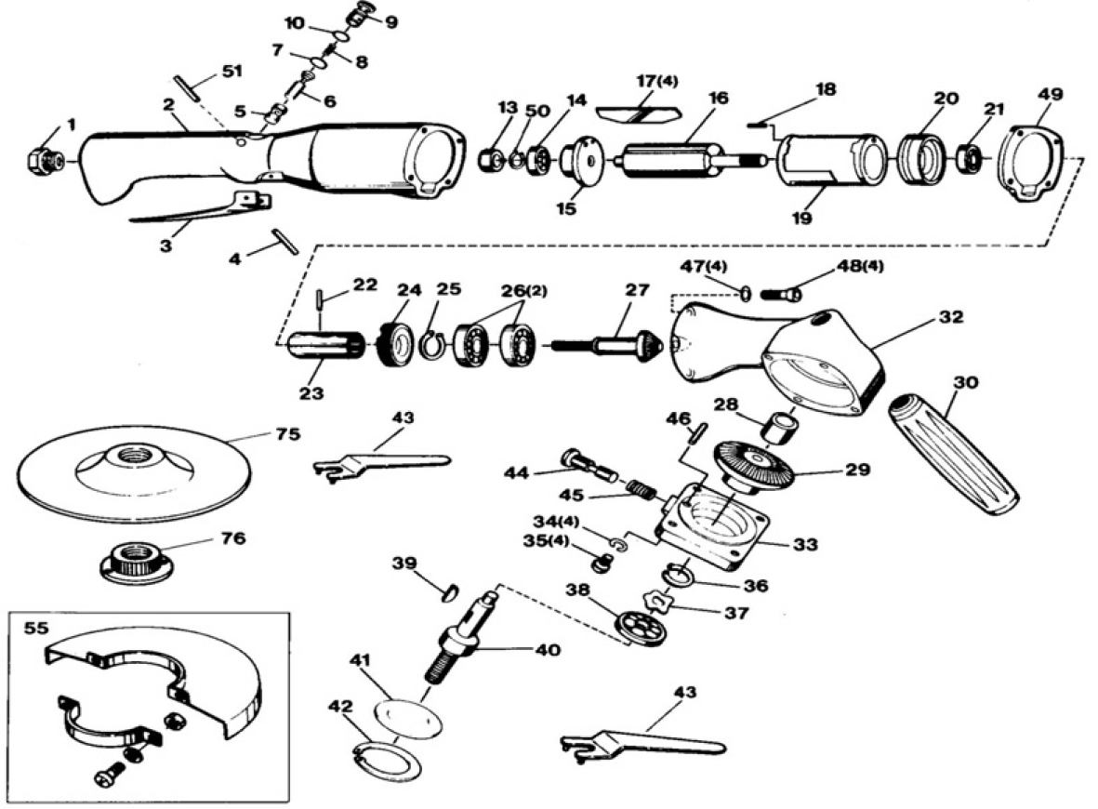

|  |  |  |  |  |  |  |  |
| --- | --- | --- | --- | --- | --- | --- | --- |
| rep | ref. | DESIGNATION | QTE | Rep | Réf. | DESIGNATION | QTE |
| 1 | GP3621-01 | Raccord | 1 | 29 | GP3621-29 | Couronne | 1 |
| 2 | GP3621-02 | Corps arrière | 1 | 30 | GP3730-35 | Poignée latérale | 1 |
| 3 | GP3621-03 | Gâchette | 1 | 32 | GP3621-32 | Carter renvoie d‘angle | 1 |
| 4 | GP3621-04 | Goupille | 1 | 33 | GP3621-33 | Carter cache | 1 |
| 5 | GP3621-05 | Poussoir | 1 | 34 | GP3621-34 | Rondelle | 4 |
| 6 | GP3621-06 | Axe | 1 | 35 | GP3621-35 | Vis | 4 |
| 7 | GP3621-07 | Joint | 1 | 36 | GP3621-36 | Circlips | 1 |
| 8 | GP3621-08 | Ressort | 1 | 37 | GP3621-37 | Rondelle | 1 |
| 9 | GP3621-09 | Régulateur d’air | 1 | 38 | 6302-2rs | Roulement 6302 | 1 |
| 10 | GP3621-10 | Joint | 1 | 39 | GP3621-39 | Clavette | 1 |
| 13 | GP3621-13 | Capuchon | 1 | 40 | GP3621-40 | Arbre support pignon | 1 |
| 14 | 608-2RS | Roulement 608 | 1 | 41 | GP3621-41 | Rondelle | 1 |
| 15 | GP3621-15 | Flasque arrière | 1 | 42 | GP3621-42 | Circlips | 1 |
| 16 | GP3621-16 | Rotor | 1 | 43 | GP3621-43 | Clé ergot | 1 |
| 17 | GP3831-17 | Palette | 4 | 44 | GP3621-44 | Bouton blocage arbre | 1 |
| 18 | GP3621-18 | Goupille | 2 | 45 | GP3621-45 | Ressort | 1 |
| 19 | GP3621-19 | Chemise | 1 | 46 | GP3621-46 | Goupille | 1 |
| 20 | GP3621-20 | Flasque avant | 1 | 47 | GP3621-47 | Rondelle | 4 |
| 21 | 608-2RS | Roulement 608 | 1 | 48 | GP3621-48 | Vis | 4 |
| 22 | GP3621-22 | Goupille | 1 | 49 | GP3621-48 | Clé | 1 |
| 23 | GP3621-23 | Coupleur | 1 | 50 | GP3621-50 | Circlips | 1 |
| 24 | GP3621-24 | Ecrou de serrage | 1 | 51 | GP3621-51 | Goupille | 1 |
| 25 | GP3621-25 | Circlips | 1 | 75 | A158653 | Plateau support + ecrou | 1 |
| 26 | 6200-2RS | Roulement 6200 | 2 | 76 |  | Voir A158653 |  |
| 27 | GP3621-27 | Pinion | 1 | 55 | GP3621-55 | Carter | 1 |
| 28 | GP3621-28 | Roulement aiguille | 1 |  |  |  |  |

**Manche Atlantique Equipements** -27 parc d’activité du Chalet - 22250 BroonsTél 02 96 84 65 59 - Fax 02 96 84 77 75

**WWW.MAE-FR.COM**