**GP3605**

**Disqueuse**

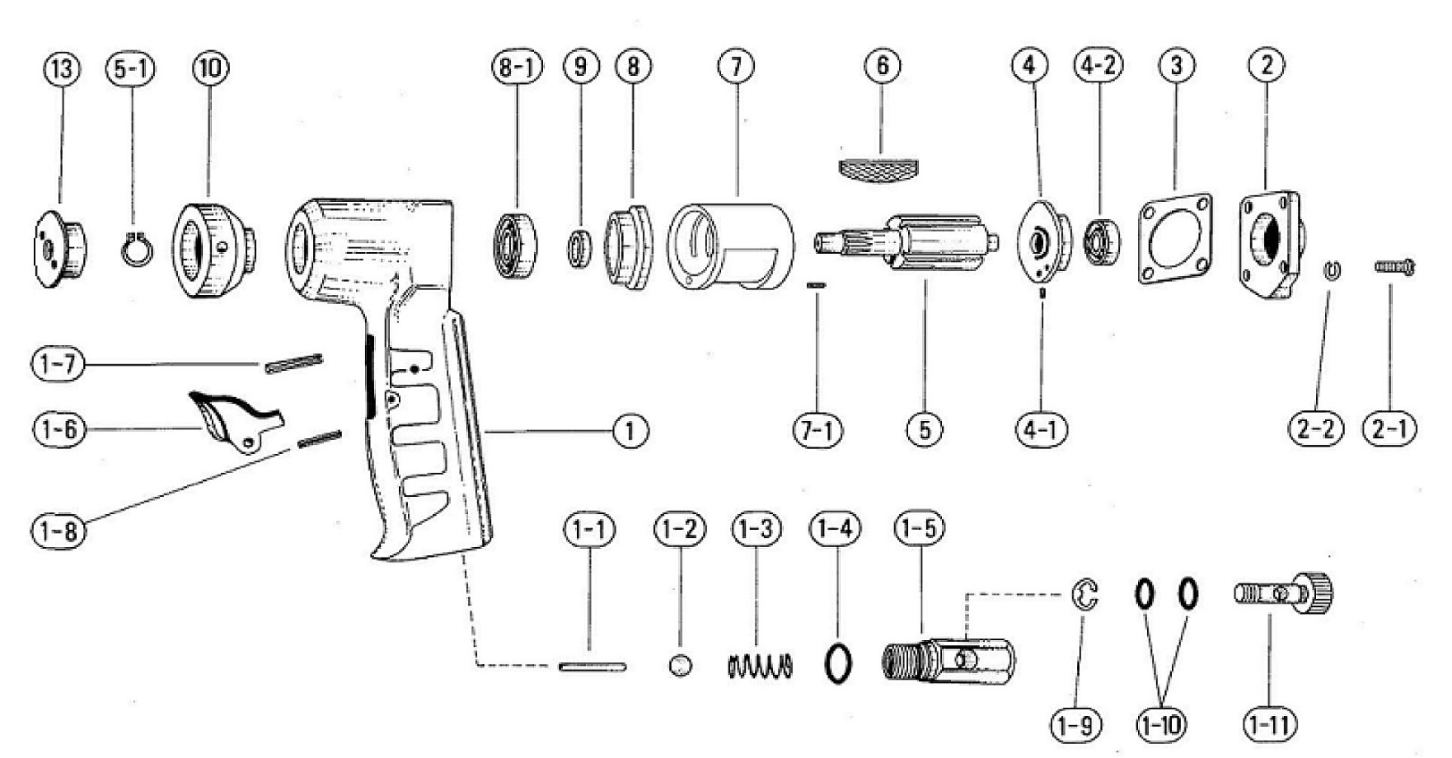

|  |  |  |  |  |  |  |  |
| --- | --- | --- | --- | --- | --- | --- | --- |
| rep | Ref | DESCRIPTION | Qté | rep | Ref | DESCRIPTION | Qté |
| 1 | GP3605-01 | Corps | 1 | 3 | GP3605-3 | Joint papier | 1 |
| 1-1 | GP3605-1-1 | Axe valve | 1 | 4 | GP3605-4 | Flasque arr | 1 |
| 1-2 | GP3606-1-2 | Bille | 1 | 4-1 | GP3605-4-1 | Goupille | 1 |
| 1-3 | GP3605-1-3 | Ressort | 1 | 4-2 | 608-2RS | Roulement 608 | 1 |
| 1-4 | GP3605-1-4 | Joint | 1 | 5 | GP3605-5 | Rotor | 1 |
| 1-5 | GP3605-1-5 | Corps variateur | 1 | 5-1 | GP3605-5-1 | Circlips | 1 |
| 1-6 | GP3605-1-6 | Gâchette | 1 | 6 | GP3605-6 | Palette | 4 |
| 1-7 | GP3605-1-7 | Goupille | 1 | 7 | GP3605-7 | Cylindre | 1 |
| 1-8 | GP3605-1-8 | Goupille | 1 | 7-1 | GP3605-7-1 | Goupille | 1 |
| 1-9 | GP3605-1-9 | Circlips | 1 | 8 | GP3605-8 | Flasque avt | 1 |
| 1-10 | GP3605-1-10 | Joint | 2 | 8-1 | 6001-2RS | Roulement 6001z | 1 |
| 1-11 | GP3605-1-11 | Bouton variateur | 1 | 9 | GP3605-9 | Rondelle | 1 |
| 2 | GP3605-2 | Capot arr | 1 | 10 | GP3605-10 | Masselotte | 1 |
| 2-1 | GP3605-2-1 | Vis | 4 | 13 | GP3605-13 | Ecrou de serrage | 1 |
| 2-2 | GP3605-2-2 | Rondelle | 4 |  |  |  |  |