

**GP3601**

**Disqueuse**

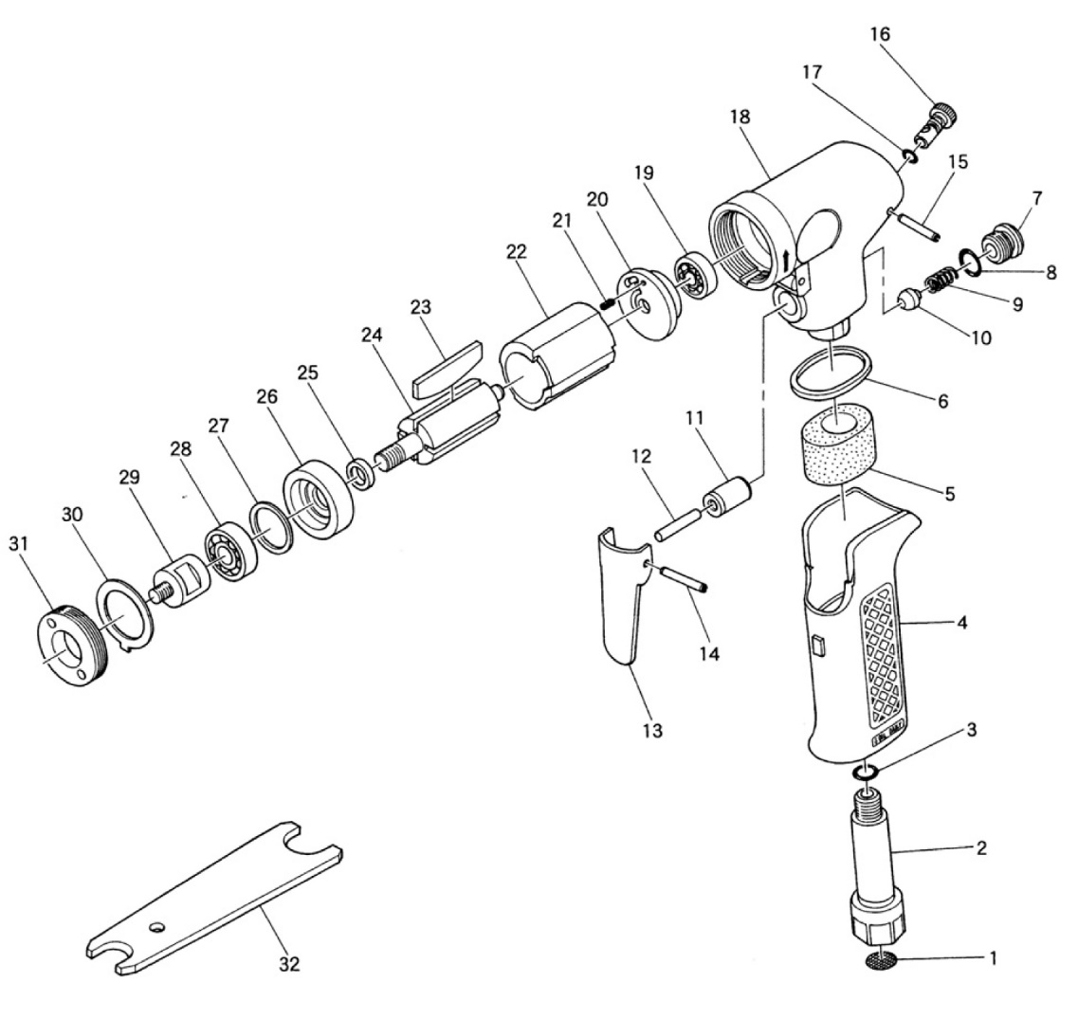

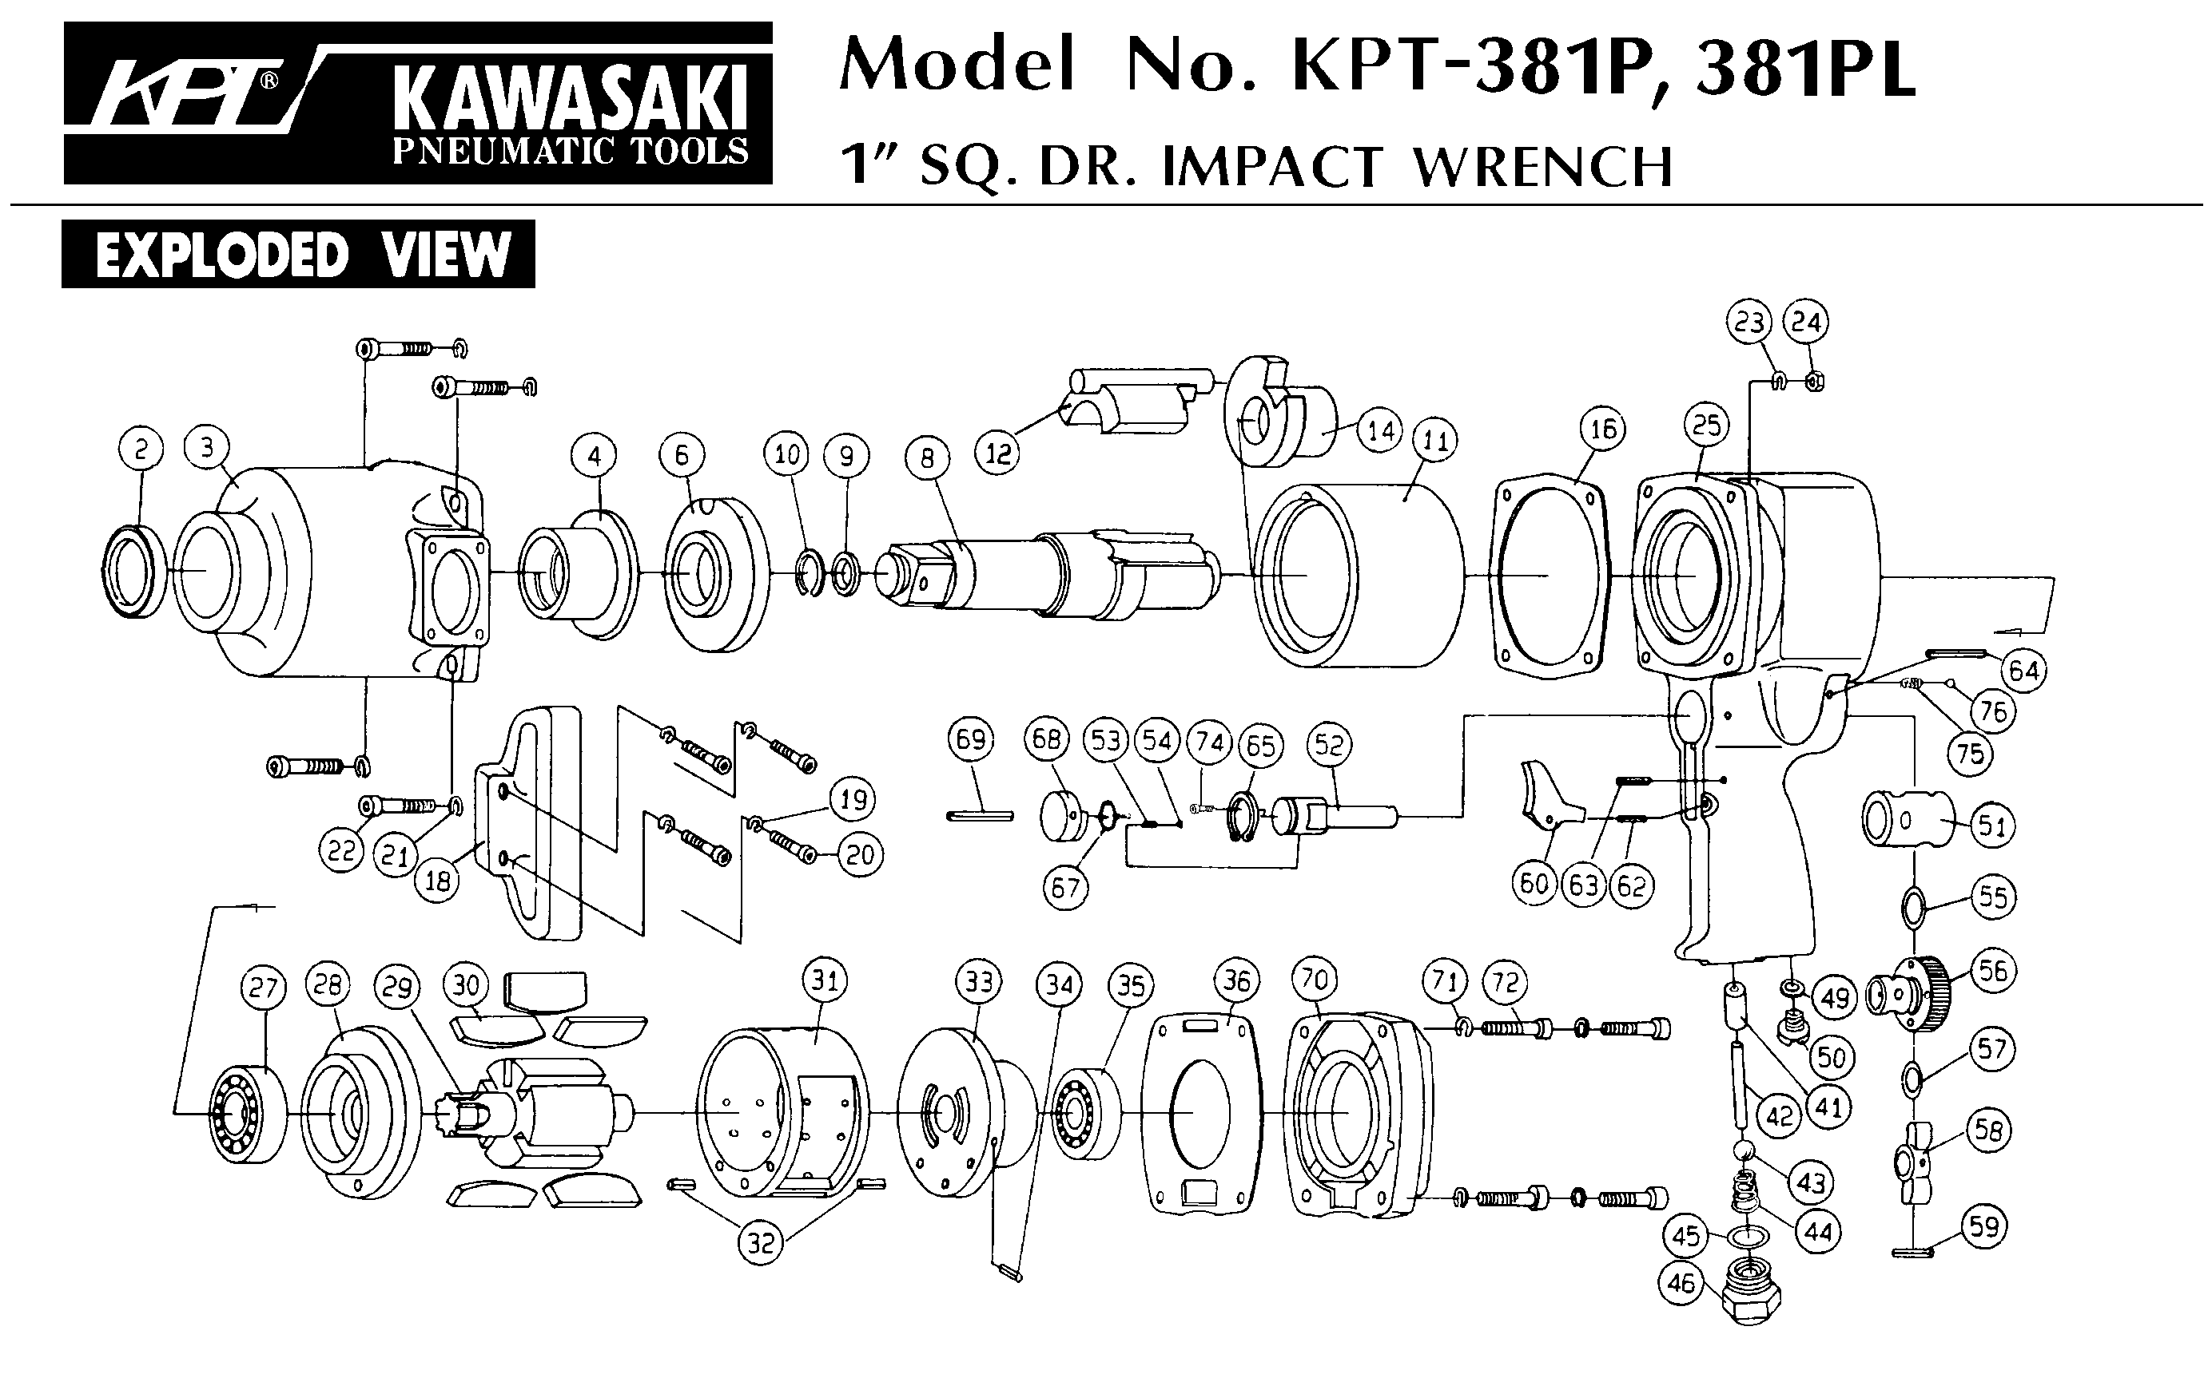





|  |  |  |  |  |  |  |  |
| --- | --- | --- | --- | --- | --- | --- | --- |
| Rep | Ref. | Désignation | Qté | Rep | Ref. | Désignation | Qté |
| 1 | GP3601-1 | Filtre/grille | 1 | 17 | GP3601-17 | Joint | 1 |
| 2 | GP3601-2 | Raccord air | 1 | 18 | GP3601-18 | Corps | 1 |
| 3 | GP3601-3 | Joint | 1 | 19 | 626-2RS | Roulement 626 | 1 |
| 4 | GP3601-4 | Grip poignée | 1 | 20 | GP3601-20 | Flasque ARR | 1 |
| 5 | GP3601-5 | Mousse | 1 | 21 | GP3601-21 | Goupille | 1 |
| 6 | GP3601-6 | Joint | 1 | 22 | GP3601-22 | Chemise | 1 |
| 7 | GP3601-7 | Ecrou | 1 | 23 | GP3601-23 | Palette | 4 |
| 8 | GP3601-8 | Joint | 1 | 24 | GP3601-24 | Rotor | 1 |
| 9 | GP3601-9 | Ressort | 1 | 25 | GP3601-25 | Rondelle | 1 |
| 10 | GP3601-10 | Valve | 1 | 26 | GP3601-26 | Flasque AVT | 1 |
| 11 | GP3601-11 | Chemise | 1 | 27 | GP3601-27 | Rondelle | 1 |
| 12 | GP3601-12 | Axe | 1 | 28 | 608-2RS | Roulement 608 | 1 |
| 13 | GP3601-13 | Gâchette | 1 | 29 | GP3601-29 | Arbre plateau | 1 |
| 14 | GP3601-14 | Goupille | 1 | 30 | GP3601-30 | Rondelle | 1 |
| 15 | GP3601-15 | Goupille | 1 | 31 | GP3601-31 | Ecrou de serrage | 1 |
| 16 | GP3601-16 | Variateur | 1 | 32 | GP3601-32 | Clé | 1 |