

**GP3595**

**Meuleuse verticale (S)**

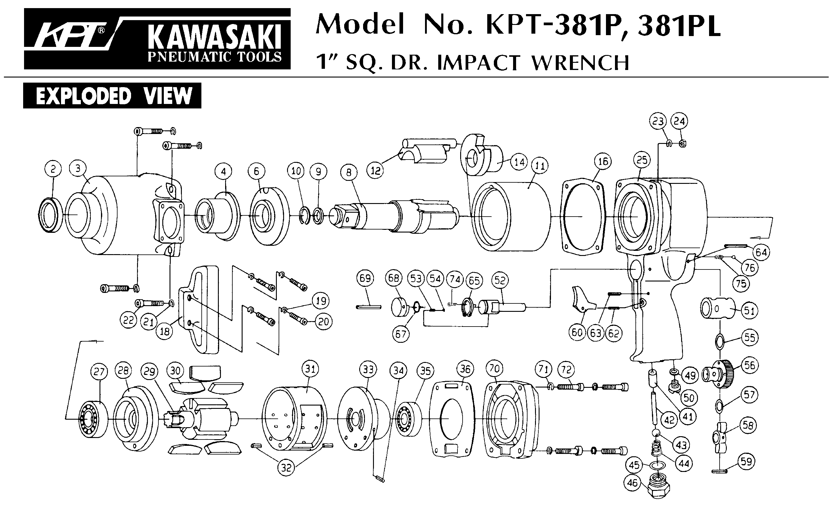





|  |  |  |  |  |  |  |  |
| --- | --- | --- | --- | --- | --- | --- | --- |
| ref. | Rep | Désignation | Qté | ref. | Rep | Désignation | Qté |
| GP3595-1 | 1 | Corps | 1 | GP3595KITCS | 11 | Goupille | 1 |
| GP3595-2 | 2 | Poignée | 1 | 14 | Flasque Arr | 1 |
| GP3595KITA | 3 | Raccord | 1 | 15 | Rotor (secu) | 1 |
| 4 | Gâchette | 1 | 18 | Chemise | 1 |
| 5 | Axe | 1 | 19 | Flasque Avt | 1 |
| 6 | Entretoise | 1 | 22 | Bouchon | 4 |
| 7 | Circlips | 1 | 28 | Ecrou | 1 |
| 8 | Ressort | 1 | GP3595-17 | 17 | Ecrou | 1 |
| 9 | Rondelle | 1 | GP3595-24 | 24 | vis | 4 |
| 13 | Goupille | 1 | GP3595-32 | 32 | Capot moteur | 1 |
| 20 | Vis | 1 | GP3595KITD | 34 | Joint | 1 |
| 21 | Joint | 1 | 39 | Joint capot | 1 |
| 23 | Joint | 1 | GP3595-35 | 35 | Vis | 3 |
| 27 | Ressort | 1 | GP3595-36 | 36 | Rondelle | 3 |
| 29 | Bouton sécurité | 1 | GP3595-37 | 37 | Vis | 3 |
| 31 | Joint | 1 | GP3595-40 | 40 | Poignée | 1 |
| 44 | Contact | 1 | GP3595KITES | 41 | Ecrou serrage (secu) | 1 |
| 45 | Joint | 1 | 42 | Flasque disque | 1 |
| GP3595KITB | 10 | Entretoise | 1 | 49 | Clé allen 5/32 (secu) | 1 |
| 12 | Entretoise | 1 | 48 | Clé 51mm | 1 |
| 16 | Palette | 4 | 47 | Clé ergot (secu) | 1 |
| 25 | Balancier | 1 | GP3595-43 | 43 | Carter Protection Ø230 | 1 |
| 26 | Rondelle élastique | 1 |  |  |  |  |
| 30 | Joint | 1 |  |  |  |
| 33 | Roulement R10-2RS | 1 |  |  |  |
| 38 | Roulement 6203ZZ | 1 |  |  |  |  |

Version 2 (nov 2019)

**Manche Atlantique Equipements** -27 parc d’activité du Chalet - 22250 BroonsTél 02 96 84 65 59 - Fax 02 96 84 77 75

**WWW.MAE-FR.COM**