

**GP3565**

**Meuleuse d’angle**

**Ø125**

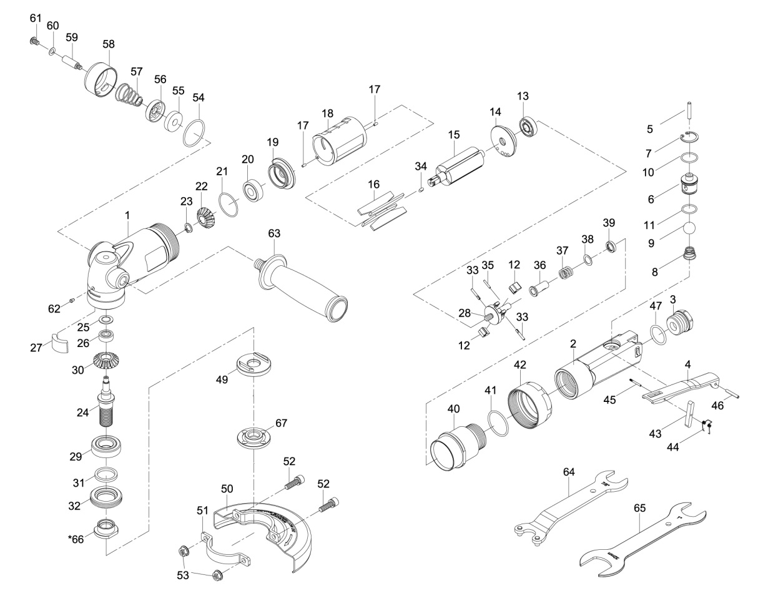

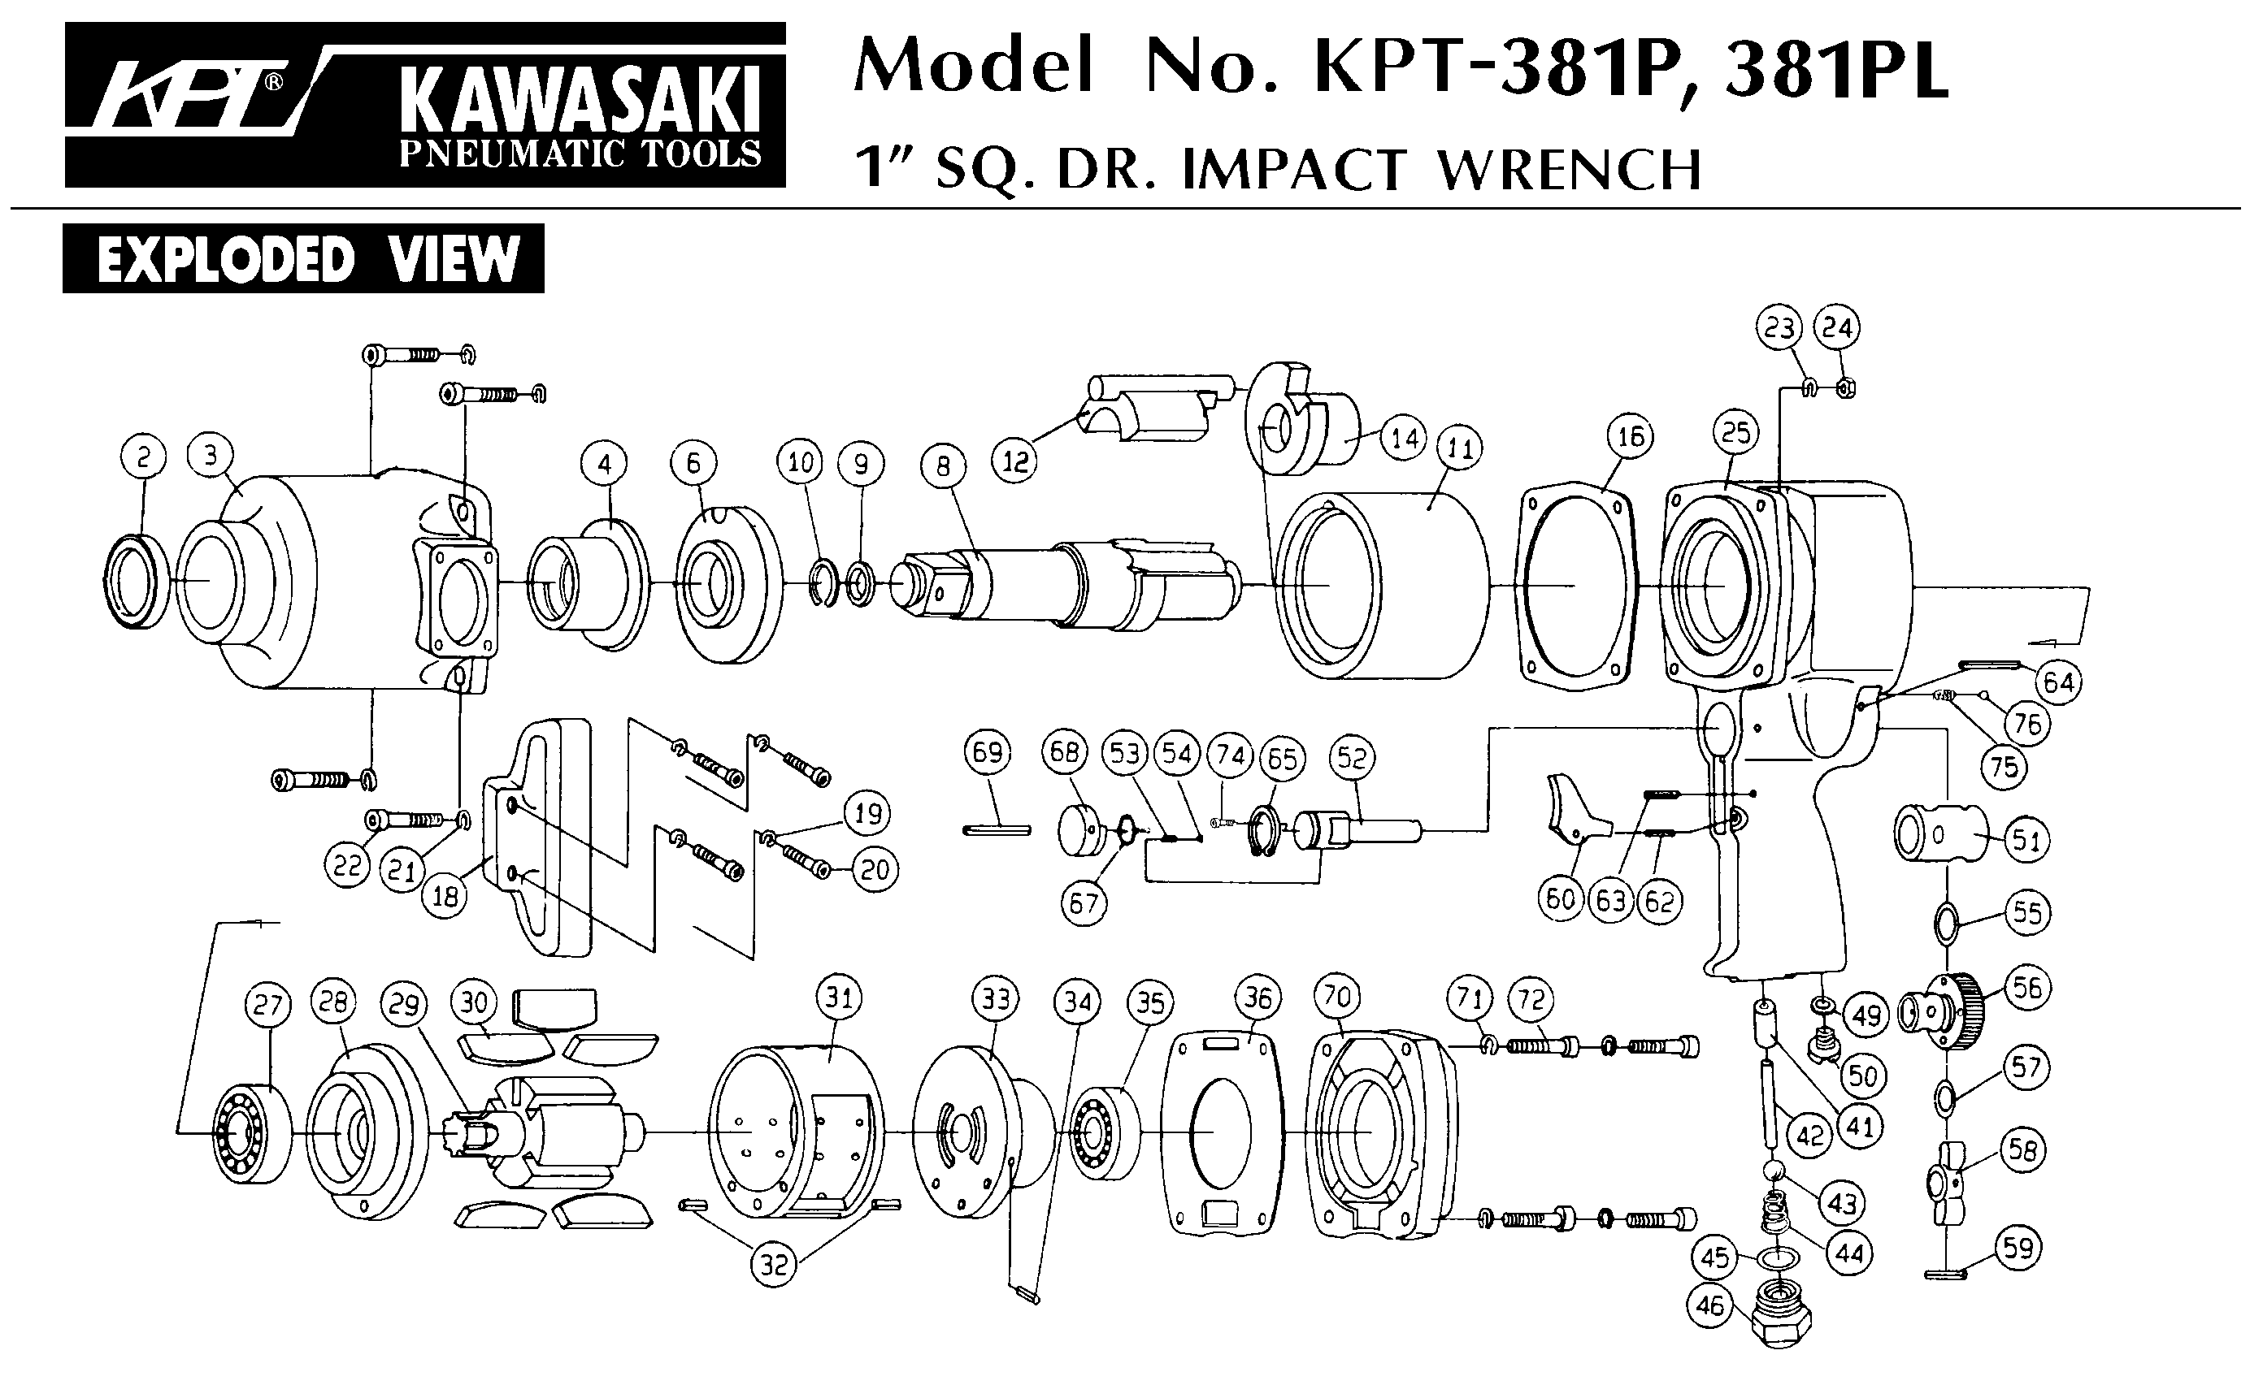





|  |  |  |  |  |  |  |  |
| --- | --- | --- | --- | --- | --- | --- | --- |
| ref. | Rep | Désignation | Qté | ref. | Rep | Désignation | Qté |
| GP3565-1 | 1 | Corps tête | 1 | GP3565KITD | 22 | Pignon | 1 |
| GP3565-2 | 2 | Poigne arr | 1 | 23 | Circlips | 1 |
| GP3565KITA | 3 | Raccord | 1 | 25 | Retenu roulement | 1 |
| 4 | Gâchette | 1 | 26 | Roulement 606zz | 1 |
| 5 | Axe | 1 | 27 | Mêche | 1 |
| 6 | Chambre valve | 1 | 29 | Roulement 6003LLU | 1 |
| 7 | Circlips | 1 | 30 | Couronne | 1 |
| 8 | Ressort | 1 | 31 | Joint Spi | 1 |
| 9 | Bille | 1 | 32 | Ecrou | 1 |
| 10 | Joint | 1 | 34 | Clavette | 1 |
| 11 | Joint | 1 | GP3565-24 | 24 | Arbre M14 | 1 |
| 43 | Sécurité | 1 | GP3565-40 | 40 | Ecrou serrage moteur | 1 |
| 44 | Ressort | 1 | GP3565-42 | 42 | Bague serrage | 1 |
| 45 | Goupille | 1 | GP3565KITE | 49 | Flasque disque | 1 |
| 46 | Goupille | 1 | 64 | Clé ergot | 1 |
| 47 | Joint | 1 | 65 | Clé | 1 |
| GP3565KITB | 12 | Masselote | 2 | 67 | Ecrou serrage disque | 1 |
| 13 | Roulement 609 | 1 | GP3565KITF | 50 | Carter disque Ø125 | 1 |
| 16 | Palette | 4 | 51 | Support carter | 1 |
| 20 | Roulement 6000LLU | 1 | 52 | Vis | 2 |
| 21 | Joint | 1 | 53 | Ecrou | 2 |
| 28 | Support balancier | 1 | GP3565KITG | 54 | Joint | 1 |
| 33 | Goupille | 2 | 55 | Mousse | 1 |
| 35 | Goupille | 1 | 56 | Deflecteur | 1 |
| 36 | Valve balancier | 1 | 57 | Ressort | 1 |
| 37 | Ressort | 1 | 58 | support silencieux | 1 |
| 38 | Rondelle | 1 | 59 | Axe | 1 |
| 39 | Clips | 1 | 60 | rondelle | 1 |
| 41 | Joint | 1 | 61 | vis | 1 |
| GP3565KITC | 14 | Flasque Arr | 1 | GP3565-62 | 62 | Graisseur | 1 |
| 15 | Rotor | 1 | GP3565-63 | 63 | Poignée latérale | 1 |
| 17 | Goupille | 2 | GP3565-66 | 66 | Ecrcou arbre | 1 |
| 18 | Chemise | 1 |  |  |  |  |
| 19 | Flasque Avt | 1 |  |  |  |  |

**Manche Atlantique Equipements** -27 parc d’activité du Chalet - 22250 BroonsTél 02 96 84 65 59 - Fax 02 96 84 77 75

**WWW.MAE-FR.COM**