

**GP3505**

**Disqueuse Ø115-125**

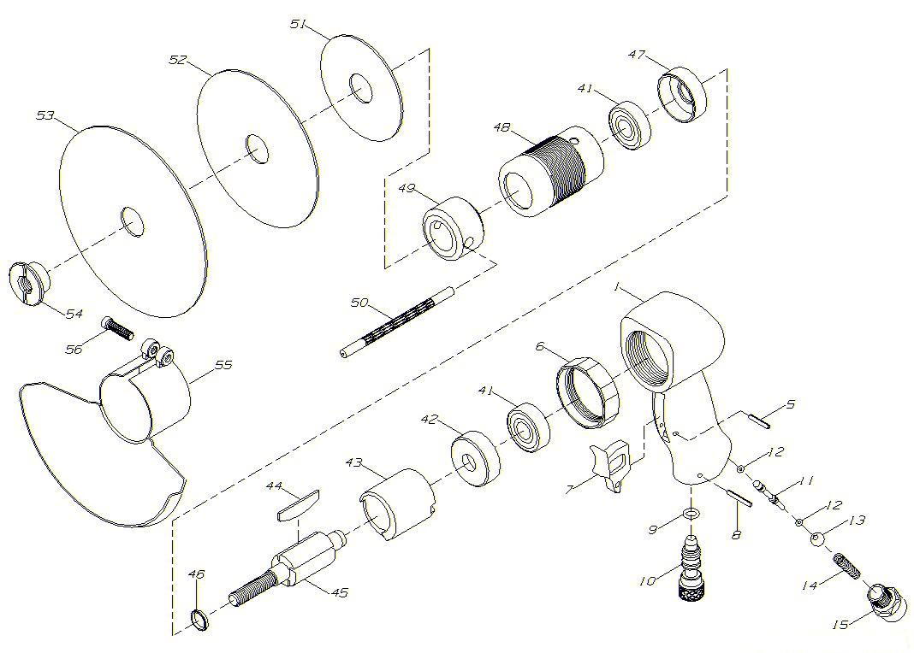

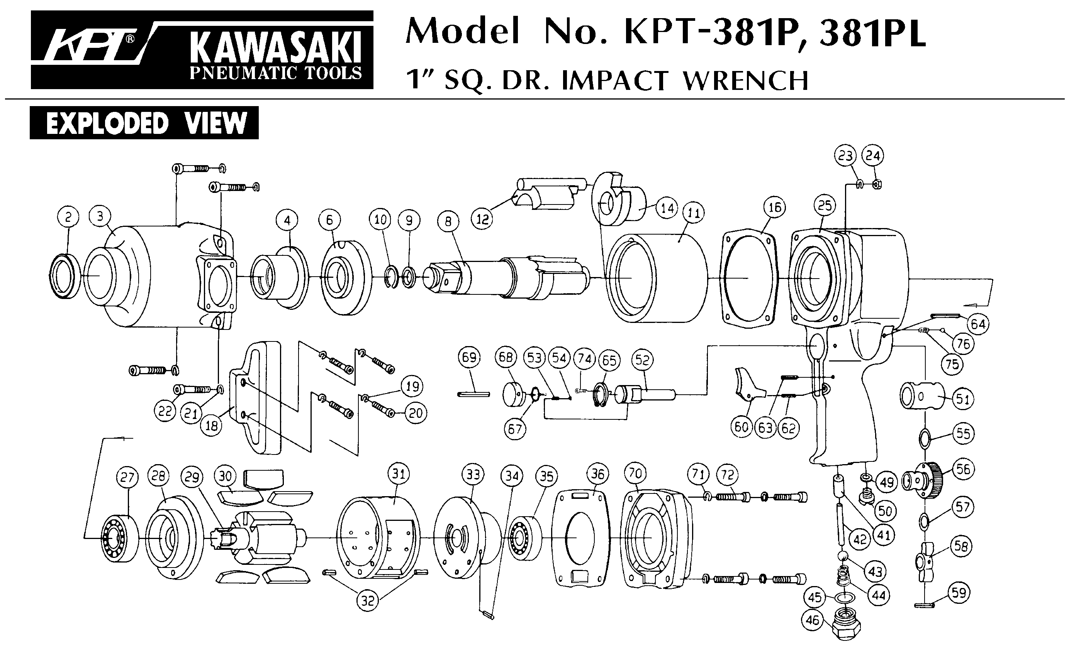

|  |  |  |  |  |  |  |  |
| --- | --- | --- | --- | --- | --- | --- | --- |
| Rep | Réf Art | DESCRIPTION | Qté | Rep | Réf Art | DESCRIPTION | Qté |
| 1 | GP3505-01 | Corps | 1 | 43 | GP3505-43 | Chemise | 1 |
| 5 | GP3505-05 | Goupille | 1 | 44 | GP3505-44 | Palette | 4 |
| 6 | GP3505-06 | Bague serrage | 1 | 45 | GP3505-45 | Rotor | 1 |
| 7 | GP3505-07 | Gâchette | 1 | 46 | GP3505-46 | Rondelle | 1 |
| 8 | GP3505-08 | Goupille | 1 | 47 | GP3505-47 | Flasque avt | 1 |
| 9 | GP3505-09 | Joint | 1 | 48 | GP3505-48 | Carter serrage moteur | 1 |
| 10 | GP3505-10 | Variateur | 1 | 49 | GP3505-49 | Masselotte | 1 |
| 11 | GP3505-11 | Axe valve | 1 | 50 | GP3505-50 | Axe de blocage | 1 |
| 12 | GP3505-12 | Joint | 2 | 51 | ORA8609 | Support Ø75 | 1 |
| 13 | GP3505-13 | Valve | 1 | 52 | ORA8610 | Support Ø115 | 1 |
| 14 | GP3505-14 | Ressort | 1 | 53 | ORA8611 | Support Ø140 | 1 |
| 15 | GP3505-15 | Raccord | 1 | 54 | GP3505-54 | Ecrou serrage disque | 1 |
| 41 | GP3505-41 | Roulement | 2 | 55 | GP3505-55 | Carter | 1 |
| 42 | GP3505-42 | Flasque arr | 1 | 56 | GP3505-56 | Vis | 1 |



**Manche Atlantique Equipements** -27 parc d’activité du Chalet - 22250 BroonsTél 02 96 84 65 59 - Fax 02 96 84 77 75

**WWW.MAE-FR.COM**