

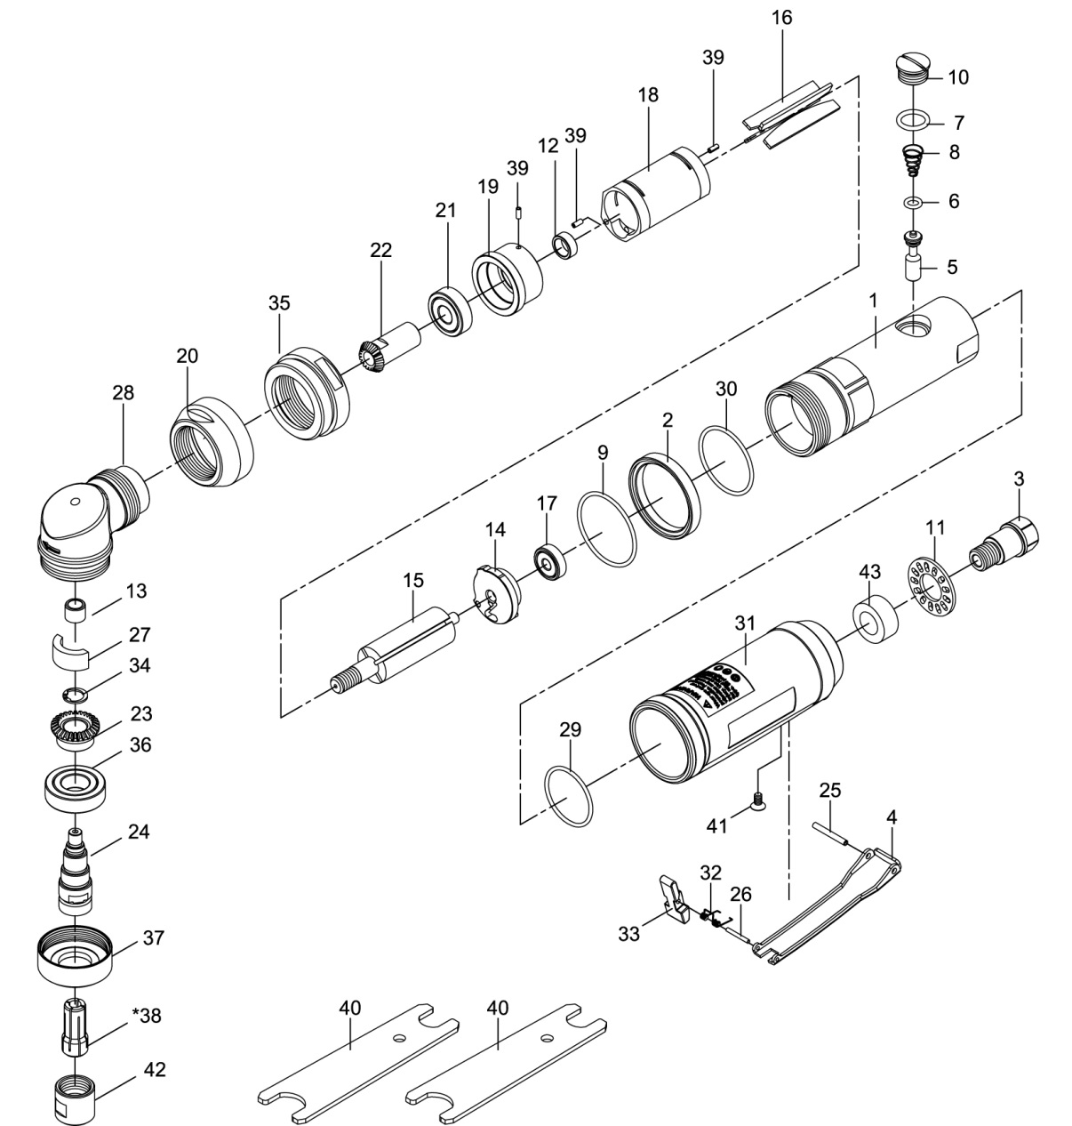

**GP3475**

**Meuleuse d’angle**

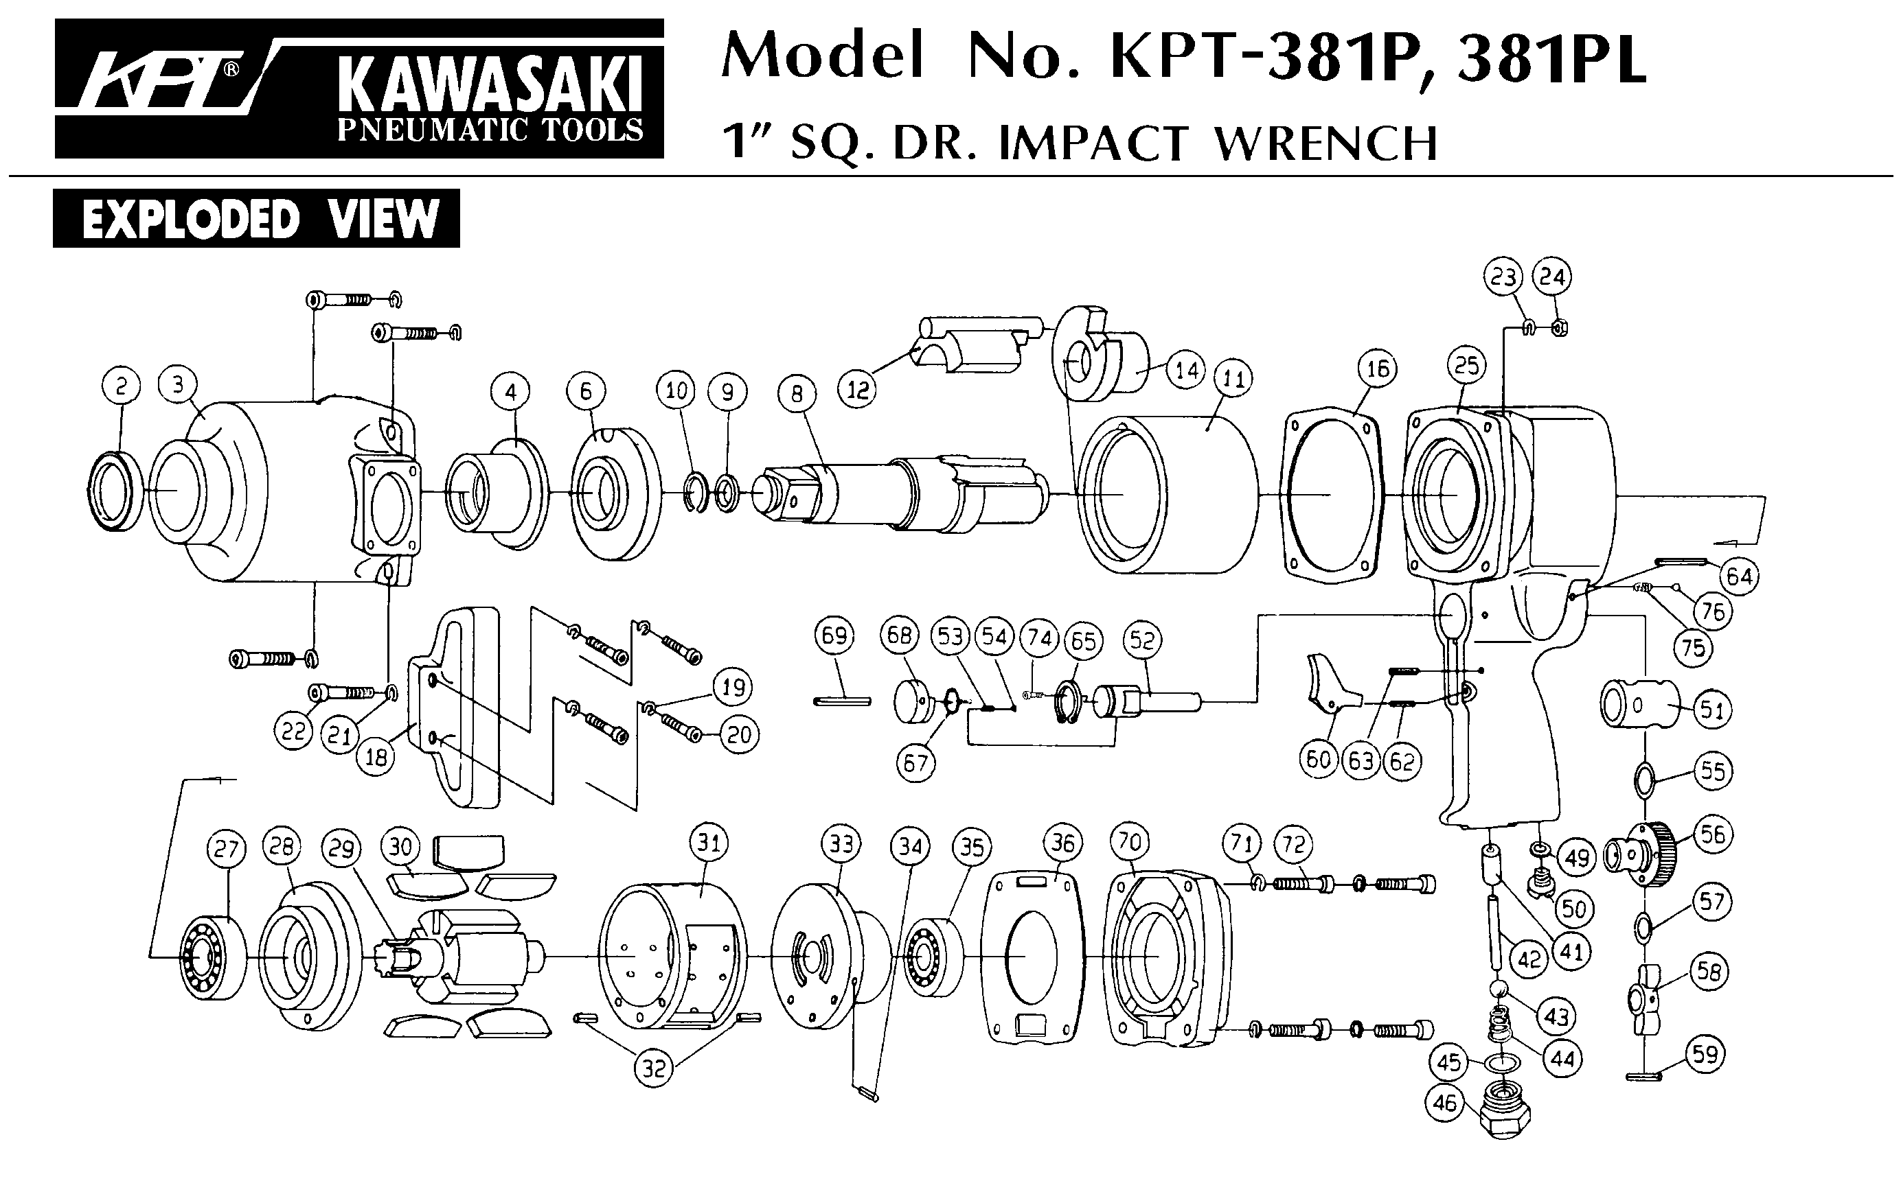





|  |  |  |  |  |  |  |  |
| --- | --- | --- | --- | --- | --- | --- | --- |
| ref. | Rep | Désignation | Qté | ref. | Rep | Désignation | Qté |
| GP3475-1 | 1 | Corps | 1 | GP3475KITE | 13 | roulement tête | 1 |
| GP3475-2 | 2 | Rondelle | 1 | 22 | Pignon | 1 |
| GP3475-3 | 3 | Raccord | 1 | 23 | couronne | 1 |
| GP3475KITA | 4 | Gâchette | 1 | 24 | Arbre porte pince | 1 |
| 25 | Goupille | 1 | 27 | graisseur | 1 |
| 26 | Goupille | 1 | 34 | circlips | 1 |
| 32 | Ressort | 4 | 36 | roulement 6002zz | 1 |
| 33 | Sécurité | 1 | GP3475KITD | 16 | Palette | 1 |
| GP3475KITB | 5 | Valve | 1 | 17 | Roulement 626ZZ | 1 |
| 6 | Joint | 1 | 21 | roulement 6000zz | 1 |
| 7 | Joint | 1 | GP3475-28 | 28 | carter tête | 1 |
| 8 | Ressort | 1 | GP3475-29 | 29 | Joint | 1 |
| 10 | Ecrou | 1 | GP3475-30 | 30 | Joint | 4 |
| GP3475-9 | 9 | Joint | 1 | GP3475-31 | 31 | Grip | 1 |
| GP3479-11 | 11 | Silencieux | 1 | GP3475-35 | 35 | Ecrou serrage moteur | 1 |
| GP3475KITC | 12 | entretoise | 1 | GP3475-37 | 37 | Ecrou serrage porte pince | 1 |
| 14 | Flasque Arr | 1 | GP3475-38 | 38 | Pince 6mm | 1 |
| 15 | Rotor | 1 | GP3475KITF | 40 | clé 14-19 | 2 |
| 18 | Chemise | 1 | 42 | Ecrou serrage pince | 1 |
| 19 | Flasque Avt | 1 | GP3475-41 | 41 | Vis | 1 |
| 39 | Goupille | 3 | GP3475-43 | 43 | Mousse | 1 |
| GP3475-20 | 20 | Ecrou réglage tête | 1 |  |  | 29 nov 2016 |  |

**Manche Atlantique Equipements** -27 parc d’activité du Chalet - 22250 BroonsTél 02 96 84 65 59 - Fax 02 96 84 77 75

**WWW.MAE-FR.COM**