

**GP3328**

**Meuleuse d’angle**

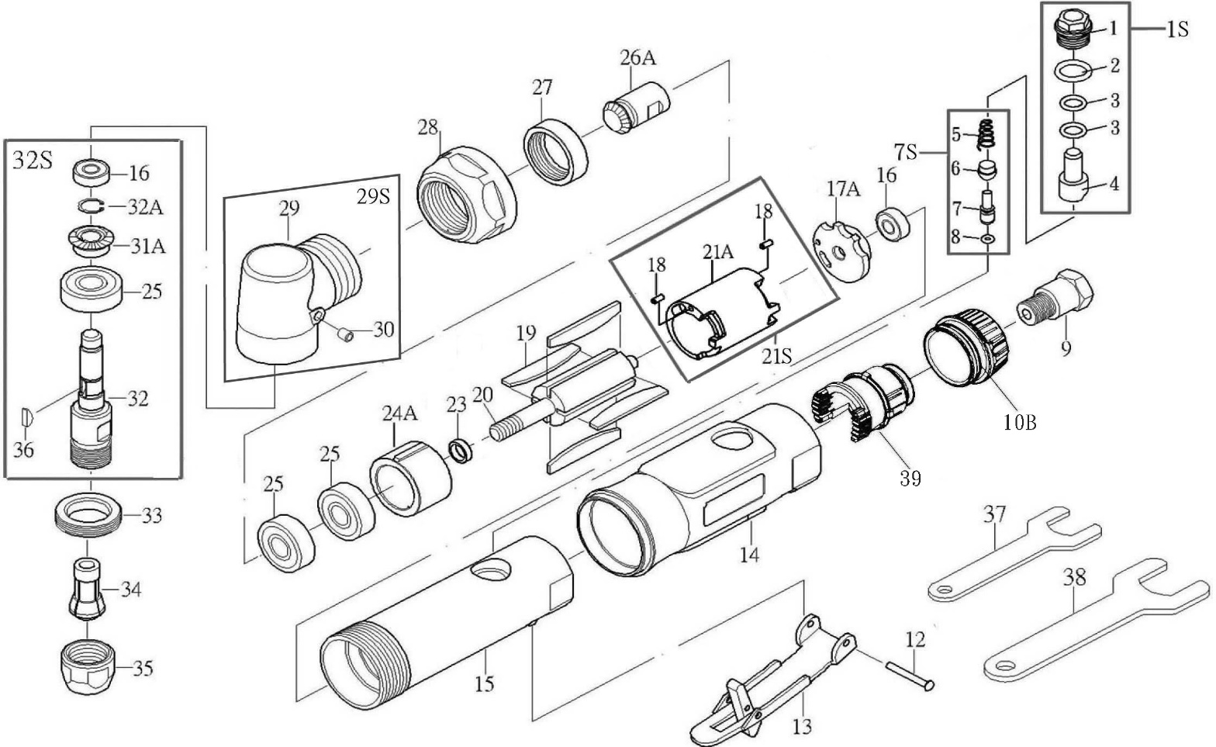

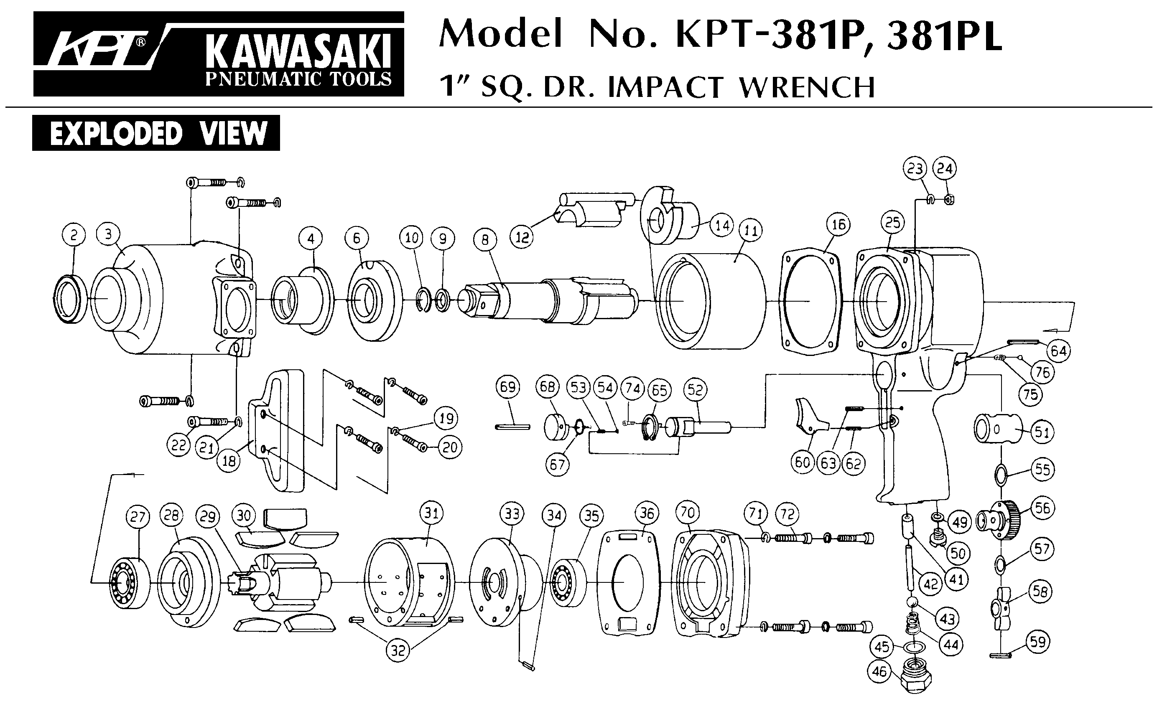





|  |  |  |  |  |  |  |  |
| --- | --- | --- | --- | --- | --- | --- | --- |
| **Rep** | **Réf.** | **Description** | **Qté** | **Rep** | **Réf.** | **Description** | **Qté** |
| 1 | GP3328-01S | Kit écrou régulateur 1/2/3/4 | 1 | 24A | GP3328-23 | Flasque Avant | 1 |
| 2 | 1 | 25 | 608-2RS | Roulement avant (608zz) | 2 |
| 3 | 2 | 26A | GP3328-26A | Pignon (11t) | 1 |
| 4 | 1 | 27 | GP3328-31 | Ecrou | 1 |
| 5 | GP3328-07S | Kit valve arrivé air 5/6/7/8 | 1 | 28 | GP3328-32 | Bague serrage | 1 |
| 6 | 1 | 29S | GP3328-29S | Carter tête + graisseur |  |
| 7 | 1 | 1 |
| 8 | 1 |  |
| 9 | GP3328-09 | Raccord | 1 | 31A | GP3328-31A | Couronne (14t) | 1 |
| 10B | GP3328-10B | Echappement | 1 | 16 | GP3328-32S | Kit arbre pince. |  |
| 12 | GP3328-12 | Goupille | 1 | 25 |  |
| 13 | GP3328-13 | Gâchette Sécurité | 1 | 31A |  |
| 14 | GP3328-14 | Protection | 1 | 32 | 1 |
| 15 | GP3328-15 | Carter moteur | 1 | 32A |  |
| 16 | 696-2RS | Roulement arrière(696zz) | 1 | 36 |  |
| 17A | GP3328-17 | Flasque arrière | 1 | 33 | GP3328-37 | Ecrou | 1 |
| 19 | GP3328-19 | Palette | 4 | 34 | GPS1021 | Pince 6mm | 1 |
| 18 | GP3328-21S | Chemise ass 18/21 | 2 | 35 | GP3328-29 | Ecrou serrage pince | 1 |
| 21S | 1 | 37 | GP3328-40 | Clé 14mm | 1 |
| 20 | GP3328-20 | Rotor | 1 | 38 | GP3328-41 | Clé 19mm | 1 |
| 23 | GP3328-22 | Rondelle | 1 | 39 | GP3328-39 | Support échappement | 1 |

Version 21/02 R2023