

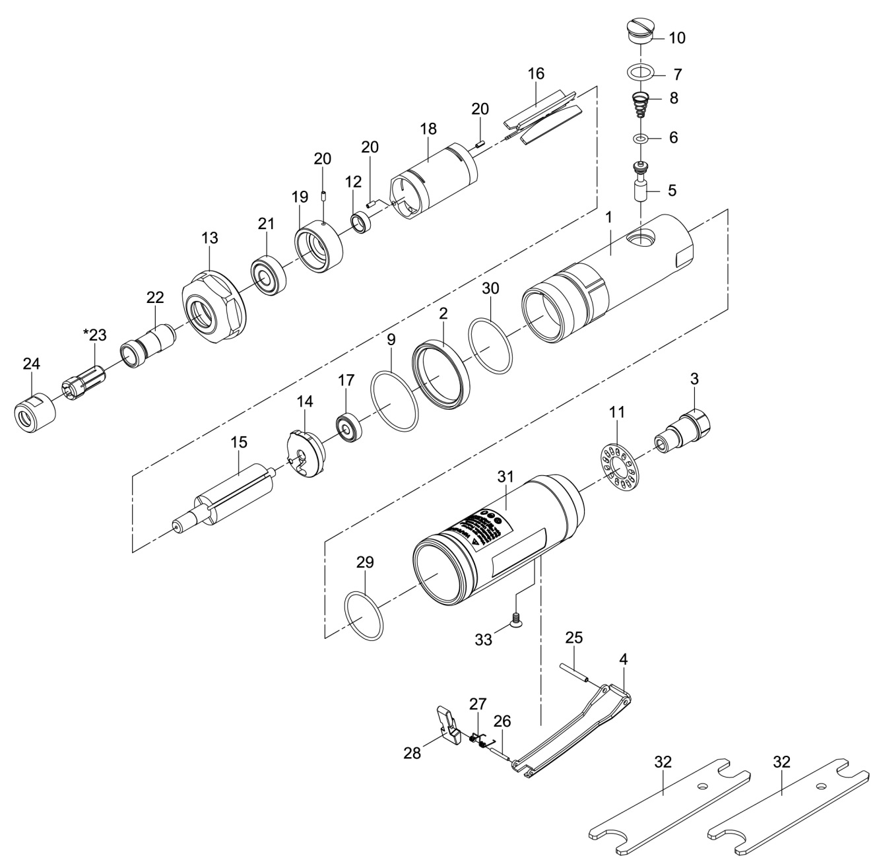

**GP3275**

**Meuleuse droite**

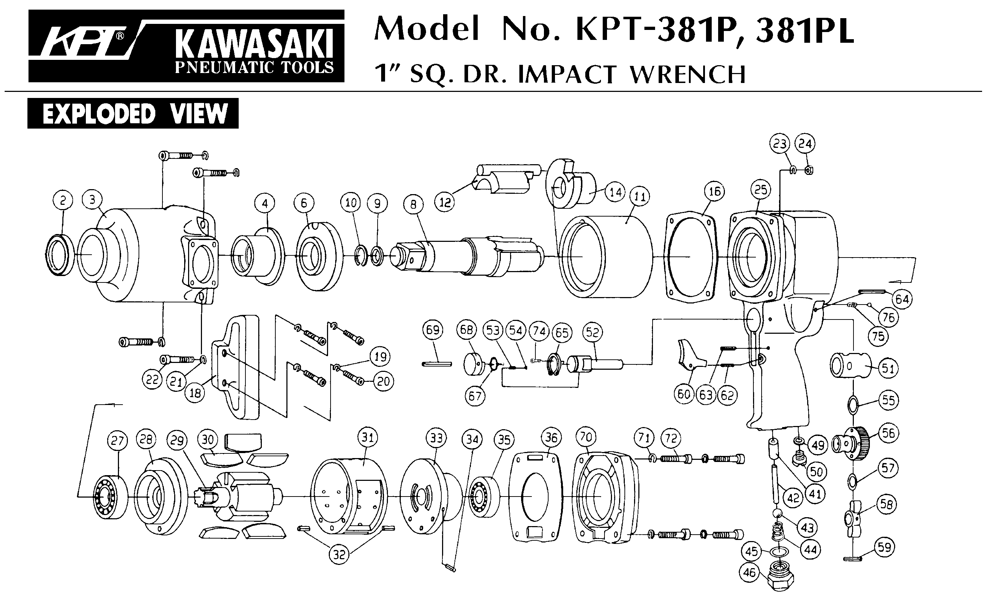





|  |  |  |  |  |  |  |  |
| --- | --- | --- | --- | --- | --- | --- | --- |
| ref. | Rep | Désignation | Qté | ref. | Rep | Désignation | Qté |
| GP3275-1 | 1 | Corps | 1 | GP3275KITC | 12 | entretoise | 1 |
| GP3275-2 | 2 | Rondelle | 1 | 14 | Flasque Arr | 1 |
| GP3275-3 | 3 | Raccord | 1 | 15 | Rotor | 1 |
| GP3275KITA | 4 | Gâchette | 1 | 18 | Chemise | 6 |
| 25 | Goupille | 1 | 19 | Flasque Avt | 1 |
| 26 | Goupille | 1 | 20 | Goupille | 3 |
| 27 | Ressort | 4 | GP3275KITD | 16 | Palette | 1 |
| 28 | Sécurité | 1 | 17 | Roulement 626ZZ | 1 |
| GP3275KITB | 5 | Valve | 1 | 21 | roulement 6000zz | 1 |
| 6 | Joint | 1 | GP3275-23 | 23 | Pince 6mm | 1 |
| 7 | Joint | 1 | GP3275-29 | 29 | Joint | 1 |
| 8 | Ressort | 1 | GP3275-30 | 30 | Joint | 4 |
| 10 | Ecrou | 2 | GP3275-31 | 31 | Grip | 1 |
| GP3275-9 | 9 | Joint | 1 | GP3275-33 | 33 | Vis | 1 |
| GP3275-11 | 11 | Silencieux | 1 | GP3275KITE | 24 | Ecrou pince | 1 |
| GP3275-13 | 13 | Ecrou serrage moteur | 1 | 32 | clé x2 | 1 |
| GP3275-22 | 22 | Porte pince | 1 |  |  |  |  |

**Manche Atlantique Equipements** -27 parc d’activité du Chalet - 22250 BroonsTél 02 96 84 65 59 - Fax 02 96 84 77 75

**WWW.MAE-FR.COM**