

**GP3250**

**Crayon graveur**

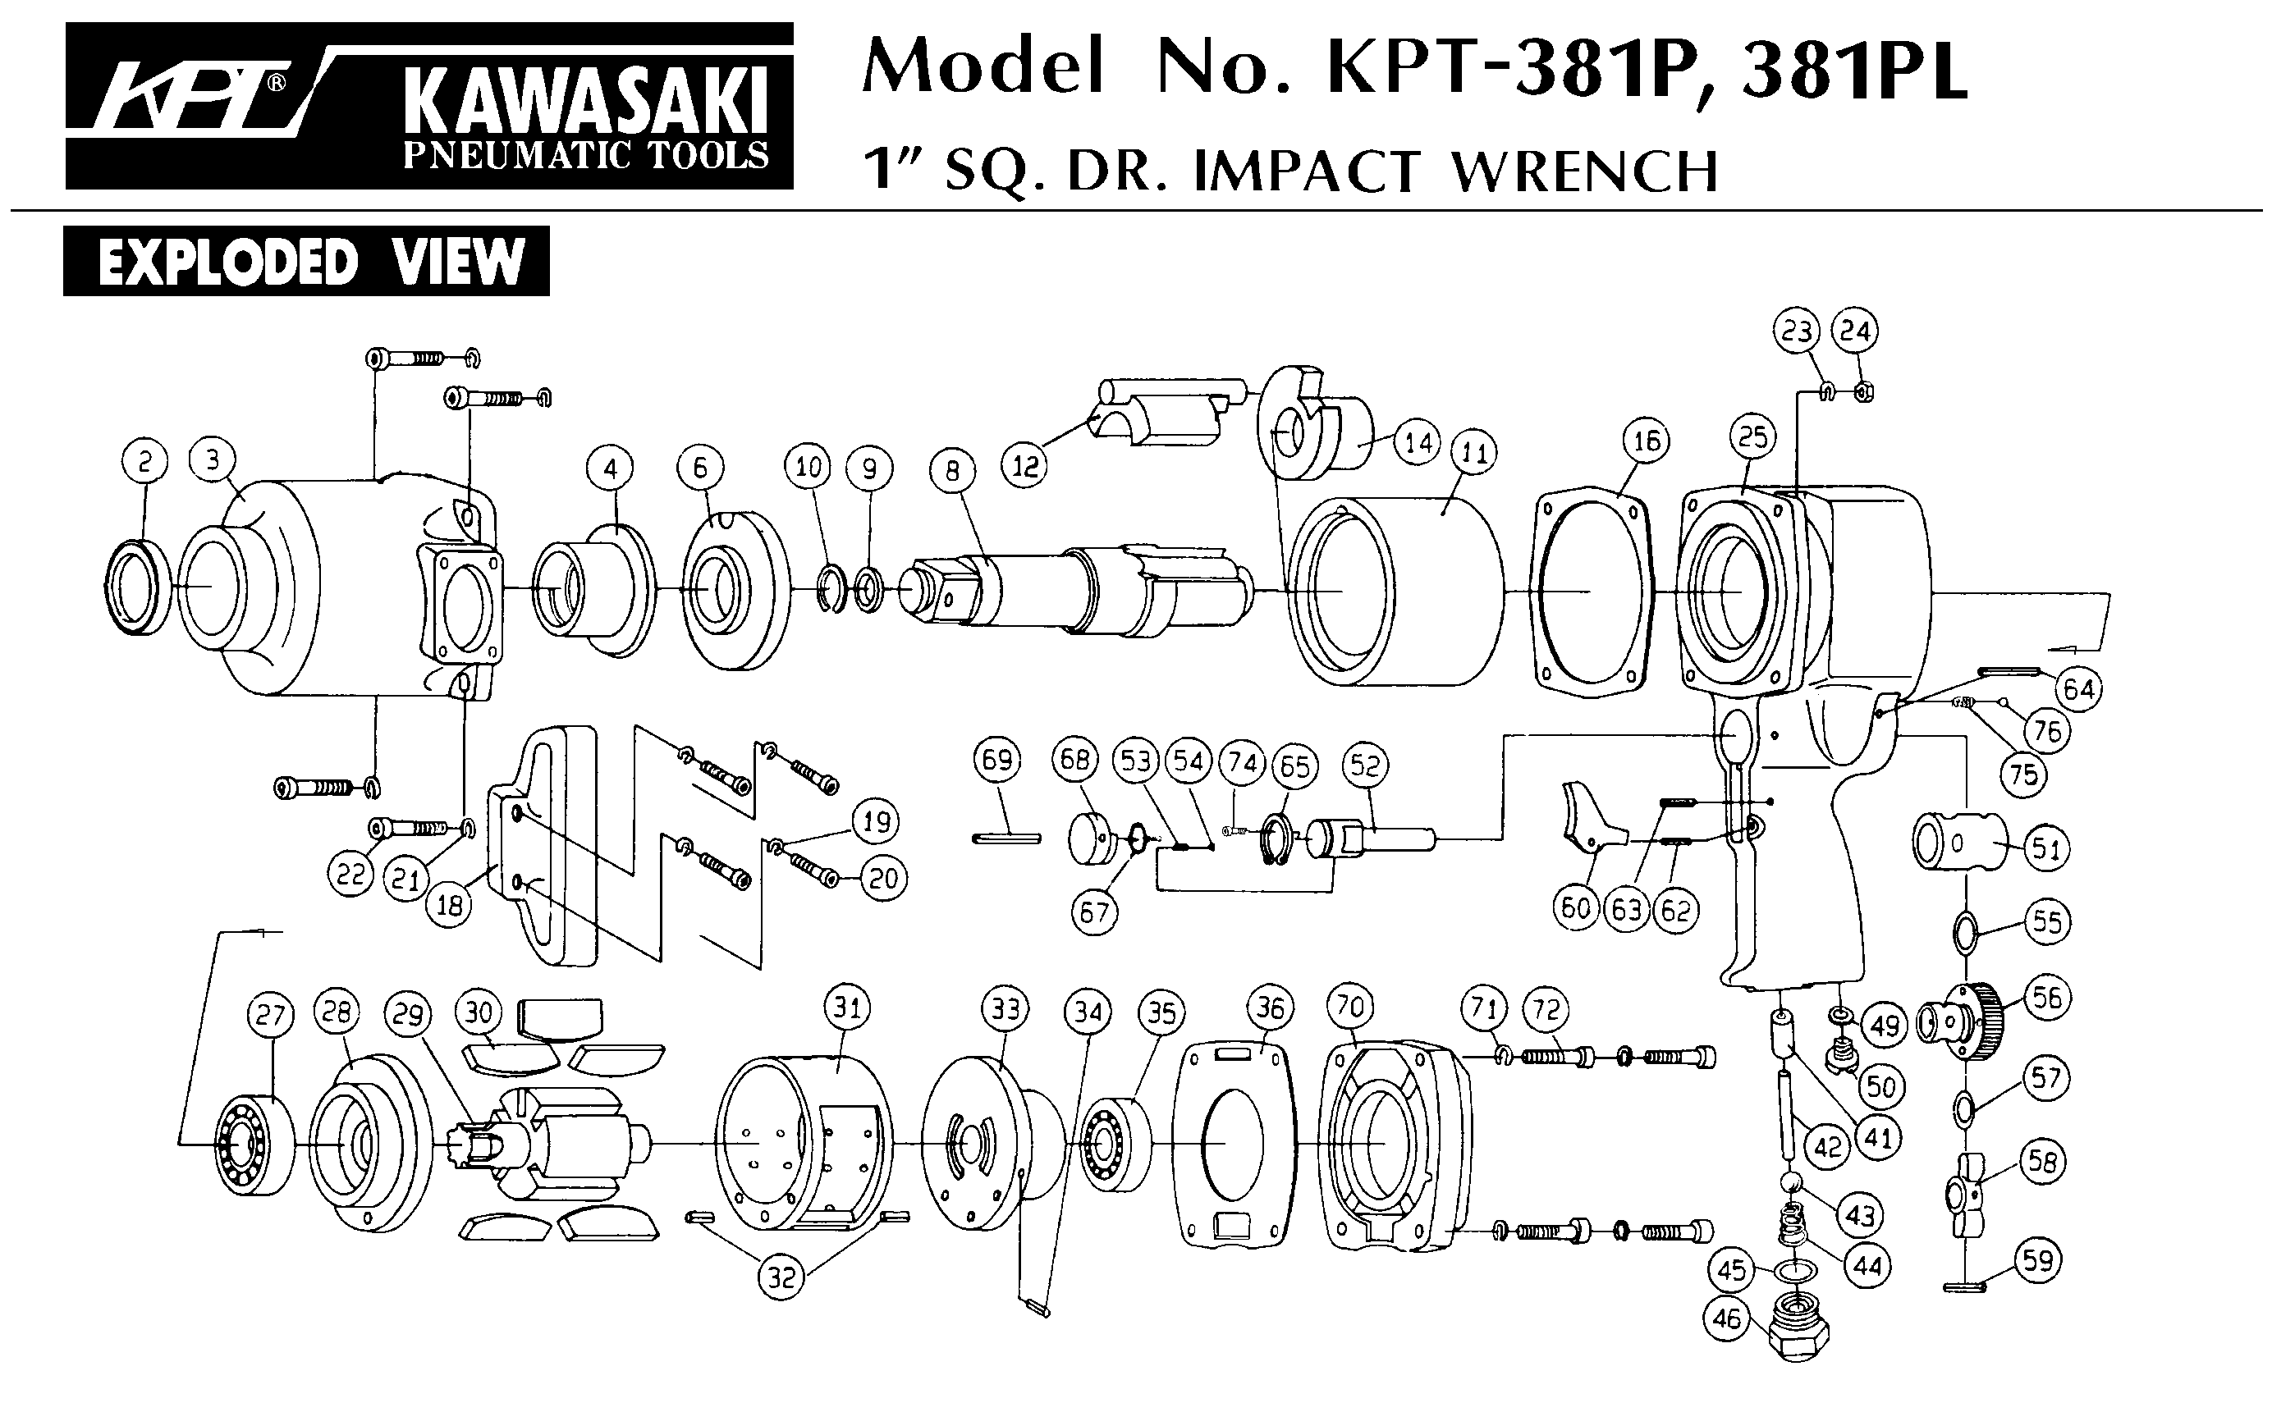

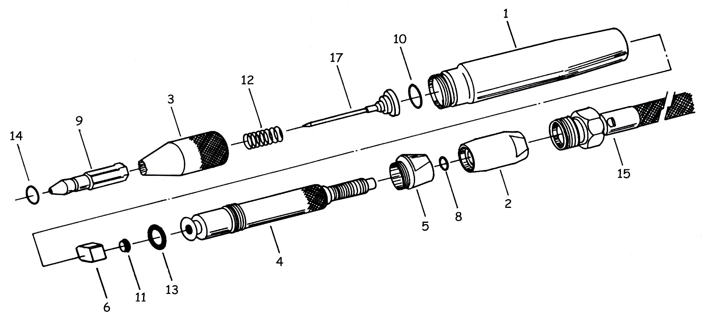



|  |  |  |  |  |  |  |  |
| --- | --- | --- | --- | --- | --- | --- | --- |
| Rep | ref. | Désignation | Qté | Rep | ref. | Désignation | Qté |
| 1 | GP3250-1 | Corps | 1 | 11 | GP3250-11 | Joint | 1 |
| 2 | GP3250-2 | Gâchette réglable | 1 | 12 | GP3250-12 | Ressort | 1 |
| 3 | GP3250-3 | Carter avant | 1 | 13 | GP3250-13 | Joint | 1 |
| 4 | GP3250-4 | Ensemble valve | 1 | 14 | GP3250-14 | Joint | 1 |
| 5 | GP3250-5 | Ecrou | 1 | 15 | GP3250-15 | Tuyau alimentation | 1 |
| 6 | GP3250-6 | Valve | 1 | 17 | GPS3250F | Pointe fine | 1 |
| 8 | GP3250-8 | Joint | 1 | 17 | GPS3250M | Pointe moyenne (opt) | 1 |
| 9 | GP3250-9 | Guide | 1 | 17 | GPS3250G | Grosse Pointe (opt) | 1 |
| 10 | GP3250-10 | Joint | 1 |  |  |  |  |

**Manche Atlantique Equipements** -27 parc d’activité du Chalet - 22250 BroonsTél 02 96 84 65 59 - Fax 02 96 84 77 75

**WWW.MAE-FR.COM**