

**GP3235**

**Meuleuse droite lente**

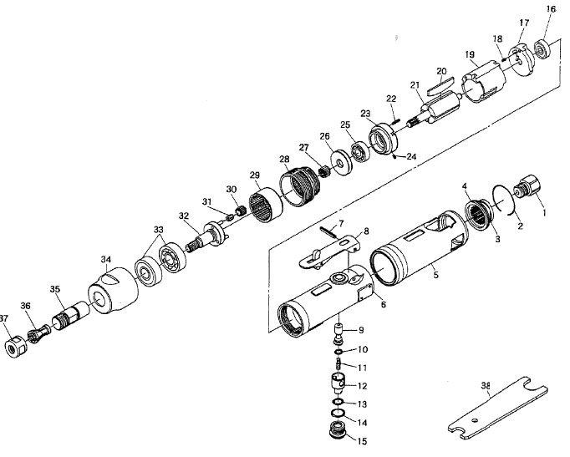

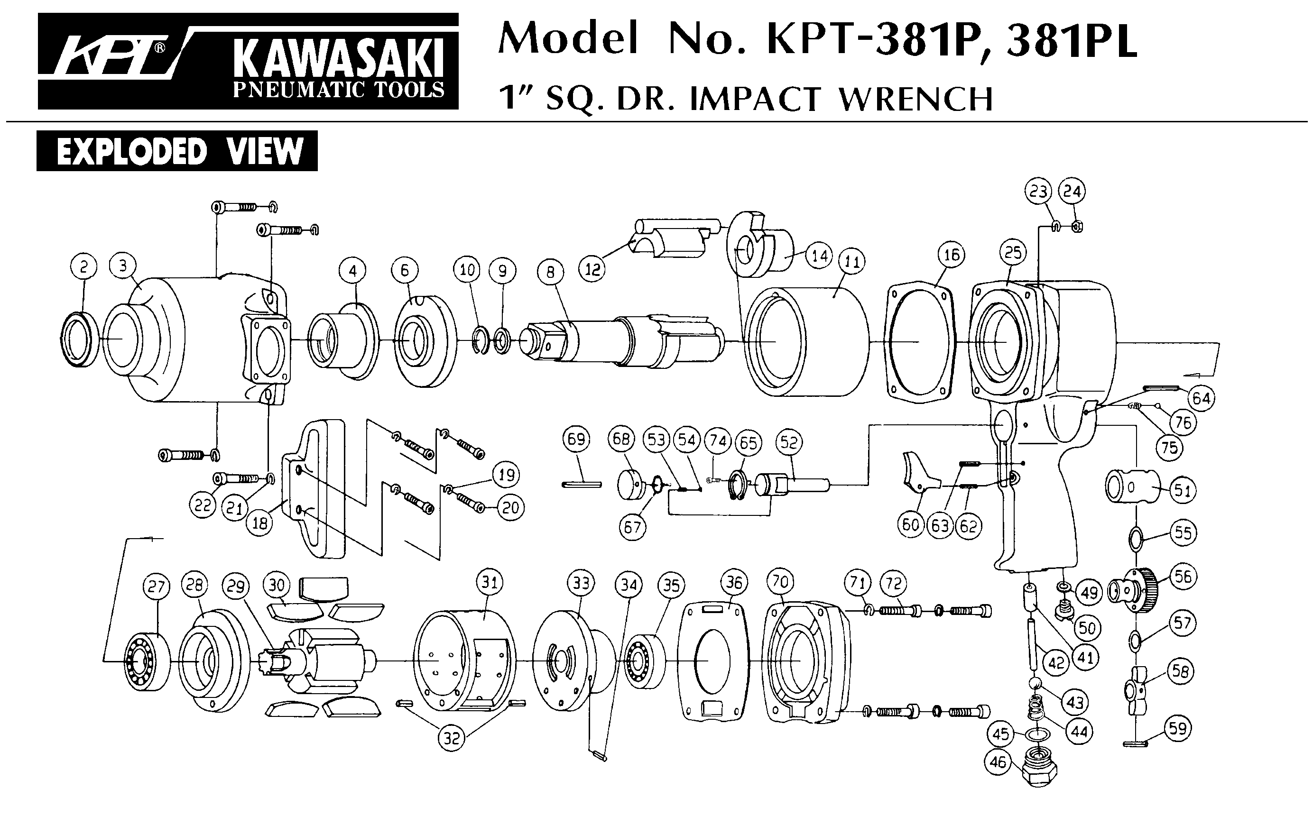





|  |  |  |  |  |  |  |  |
| --- | --- | --- | --- | --- | --- | --- | --- |
| Rep | Réf | Désignation | Qté | Rep | Réf | Désignation | Qté |
| 1 | GP3235-1 | Raccord | 1 | 20 | GP3235-20 | Palette | 4 |
| 2 | GP3235-2 | Circlips | 1 | 21 | GP3235-21 | Rotor | 1 |
| 3 | GP3235-3 | Silencieux | 1 | 22 | GP3235-22 | Goupille | 1 |
| 4 | GP3235-4 | Joint | 1 | 23 | GP3235-23 | Flasque avt | 1 |
| 5 | GP3235-5 | Protection | 1 | 24 | GP3235-24 | Goupille | 1 |
| 6 | GP3235-6 | Corps | 1 | 25 | 608-2RS | Roulement 608 | 1 |
| 7 | GP3235-7 | Goupille | 1 | 26 | GP3235-26 | Rondelle | 1 |
| 8 | GP3235-8 | Gâchette | 1 | 27 | GP3235-27 | Pignon | 1 |
| 9 | GP3235-9 | Valve | 1 | 28 | GP3235-28 | Bague de serrage | 1 |
| 10 | GP3235-10 | Joint | 1 | 29 | GP3235-29 | Couronne | 1 |
| 11 | GP3235-11 | Ressort | 1 | 30 | GP3235-30 | Pignon | 1 |
| 12 | GP3235-12 | Variateur | 1 | 31 | GP3235-31 | Entretoise + axe | 1 |
| 13 | GP3235-13 | Joint | 1 | 32 | GP3235-32 | Porte satellite | 1 |
| 14 | GP3235-14 | Joint | 1 | 33 | 6201-2RS | Roulement 6201 | 1 |
| 15 | GP3235-15 | Ecrou | 1 | 34 | GP3235-34 | Carter avt | 1 |
| 16 | 626-2RS | Roulement 626 | 1 | 35 | GP3235-35 | Porte pince | 1 |
| 17 | GP3235-17 | Flasque Arr | 1 | 36 | GP3235-36 | Pince | 1 |
| 18 | GP3235-18 | Goupille | 1 | 37 | GP3235-37 | Ecrou | 1 |
| 19 | GP3235-19 | Chemise | 1 | 38 | GP3235-38 | Clé | 1 |