**GP3230M**

**Meuleuse droite**

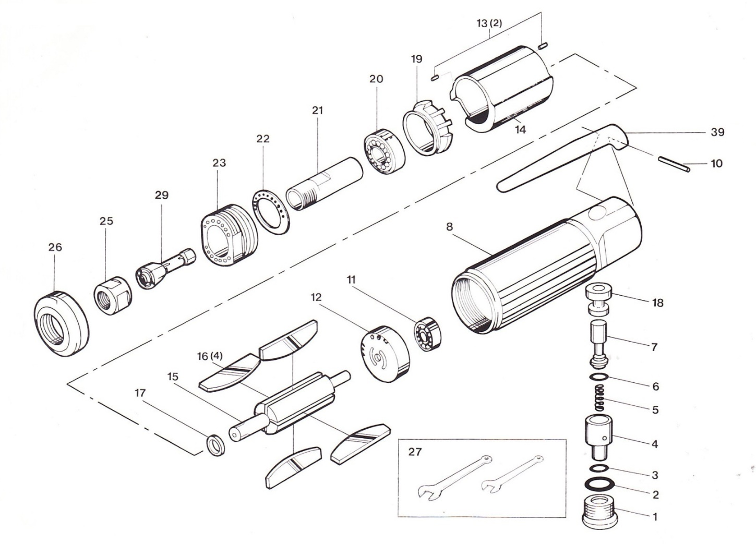

|  |  |  |  |  |  |  |  |
| --- | --- | --- | --- | --- | --- | --- | --- |
| rep | Ref | DESCRIPTION | Qté | rep | Ref | DESCRIPTION | Qté |
| 1 | GP3230M-01 | Ecrou | 1 | 16 | GP3230M-16 | Palette | 4 |
| 2 | GP3230M-02 | Joint | 1 | 17 | GP3230M-17 | Entretoise | 1 |
| 3 | GP3230M-03 | Joint | 1 | 18 | GP3230M-18 | Chemise valve | 1 |
| 4 | GP3230M-04 | Variateur | 1 | 19 | GP3230M-19 | Flasque avant | 1 |
| 5 | GP3230M-05 | Ressort | 1 | 20 | GP3230M-20 | Roulement | 1 |
| 6 | GP3230M-06 | Joint | 1 | 21 | GP3230M-21 | Porte pince | 1 |
| 7 | GP3230M-07 | Valve | 1 | 22 | GP3230M-22 | Silencieux | 1 |
| 8 | GP3230M-08 | Carter machine | 1 | 23 | GP3230M-23 | Ecrou serrage moteur | 1 |
| 10 | GP3230M-10 | Goupille | 1 | 25 | GP3230M-25 | Ecrou serrage | 1 |
| 11 | GP3230M-11 | Roulement | 1 | 26 | GP3230M-26 | Carter protection | 1 |
| 12 | GP3230M-12 | Flasque arrière | 1 | 27 | GP3230M-27 | Clé serrage | 2 |
| 13 | GP3230M-13 | Goupille | 2 | 29 | GPS1021 | Pince 6mm | 1 |
| 14 | GP3230M-14 | Chemise | 1 | 39 | GP3230M-39 | Gâchette de sécurité | 1 |
| 15 | GP3230M-15 | Rotor | 1 |  |  |  |  |