

**GP3222S**

**Meuleuse droite longue**

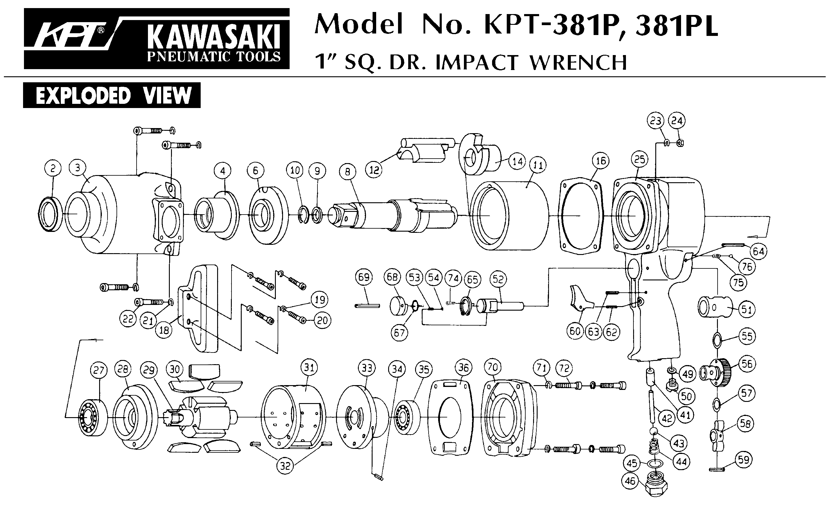





|  |  |  |  |  |  |  |  |
| --- | --- | --- | --- | --- | --- | --- | --- |
| Rep | Référence | Désignation | Qté | Rep | Référence | Désignation | Qté |
| 1 | GP3222S-1 | Ecrou | 1 | 22 | GP3222S-22 | Rotor | 1 |
| 2 | GPS1021 | Pince 6mm | 1 | 23 | GP3222S-23 | Palette | 4 |
| 3 | GP3222S-3 | Porte pince | 1 | 24 | GP3222S-24 | Flasque ARR | 1 |
| 4 | GP3222S-4 | Ecrou arbre | 1 | 25 | EE-3 | Roulement EE3 | 1 |
| 5 | 6001-2RS | Roulement 6001 | 1 | 26 | GP3222S-26 | Corps | 1 |
| 6 | GP3222S-6 | Arbre | 1 | 27 | GP3222S-27 | Gâchette | 1 |
| 7 | EE-3 | Roulement EE-3 | 1 | 28 | GP3222S-28 | Goupille | 1 |
| 8 | GP3222S-8 | Cardan | 2 | 29 | GP3222S-29 | Joint | 1 |
| 9 | GP3222S-9 | Bague | 1 | 30 | GP3222S-30 | Silencieux | 1 |
| 10 | GP3222S-10 | Goupille | 1 | 31 | GP3222S-31 | Clips | 1 |
| 11 | GP3222S-11 | Carter arbre | 1 | 33 | GP3222S-33 | Raccord | 1 |
| 12 | GP3222S-12 | Ecrou | 1 | 34 | GP3222S-34 | Axe gâchette | 1 |
| 13 | GP3222S-13 | Bague fileté | 1 | 35 | GP3222S-35 | Joint | 1 |
| 14 | GP3222S-14 | Joint | 1 | 36 | GP3222S-36 | Ressort | 1 |
| 15 | 6000-2RS | Roulement 6000 | 1 | 37 | GP3222S-37 | Variateur | 1 |
| 16 | GP3222S-16 | Rondelle | 1 | 38 | GP3222S-38 | Joint | 1 |
| 17 | GP3222S-17 | Flasque AV | 1 | 39 | GP3222S-39 | Joint | 1 |
| 18 | GP3222S-18 | Goupille | 2 | 40 | GP3222S-40 | Ecrou | 1 |
| 19 | GP3222S-19 | Goupille | 1 | 41 | GP3222S-41 | Clé de serrage | 2 |
| 20 | GP3222S-20 | Entretoise | 1 |  |  |  |  |
| 21 | GP3222S-21 | Cylindre | 1 |  |  |  |  |