

**GP3220S**

**Meuleuse droite**

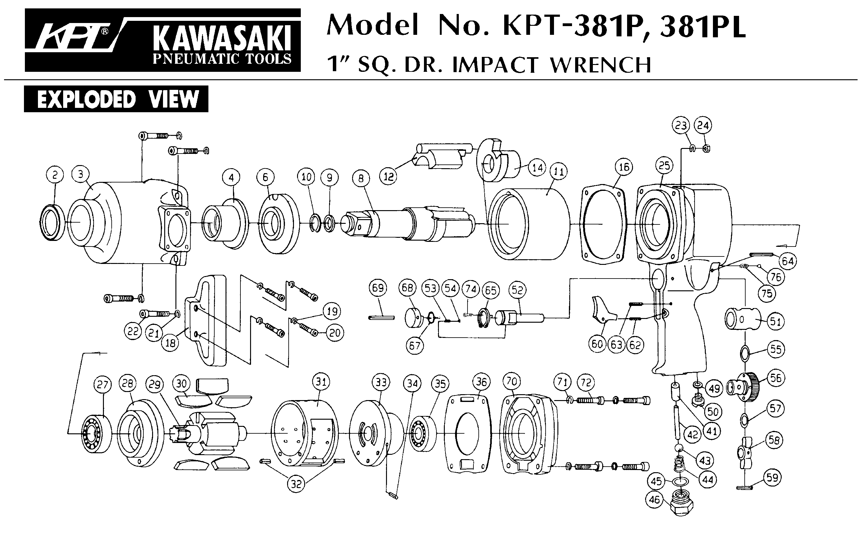



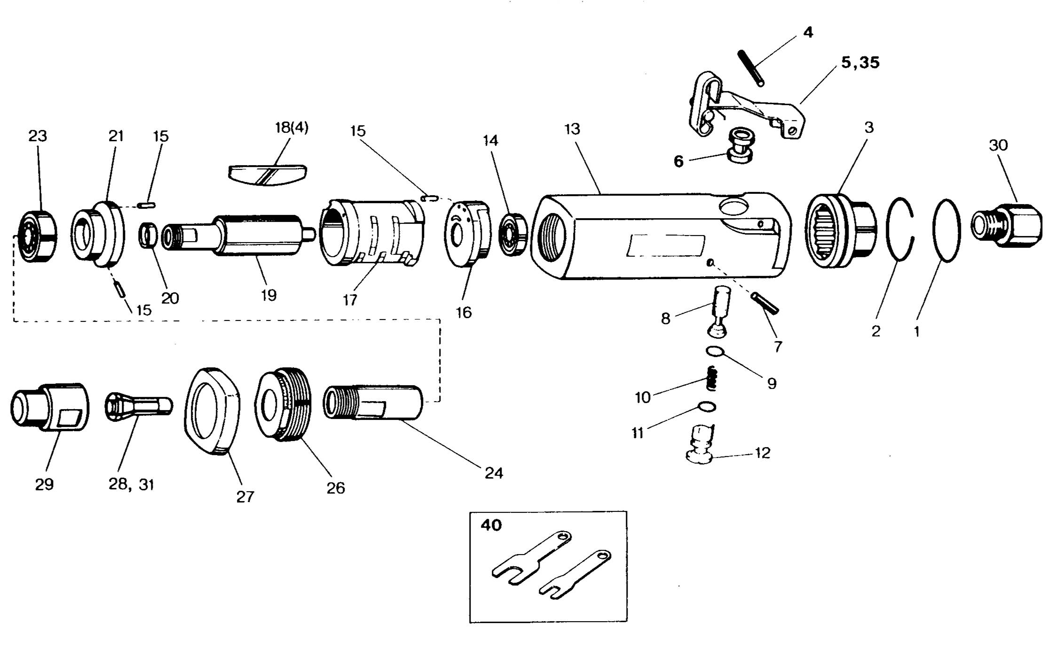



|  |  |  |  |  |  |  |  |
| --- | --- | --- | --- | --- | --- | --- | --- |
| Rep | Ref. | Description | Qté | Rep | Ref | Description | Qté |
| 1 | GP3220S-1 | Joint | 1 | 17 | GP3220S-17 | Chemise | 1 |
| 2 | GP3220S-2 | Clips | 1 | 18 | GP3220S-18 | Palette | 4 |
| 3 | GP3220S-3 | Echappement | 1 | 19 | GP3220S-19 | Rotor | 1 |
| 4 | GP3220S-4 | Goupille | 1 | 20 | GP3220S-20 | Entretoise | 1 |
| 5 | GP3220S-5 | Gâchette | 1 | 21 | GP3220S-21 | Flasque avt | 1 |
| 6 | GP3220S-6 | Chemise | 1 | 23 | 608-2RS | Roulement 608 | 1 |
| 7 | GP3220S-7 | Goupille | 1 | 24 | GP3220S-24 | Arbre | 1 |
| 8 | GP3220S-8 | Axe | 1 | 26 | GP3220S-26 | Ecrou serrage | 1 |
| 9 | GP3220S-9 | Joint | 1 | 27 | GP3220S-27 | Protection | 1 |
| 10 | GP3220S-10 | Ressort | 1 | 28 | GP3220S-28 | Pince 3 mm | 2 |
| 11 | GP3220S-11 | Variateur | 1 | 29 | GP3220S-29 | Ecrou Serrage pince | 1 |
| 13 | GP3220S-13 | Corps (inclus 6) | 2 | 30 | GP3220s-30 | Raccord | 1 |
| 14 | 696-2RS | Roulement 696 | 1 | 31 | GP3220S-31 | Pince 6 mm | 1 |
| 15 | GP3220S-15 | Goupille | 3 | 35 | GP3220S-35 | Gâchette de sécurité | 1 |
| 16 | GP3220S-16 | Flasque Arr | 1 | 40 | GP3220s-40 | Jeu de clé | 1 |

Version 21/02 R2022