

**GP3218A**

**Affleureuse**

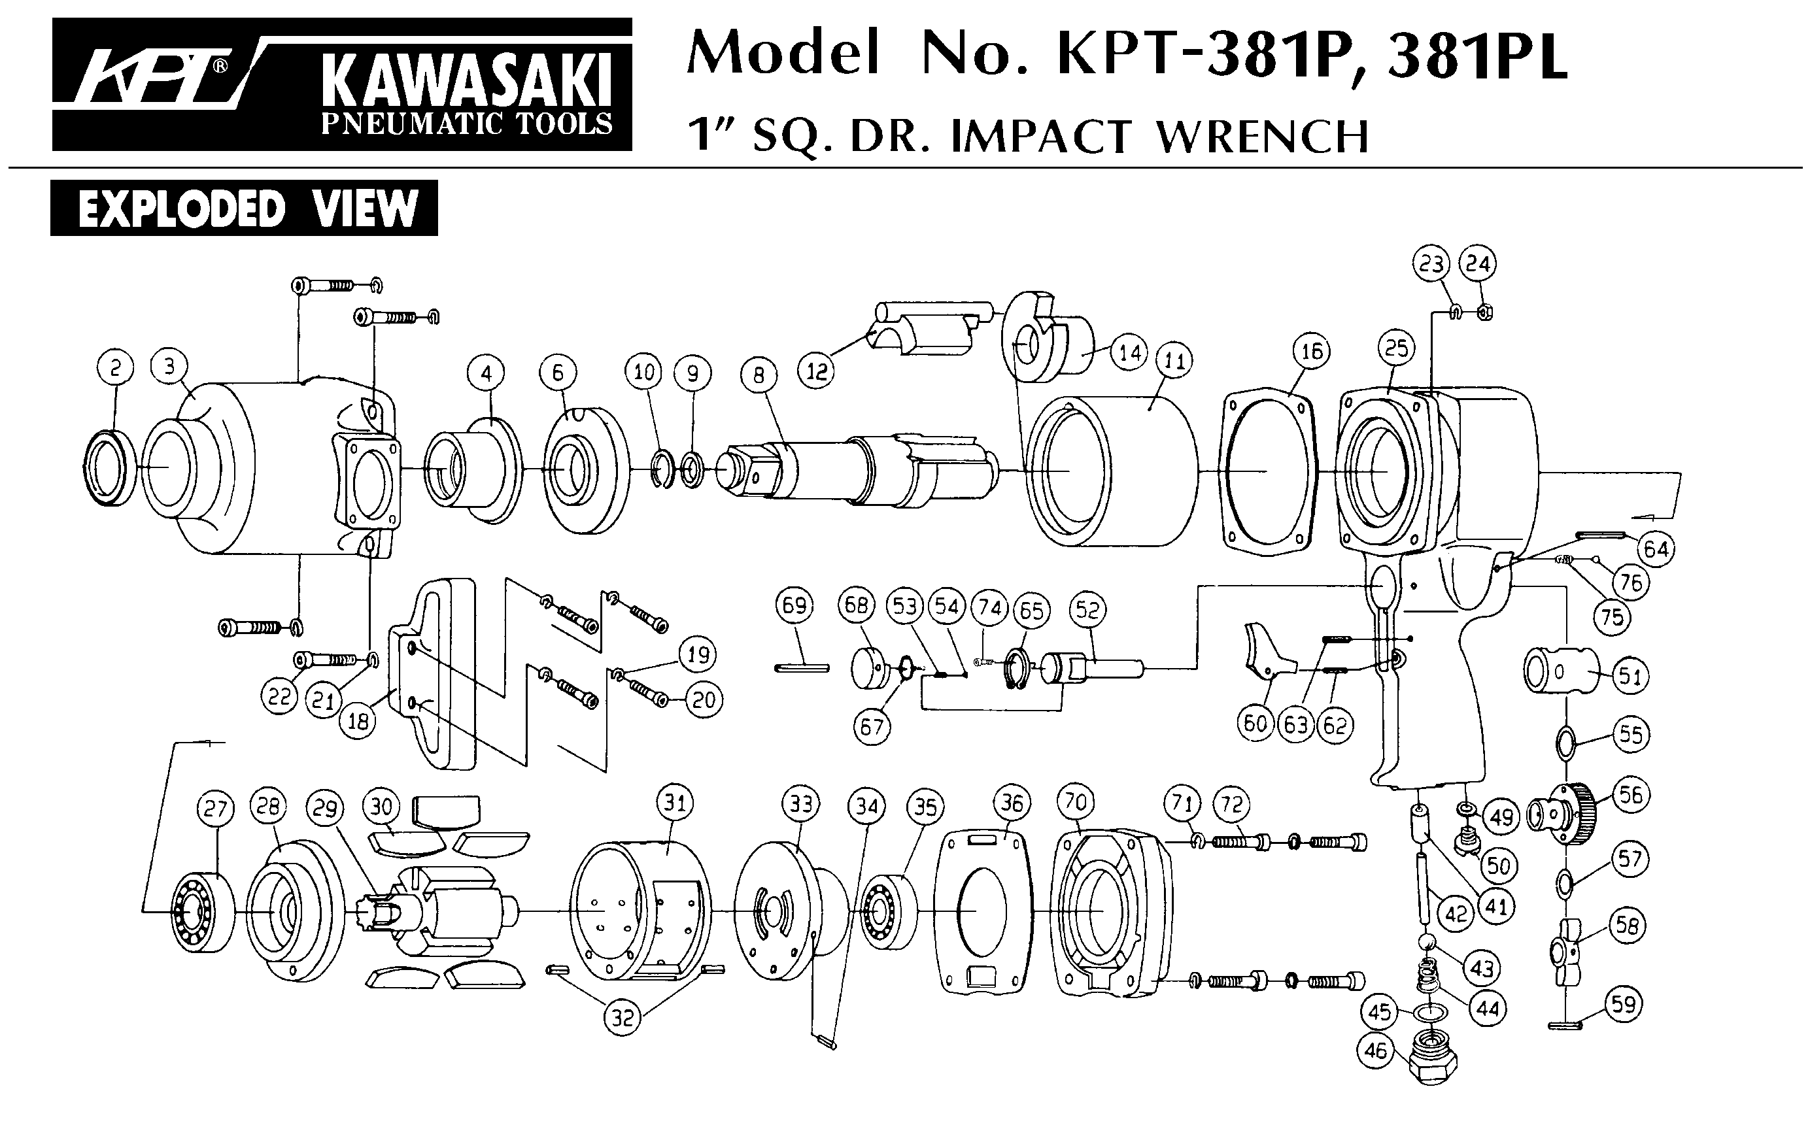





|  |  |  |  |  |  |  |  |
| --- | --- | --- | --- | --- | --- | --- | --- |
| Rep | ref. | Désignation | Qté | Rep | ref. | Désignation | Qté |
| 1 | GP3218A-1 | Ecrou | 1 | 23 | GP3218A-23 | Porte pince | 1 |
| 2 | GP3218A-2 | Joint | 1 | 24 | GP3218A-24 | Rondelle d’échappement | 1 |
| 3 | GP3218A-3 | Joint | 1 | 25 | GP3218A-25 | Ecrou serrage moteur | 1 |
| 4 | GP3218A-4 | Variateur | 1 | 26 | GPS1021 | Pince 6mm | 1 |
| 5 | GP3218A-5 | Ressort | 1 | 27 | GP3218A-27 | Ecrou de pince | 1 |
| 6 | GP3218A-6 | Joint | 1 | 28 | GP3218A-28 | Porte guide | 1 |
| 7 | GP3218A-7 | Axe valve | 1 | 29 | GP3218A-29 | Vis | 1 |
| 8 | GP3218A-8 | Chemise valve | 1 | 30 | GP3218A-30 | Goupille | 1 |
| 9 | GP3218A-9 | Gâchette | 1 | 32 | GP3218A-32 | Ecrou | 9 |
| 10 | GP3218A-10 | Goupille | 1 | 33 | GP3218A-33 | Vis | 2 |
| 11 | GP3218A-11 | Raccord | 1 | 24 | GP3218A-34 | Goupille | 1 |
| 12 | GP3218A-12 | Corps | 1 | 35 | GP3218A-35 | Vis | 2 |
| 13 | 626-2RS | Roulement 626 | 2 | 36 | GP3218A-36 | Vis | 1 |
| 14 | GP3218A-14 | Flasque AR | 6 | 37 | GP3218A-37 | Rondelle | 1 |
| 15 | GP3218A-15 | Palette | 1 | 38 | R3 | Roulement R3 12.7X4.97X4.76 | 1 |
| 16 | GP3218A-16 | Rotor | 1 | 39 | GP3218A-39 | Guide | 1 |
| 17 | GP3218A-17 | Entretoise | 1 | 40 | GP3218A-40 | Molette de réglage | 1 |
| 18 | GP3218A-18 | Goupille | 1 | 41 | GP3218A-41 | Rondelle | 1 |
| 19 | GP3218A-19 | Chemise | 2 | 45 | GP3218A-45 | Guide | 1 |
| 20 | GP3218A-20 | Flasque AV | 1 | 46 | GP3218A-46 | Clé plate | 1 |
| 21 | GP3218A-21 | Rondelle de calage | 4 | 47 | GP3218A-47 | Clé Allen | 1 |
| 22 | 6000-2RS | Roulement 6000 | 1 |  |  |  |  |