

**GP3200**

**Meuleuse droite**

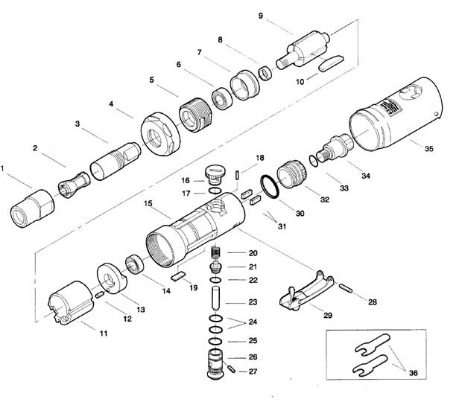

|  |  |  |  |  |  |  |  |
| --- | --- | --- | --- | --- | --- | --- | --- |
| Rep | Réf Art | DESCRIPTION | Qté | Rep | Réf Art | DESCRIPTION | Qté |
| 1 | GP3200-1 | Ecrou | 1 | 19 | GP3200-19 | Buté | 1 |
| 2 | GP3200-2 | Pince 6mm | 1 | 20 | GP3200-20 | Ressort | 1 |
| 3 | GP3200-3 | Guide | 1 | 21 | GP3200-21 | Valve | 1 |
| 4 | GP3200-4 | Carter de protection | 1 | 22 | GP3200-22 | Joint | 1 |
| 5 | GP3200-5 | Bague de serrage | 1 | 23 | GP3200-23 | Axe | 1 |
| 6 | 608-2RS | Roulement 608 | 1 | 24 | GP3200-24 | Joint | 1 |
| 7 | GP3200-7 | Flasque avt | 1 | 25 | GP3200-25 | Joint | 1 |
| 8 | GP3200-8 | Entretoise | 1 | 26 | GP3200-26 | Chemise variateur | 1 |
| 9 | GP3200-9 | Rotor | 1 | 27 | GP3200-27 | Goupille | 1 |
| 10 | GP3200-10 | Palette | 4 | 28 | GP3200-28 | Goupille | 1 |
| 11 | GP3200-11 | Chemise | 1 | 29 | GP3200-29 | Gâchette | 1 |
| 12 | GP3200-12 | Goupille | 1 | 30 | GP3200-30 | Joint | 1 |
| 13 | GP3200-13 | Flasque arr | 1 | 31 | GP3200-31 | Patte | 1 |
| 14 | 696-2RS | Roulement 696 | 1 | 32 | GP3200-32 | Entretoise | 1 |
| 15 | GP3200-15 | Corps | 1 | 33 | GP3200-33 | Joint | 1 |
| 16 | GP3200-16 | Variateur | 1 | 34 | GP3200-34 | Raccord | 1 |
| 17 | GP3200-17 | Joint | 1 | 35 | GP3200-35 | Enveloppe protection | 1 |
| 18 | GP3200-18 | Gaine de protection corps | 1 | 36 | GP3200-36 | Jeu de clé | 1 |

