

**GP3130**

**Meuleuse droite**

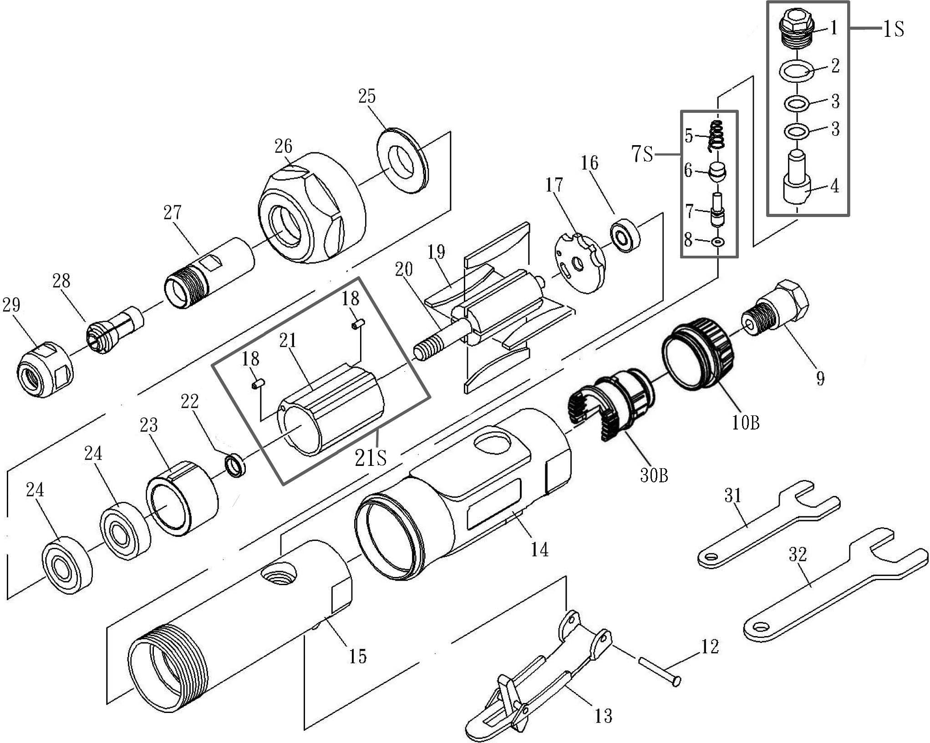

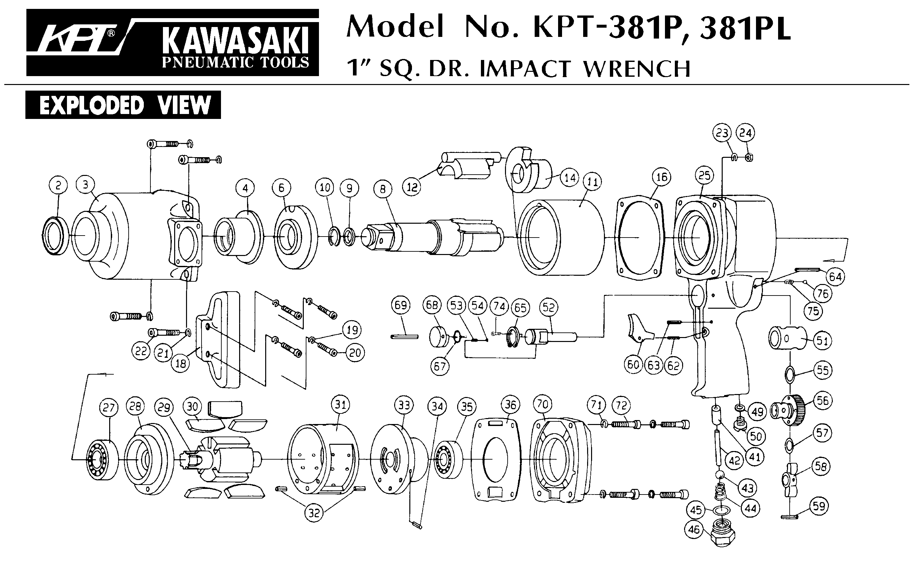





|  |  |  |  |  |  |  |  |
| --- | --- | --- | --- | --- | --- | --- | --- |
| **rep** | **ref** | **Description** | **qte** | **rep** | **ref** | **Description** | **qte** |
| 01 | GP3130-01S | Ensemble régulateur 1/2/3/4 | 1 | 17 | GP3130-17 | Flasque arrière | 1 |
| 02 | 1 | 19 | GP3130-19 | Palette | 4 |
| 03 | 2 | 20 | GP3130-20 | Rotor | 1 |
| 04 | 1 | 18 | GP3130-21S | Chemise ass18/21 | 2 |
| 05 | GP3130-7S | Ensemble valve arrivé air 5/6/7/8 | 1 | 21 | 1 |
| 06 | 1 | 22 | GP3130-23 | Rondelle | 1 |
| 07 | 1 | 23 | GP3130-24 | Flasque Avant | 1 |
| 08 | 1 | 24 | 608-2RS | Roulement (608zz) | 2 |
| 09 | GP3130-09 | Raccord | 1 | 25 | GP3130-26 | Rondelle | 1 |
| 10 | GP3130-10B | Echappement 2022 | 1 | 26 | GP3130-27 | Ecrou | 1 |
| 12 | GP3130-12 | Goupille | 1 | 27 | GP3130-28 | Porte pince | 1 |
| 13 | GP3130-13 | Gâchette Sécurité | 1 | 28 | GPS1021 | Pince | 1 |
| 14 | GP3130-14 | Protection | 1 | 29 | GP3130-29 | Ecrou pince | 1 |
| 15 | GP3130-15 | Carter moteur | 1 | 30B | GP3130-30B | Filtre silencieux 2022 | 1 |
| 16 | 696-2RS | Roulement (696zz) | 1 | 31 | GP3130-35 | Clé 14mm | 1 |
|  |  |  | 1 | 32 | GP3130-36 | Clé 19mm | 1 |

Version 21/02 R2022