

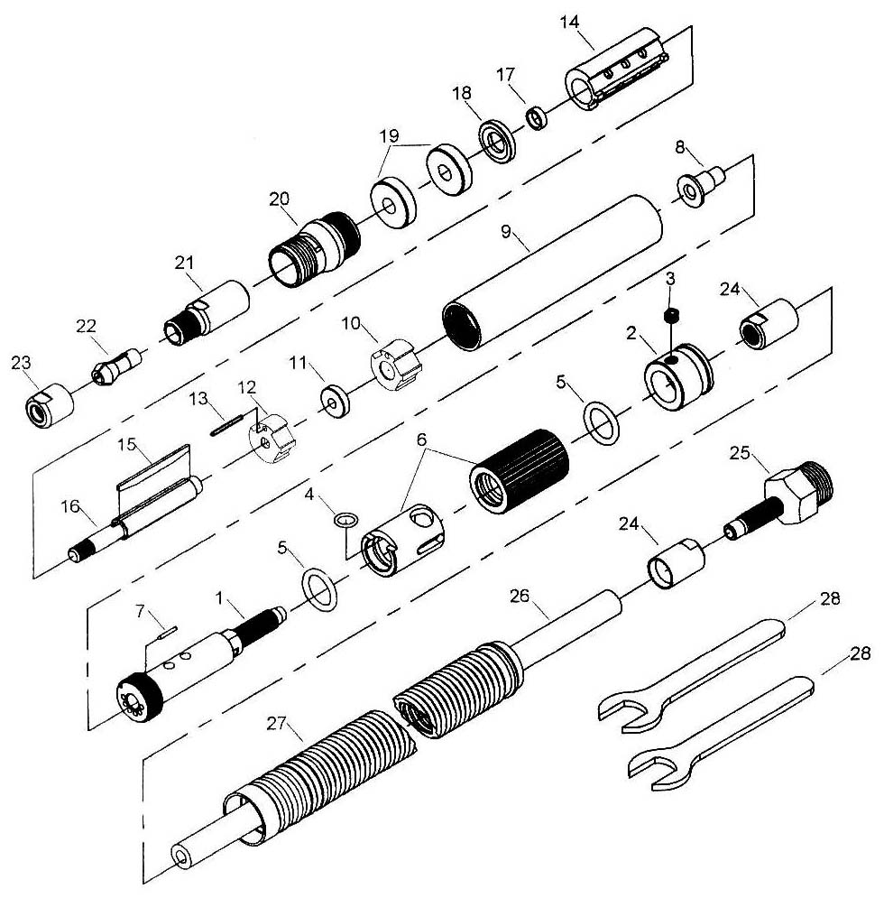

**GP3110**

**MICRO MEULEUSE**

**54 000 tr/min**

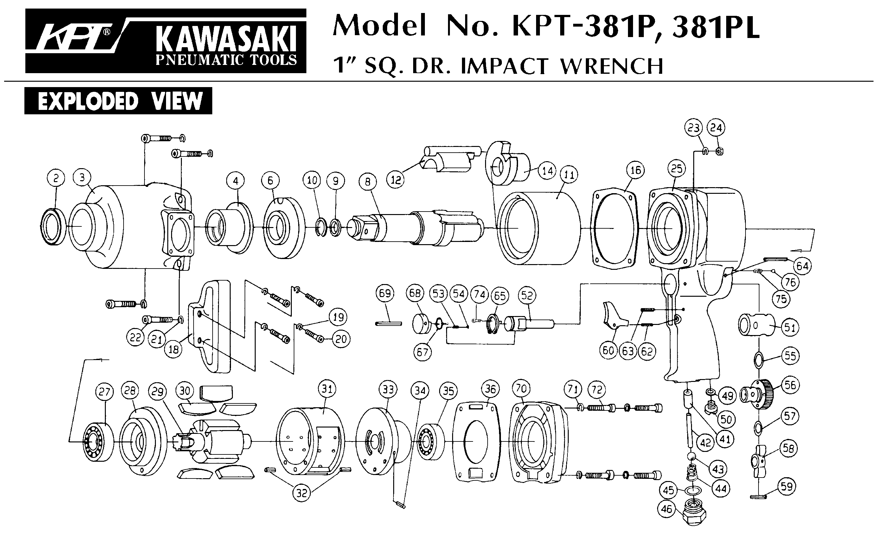





|  |  |  |  |  |  |  |  |
| --- | --- | --- | --- | --- | --- | --- | --- |
| Rep | Réf Art | DESCRIPTION | Qté | Rep | Réf Art | DESCRIPTION | Qté |
| 1 | GP3110-01 | Corps régulateur | 1 | 15 | GP3110-15 | Palette | 3 |
| 2 | GP3110-02 | Bague | 1 | 16 | GP3110-16 | Rotor | 1 |
| 3 | GP3110-03 | Vis | 1 | 17 | GP3110-17 | Rondelle | 1 |
| 4 | GP3110-04 | Joint | 1 | 18 | GP3110-18 | Flasque avt | 1 |
| 5 | GP3110-05 | Joint | 2 | 19 | 695-2RS | Roulement 695 | 2 |
| 6 | GP3110-06 | Régulateur | 1 | 20 | GP3110-20 | Ecrou moteur | 1 |
| 7 | GP3110-07 | Goupille | 1 | 20A | GP3110-21 | Porte pince | 1 |
| 8 | GP3110-08 | Entretoise | 1 | 22 | GP3110-22 | Pince | 1 |
| 9 | GP3110-09 | Corps | 1 | 23 | GP3110-23 | Ecrou pince | 1 |
| 10 | GP3110-10 | Cage roulement | 1 | 24 | GP3110-24 | Ecrou | 2 |
| 11 | 693-2RS | Roulement 693 | 1 | 25 | GP3110-25 | Insert | 1 |
| 12 | GP3110-12 | Flasque AR | 1 | 26 | GP3110-26 | Tuyau | 1 |
| 13 | GP3110-13 | Axe | 1 | 27 | GP3110-27 | Gaine silencieux | 1 |
| 14 | GP3110-14 | Chemise | 1 | 28 | GP3110-28 | Clé | 2 |

**Manche Atlantique Equipements** -27 parc d’activité du Chalet - 22250 BroonsTél 02 96 84 65 59 - Fax 02 96 84 77 75

**WWW.MAE-FR.COM**