

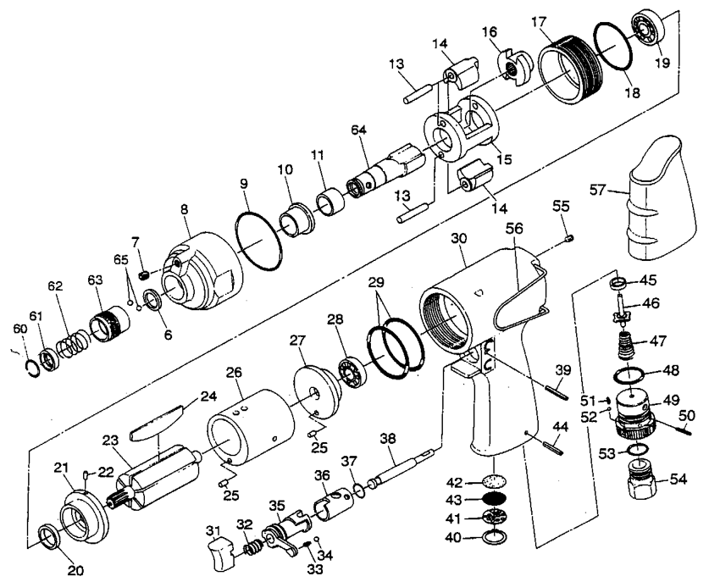

**GP2950**

**Visseuse à chocs**

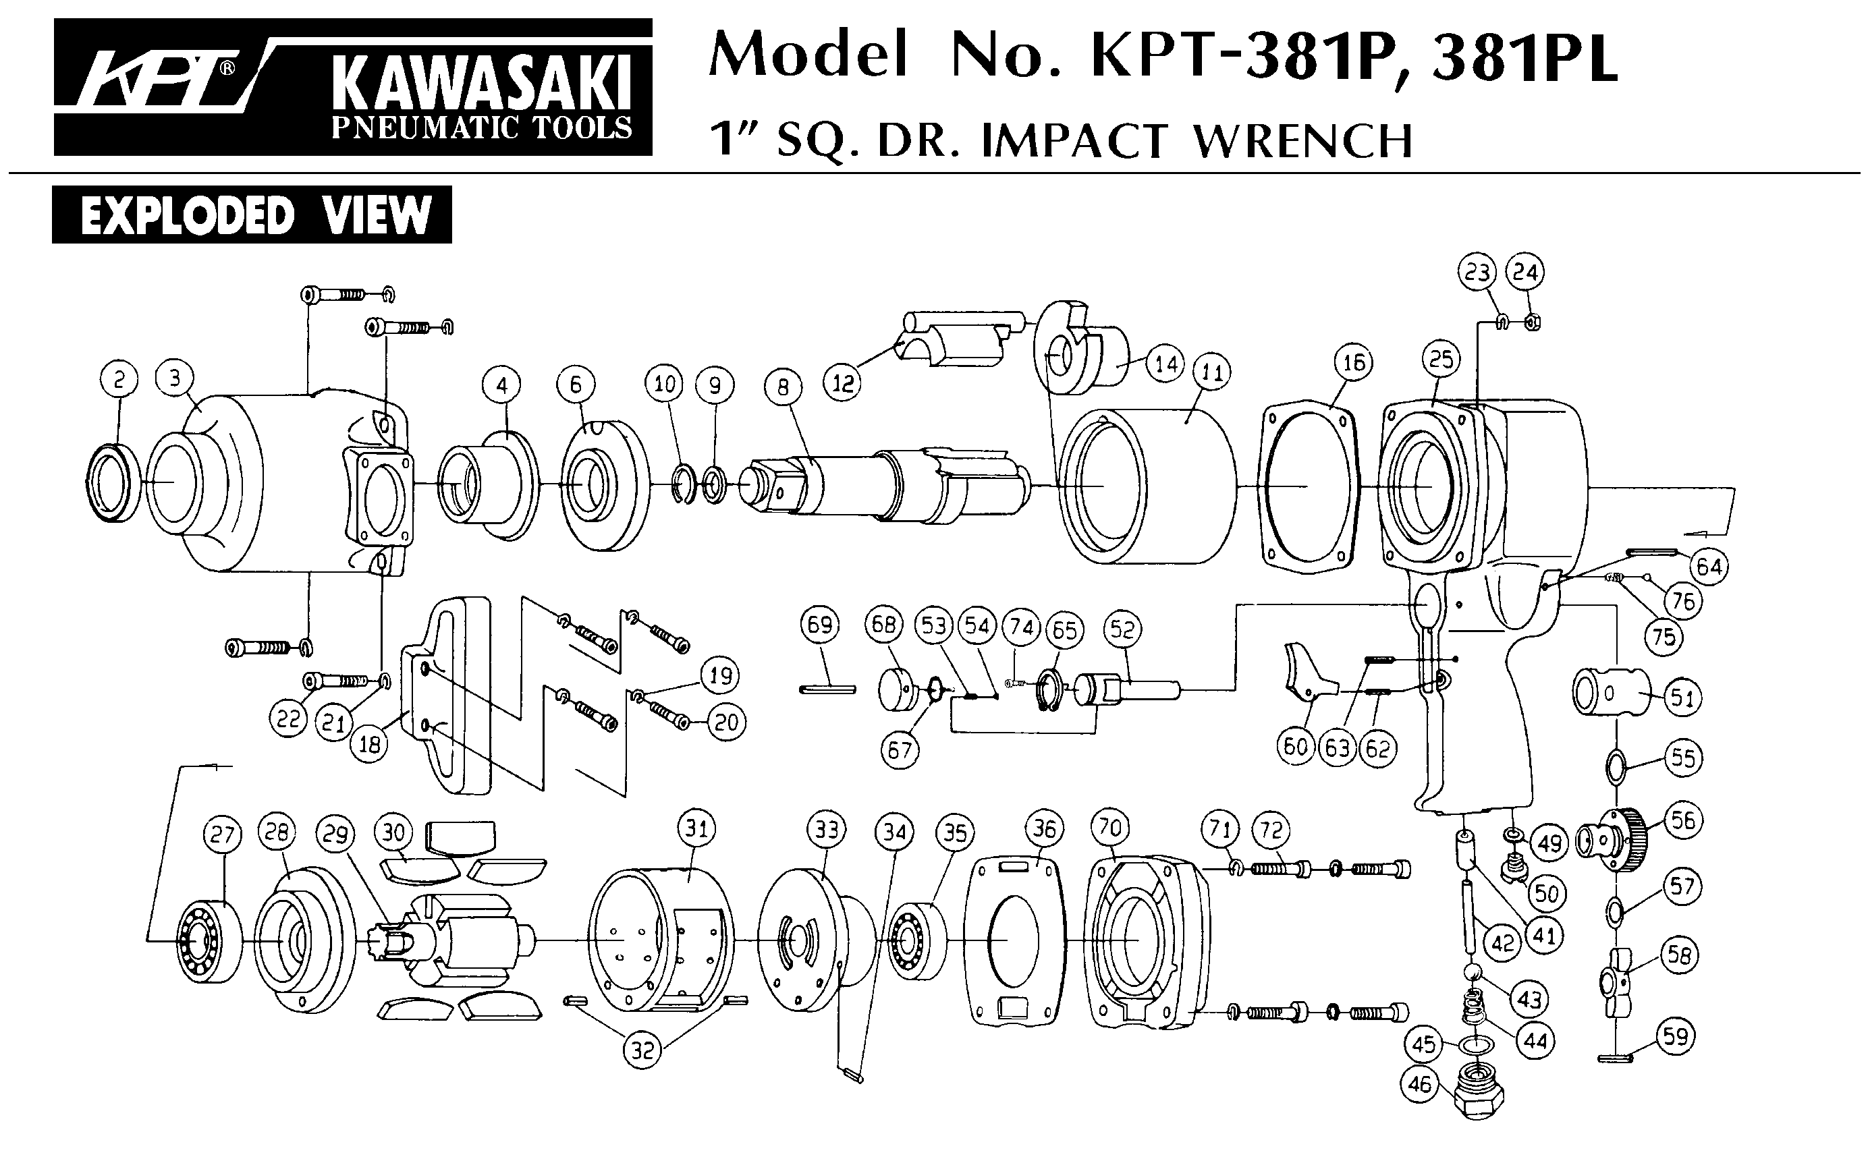





|  |  |  |  |  |  |  |  |
| --- | --- | --- | --- | --- | --- | --- | --- |
| Rep | réf art | Description | Qté | Rep | réf art | Description | Qté |
| 6 | GP2950-06 | Joint spi | 1 | 36 | GP2950-36 | Chemise inverseur | 1 |
| 7 | GP2950-07 | Vis | 1 | 37 | GP2950-37 | Joint | 1 |
| 8 | GP2950-08 | Cloche | 1 | 38 | GP2950-38 | Axe gâchette | 1 |
| 9 | GP2950-09 | Joint | 1 | 39 | GP2950-39 | Goupille | 1 |
| 10 | GP2950-10 | Entretoise | 1 | 40 | GP2950-40 | Clips | 1 |
| 11 | GP2950-11 | Entretoise | 1 | 41 | GP2950-41 | Grille silencieux | 1 |
| 13 | GP2950-13 | Axe marteau | 2 | 42 | GP2950-42 | Filtre | 1 |
| 14 | GP2950-14 | Marteau | 2 | 43 | GP2950-43 | Clips | 1 |
| 15 | GP2950-15 | Cage de frappe | 1 | 44 | Gp2950-44 | Goupille | 1 |
| 16 | GP2950-16 | Came | 1 | 45 | GP2950-45 | Joint | 1 |
| 17 | GP2950-17 | Jonction fileté | 1 | 46 | GP2950-46 | Valve | 1 |
| 18 | GP2950-18 | Joint | 4 | 47 | GP2950-47 | Ressort | 1 |
| 19 | R6 | Roulement R6 9.5x22.2x5.6 | 1 | 48 | GP2950-48 | Joint | 1 |
| 20 | GP2950-20 | Joint | 1 | 49 | GP2950-49 | Variateur | 1 |
| 21 | GP2950-21 | Flasque avt | 1 | 50 | GP2950-50 | Goupille | 1 |
| 22 | GP2950-22 | Goupille | 1 | 51 | GP2950-51 | Ressort | 1 |
| 23 | GP2950-23 | Rotor | 1 | 52 | GP2950-52 | Bille | 1 |
| 24 | GP2950-24 | Palette | 6 | 53 | GP2950-53 | Joint | 1 |
| 25 | GP2950-25 | Goupille | 2 | 54 | GP2950-54 | Raccord | 1 |
| 26 | GP2950-26 | Chemise | 1 | 55 | GP2950-55 | Vis | 1 |
| 27 | GP2950-27 | Flasque arr | 1 | 56 | GP2950-56 | Crochet suspension | 1 |
| 28 | 626-2RS | Roulement 626 | 1 | 57 | GP2950-57 | Gaine | 1 |
| 29 | GP2950-29 | Joint | 2 | 60 | GP2950-60 | Clips | 1 |
| 30 | GP2950-30 | Corp | 1 | 61 | GP2950-61 | Rondelle | 1 |
| 31 | GP2950-31 | Gâchette | 1 | 62 | GP2950-62 | Ressort | 1 |
| 32 | GP2950-32 | Ressort | 1 | 63 | GP2950-63 | Douille | 1 |
| 33 | GP2950-33 | Ressort | 1 | 64 | GP2950-64 | Arbre porte embout | 1 |
| 34 | GP2950-34 | Bille | 1 | 65 | GP2950-65 | Bille | 2 |
| 35 | GP2950-35 | Inverseur | 1 |  |  |  |  |