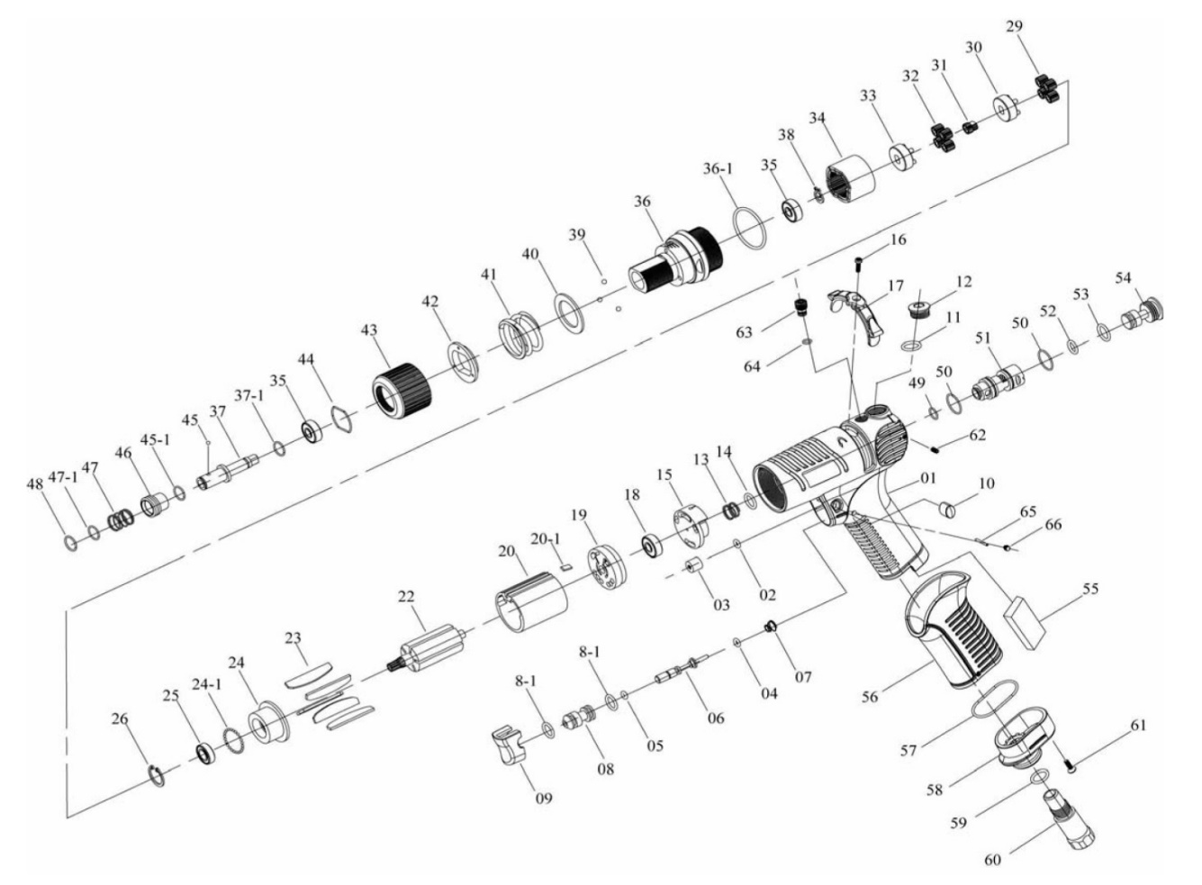

**GP2858**

**Visseuse a réglage**

**Externe**

|  |  |  |  |  |  |  |  |
| --- | --- | --- | --- | --- | --- | --- | --- |
| Réf. | Rep | Désignation | Qté | Réf. | Rep | Désignation | Qté |
| GP2858-1 | 1 | Corps | 1 | GP2858KITE | 35 | Roulement | 2 |
| GP2858-2 | 2 | Joint | 1 | 36-1 | Joint | 1 |
| GP2858-3 | 3 | Bouchon | 1 | 37-1 | Rondelle | 2 |
| GP2858KITA | 4 | Joint | 1 | 39 | Bille | 3 |
| 5 | Joint | 1 | 40 | Rondelle | 1 |
| 6 | Axe | 1 | 41 | Ressort | 1 |
| 7 | Ressort | 1 | 42 | Rondelle réglage | 1 |
| 8 | Chambre axe gâchette | 1 | 44 | Circlips | 1 |
| 8-1 | Joint | 2 | GP2858-36 | 36 | Support friction | 1 |
| 9 | Gâchette | 1 | GP2858-37 | 37 | Porte embout | 1 |
| GP2858-10 | 10 | Bouchon | 2 | GP2858-43 | 43 | Bague réglage | 1 |
| GP2858-11 | 11 | Joint | 1 | GP2858KITF | 45 | Bille | 1 |
| GP2858-12 | 12 | Vis | 1 | 45-1 | Rondelle | 1 |
| GP2858-13 | 13 | Ressort | 1 | 46 | Entretoise | 1 |
| GP2858-14 | 14 | Joint | 1 | 47 | Ressort | 1 |
| GP2858-15 | 15 | Valve | 1 | 47-1 | Rondelle | 1 |
| GP2858-16 | 16 | Vis | 1 | 48 | Circlips | 1 |
| GP2858-17 | 17 | Inverseur | 1 | GP2858-49 | 49 | Joint | 1 |
| GP2858KITB | 18 | Roulement | 1 | GP2858-50 | 50 | Joint | 2 |
| 23 | Palette | 6 | GP2858-51 | 51 | Chambre alimentation | 1 |
| 25 | Roulement | 1 | GP2858-52 | 52 | Joint | 1 |
| GP2858KITC | 19 | Flasque Arr | 1 | GP2858-53 | 53 | Joint | 1 |
| 20 | Chemise | 1 | GP2858-54 | 54 | Vis | 1 |
| 20-1 | Clavette | 1 | GP2858-55 | 55 | Mousse | 1 |
| 22 | Rotor | 1 | GP2858-56 | 56 | Gaine poignée | 1 |
| 24 | Flasque Avt | 1 | GP2858-57 | 57 | Joint | 1 |
| GP2858-26 | 26 | Circlips | 1 | GP2858-58 | 58 | Déflecteur | 1 |
| GP2858KITD | 24-1 | Bille | 36 | GP2858-59 | 59 | Joint | 1 |
| 29 | Satellite | 4 | GP2858-60 | 60 | Raccord | 1 |
| 30 | Porte satellite | 1 | GP2858-61 | 61 | Vis | 1 |
| 31 | Pignon | 1 | GP2858-62 | 62 | Vis | 2 |
| 32 | Satellite | 4 | GP2858-63 | 63 | Vis | 1 |
| 33 | Porte satellite | 1 | GP2858-64 | 64 | Joint | 1 |
| 34 | Couronne | 1 | GP2858-65 | 65 | Goupille | 1 |
| 38 | Circlips | 1 |  |  |  |  |