

**GP2510**

**Visseuse 800 tr/min**

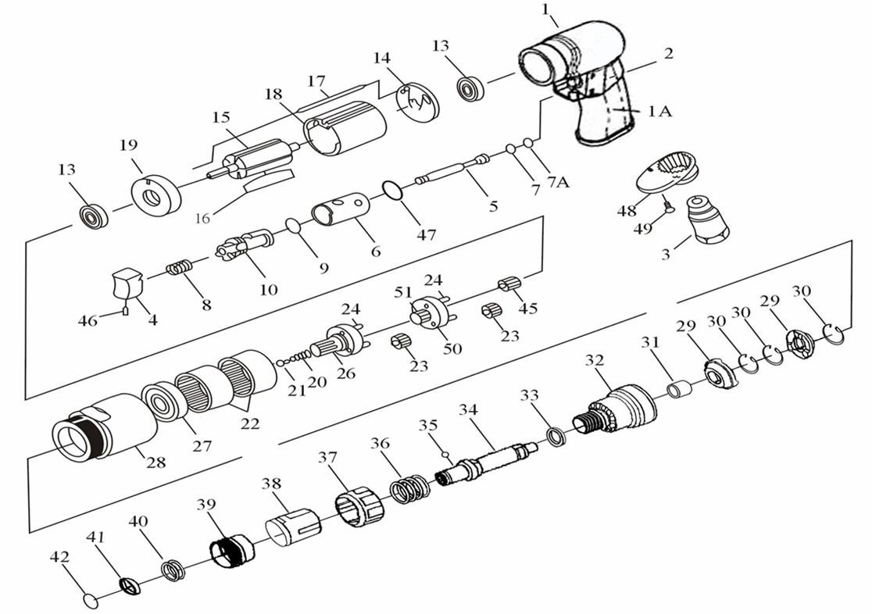

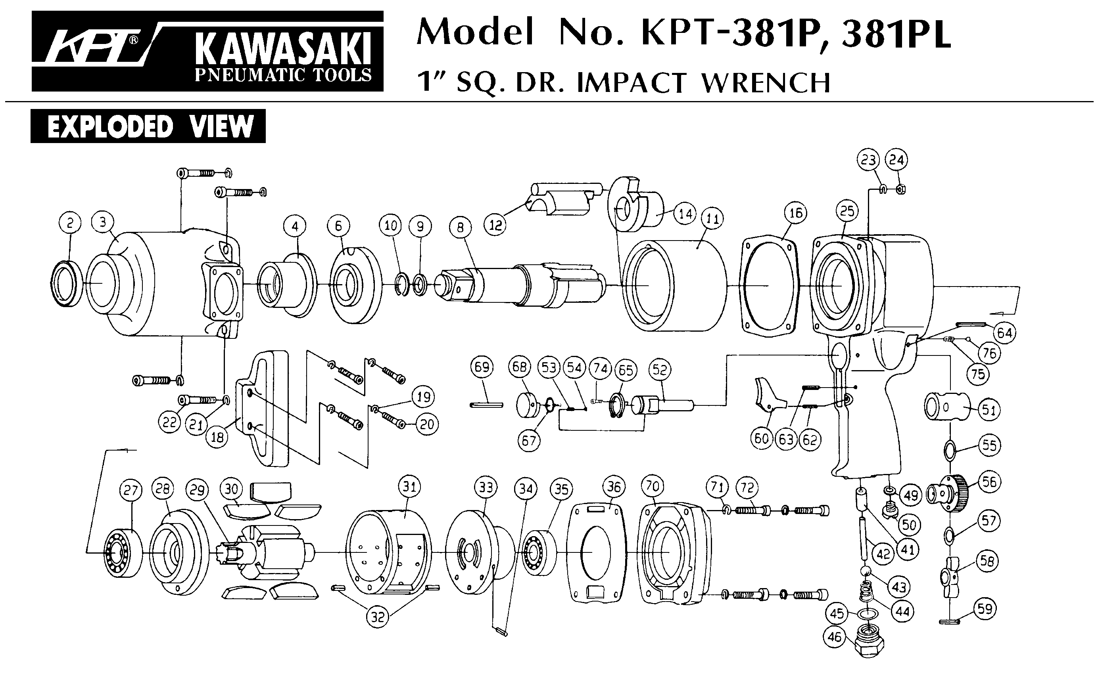





|  |  |  |  |  |  |  |  |
| --- | --- | --- | --- | --- | --- | --- | --- |
| Rep | Réf Art | DESCRIPTION | Qté | Rep | Réf Art | DESCRIPTION | Qté |
| 1 | GP2510-01 | Corps | 1 | 26 | GP2510-26 | Porte satellite | 1 |
| 1A | GP2510-01A | Grip | 1 | 27 | 6201-2RS | Roulement 6201 | 1 |
| 2 | GP2510-02 | Goupille | 1 | 28 | GP2510-28 | Ecrou serrage moteur | 1 |
| 3 | GP2510-03 | Raccord | 1 | 29 | GP2510-29 | Clabot | 2 |
| 4 | GP2510-04 | Gâchette | 1 | 30 | GP2510-30 | Clips | 3 |
| 5 | GP2510-05 | Axe gâchette | 1 | 31 | GP2510-31 | Entretoise | 1 |
| 6 | GP2510-06 | Chemise inverseur | 1 | 32 | GP2510-32 | Carter système embrayage | 1 |
| 7 | GP2510-07 | Joint | 1 | 33 | GP2510-33 | Entretoise | 1 |
| 7A | GP2510-7A | Joint | 1 | 34 | GP2510-34 | Porte embout | 1 |
| 8 | GP2510-08 | Ressort | 1 | 35 | GP2510-35 | Bille | 1 |
| 9 | GP2510-09 | Joint | 1 | 36 | GP2510-36 | Ressort | 1 |
| 10 | GP2510-10 | Inverseur | 1 | 37 | GP2510-37 | Bague de réglage | 1 |
| 13 | 626-2RS | Roulement 626 | 2 | 38 | GP2510-38 | Carter | 1 |
| 14 | GP2510-14 | Flasque arr | 1 | 39 | GP2510-39 | Verrou porte embout | 1 |
| 15 | GP2510-15 | Rotor | 1 | 40 | GP2510-40 | Ressort | 1 |
| 16 | GP2510-16 | Palette | 5 | 41 | GP2510-41 | Rondelle | 1 |
| 18 | GP2510-18 | Chemise | 1 | 42 | GP2510-42 | Clips | 1 |
| 17 | GP2510-17 | Axe chemise | 1 | 45 | GP2510-45 | Pignon | 1 |
| 19 | GP2510-19 | Flasque avt | 1 | 46 | GP2510-46 | Vis | 1 |
| 20 | GP2510-20 | Ressort | 1 | 47 | GP2510-47 | Joint | 1 |
| 21 | GP2510-21 | Guide ressort | 1 | 48 | GP2510-48 | Silencieux | 1 |
| 22 | GP2510-22 | Couronne | 2 | 49 | GP2510-49 | Vis | 2 |
| 23 | GP2510-23 | Satellite | 6 | 50 | GP2510-50 | Porte satellite | 1 |
| 24 | GP2510-24 | Axe satellite | 6 | 51 | GP2510-51 | Pignon | 1 |

**Manche Atlantique Equipements** -27 parc d’activité du Chalet - 22250 BroonsTél 02 96 84 65 59 - Fax 02 96 84 77 75

**WWW.MAE-FR.COM**