

**GP2324A**

**Perceuse réversible**

**13mm**

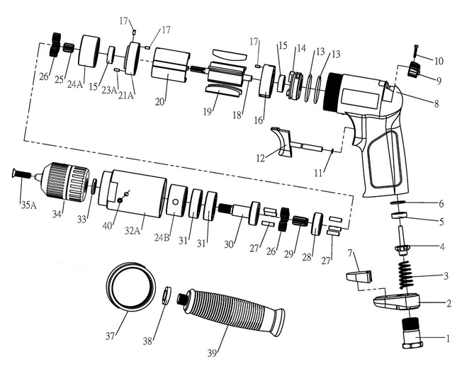

|  |  |  |  |  |  |  |  |  |
| --- | --- | --- | --- | --- | --- | --- | --- | --- |
| **No.** | **Parts No.** | **Description** | **Q'ty** |  | **No.** | **Parts No.** | **Description** | **Q'ty** |
| 1 | GP2324-01 | Raccord | 1 |  | 21A | GP2324-21A | Flasque Avt | 1 |
| 2 | GP2324-02 | Déflecteur | 1 |  | 23A | GP2324-23A | Goupille | 1 |
| 3 | GP2324-03 | Ressort | 1 |  | 24A | GP2324-24A | Couronne | 1 |
| 4 | GP2324-04 | Valve | 1 |  | 24B | GP2324-24B | Couronne | 1 |
| 5 | GP2324-05 | Joint valve | 1 |  | 25 | GP2324-25 | Pignon entretoise | 1 |
| 6 | GP2324-06 | Rondelle | 1 |  | 26 | GP2324-26 | Satellite | 6 |
| 7 | GP2324-07 | Silencieux | 1 |  | 27 | GP2324-27 | Axe satellite | 6 |
| 8 | GP2324-08 | Corps composite | 1 |  | 28 | GP2324-28 | Rondelle de réduction | 1 |
| 9 | GP2324-09 | Bouton inverseur | 1 |  | 29 | GP2324-29 | Pignon de réduction | 1 |
| 10 | GP2324-10 | Vis | 1 |  | 30 | GP2324-30 | Porte satellite | 1 |
| 11 | GP2324-11 | Joint (27x2) | 2 |  | 31 | 6201-2RS | Roulement 6201 | 2 |
| 12 | GP2324-12 | Gâchette | 1 |  | 32A | GP2324-32A | Carter avt | 1 |
| 13 | GP2324-13 | Joint | 2 |  | 33 | GP2324-33 | Entretoise | 1 |
| 14 | GP2324-14 | Inverseur | 1 |  | 34 | GP2324-34 | Mandrin auto-serrant | 1 |
| 15 | 626-2RS | Roulement 626 | 2 |  | 35 | GP2324-35 | Vis | 1 |
| 16 | GP2324-16 | Flasque Arr | 1 |  | 37 | GP2324-37 | Anneau | 1 |
| 17 | GP2324-17 | Goupille | 3 |  | 38 | GP2324-38 | Rondelle | 1 |
| 18 | GP2324-18 | Rotor | 1 |  | 39 | GP2324-39 | Poignée | 1 |
| 19 | GP2324-19 | Palette | 5 |  | 40 | GP2324-40 | Vis | 1 |
| 20 | GP2324-20 | Cylindre | 1 |  |  |  |  |  |

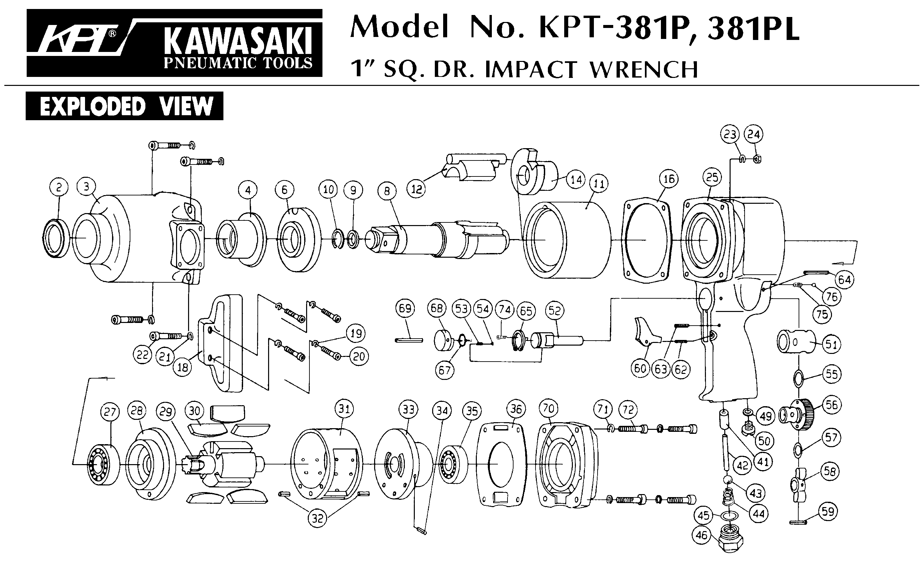 REV-01/22