

**GP2306A**

**Perceuse réversible**

**10 mm**

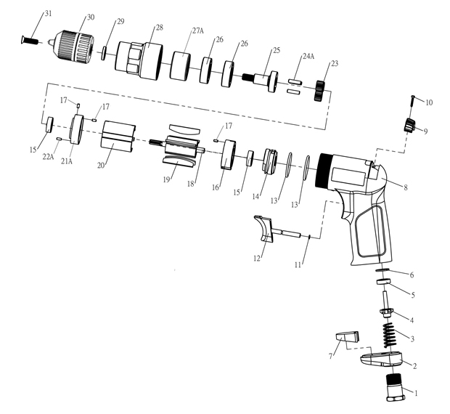

|  |  |  |  |  |  |  |  |  |
| --- | --- | --- | --- | --- | --- | --- | --- | --- |
| **No.** | **Parts No.** | **Description** | **Q'ty** |  | **No.** | **Parts No.** | **Description** | **Q'ty** |
| 1 | GP2306-01 | Raccord | 1 |  | 17 | GP2306-17 | Goupille | 3 |
| 2 | GP2306-02 | Déflecteur | 1 |  | 18 | GP2306-18 | Rotor | 1 |
| 3 | GP2306-03 | Ressort | 1 |  | 19 | GP2306-19 | Palette | 5 |
| 4 | GP2306-04 | Valve | 1 |  | 20 | GP2306-20 | Cylindrer | 1 |
| 5 | GP2306-05 | Joint valve | 1 |  | 21A | GP2306-21A | Flasque Avt | 1 |
| 6 | GP2306-06 | Rondelle | 1 |  | 22A | GP2306-22A | Goupille | 1 |
| 7 | GP2306-07 | Silencieux | 1 |  | 23 | GP2306-23 | Satellite | 3 |
| 8 | GP2306-08 | Corps composite | 1 |  | 24A | GP2306-24A | Axe satellite | 3 |
| 9 | GP2306-09 | Bouton inverseur | 1 |  | 25 | GP2306-25 | Porte satellite | 1 |
| 10 | GP2306-10 | Vis | 1 |  | 26 | 6201-2RS | Roulement 6201 | 2 |
| 11 | GP2306-11 | Joint (27x2) | 2 |  | 27A | GP2306-27A | Couronne | 1 |
| 12 | GP2306-12 | Gâchette | 1 |  | 28 | GP2306-28 | Carter de serrage | 1 |
| 13 | GP2306-13 | Joint | 2 |  | 29 | GP2306-29 | Entretoise | 1 |
| 14 | GP2306-14 | Inverseur | 1 |  | 30 | GP2306-30 | Mandrin | 1 |
| 15 | 626-2RS | Roulement 626 | 2 |  | 31 | GP2306-31 | Vis | 1 |
| 16 | GP2306-16 | Flasque Arr | 1 |  |  |  |  |  |

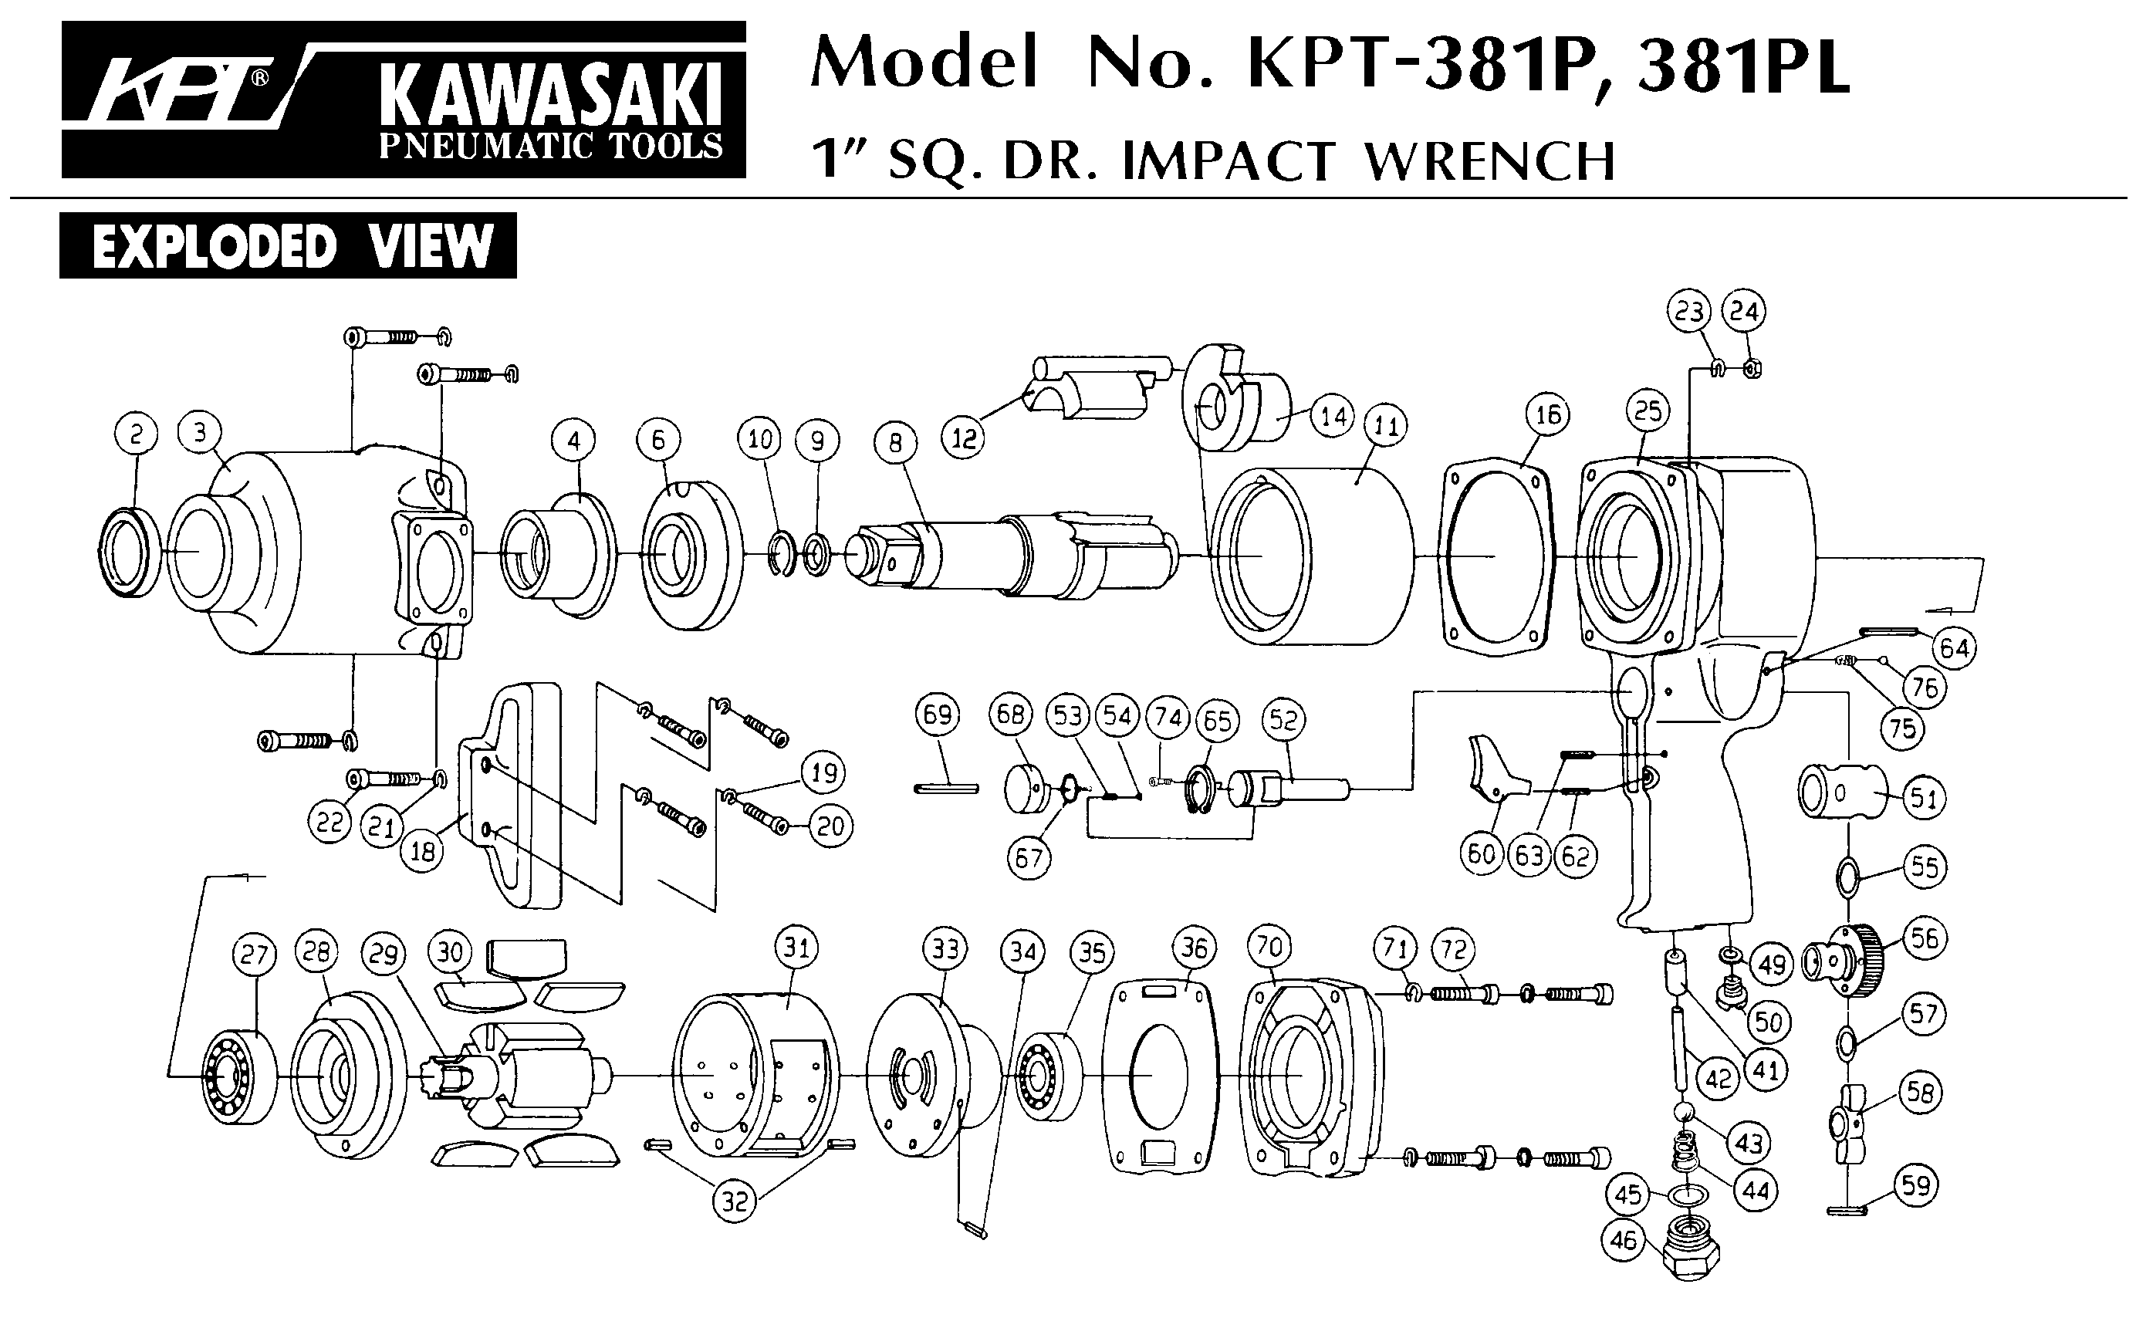 REV-01/22