GP2140C (A)
Perceuse 13mm
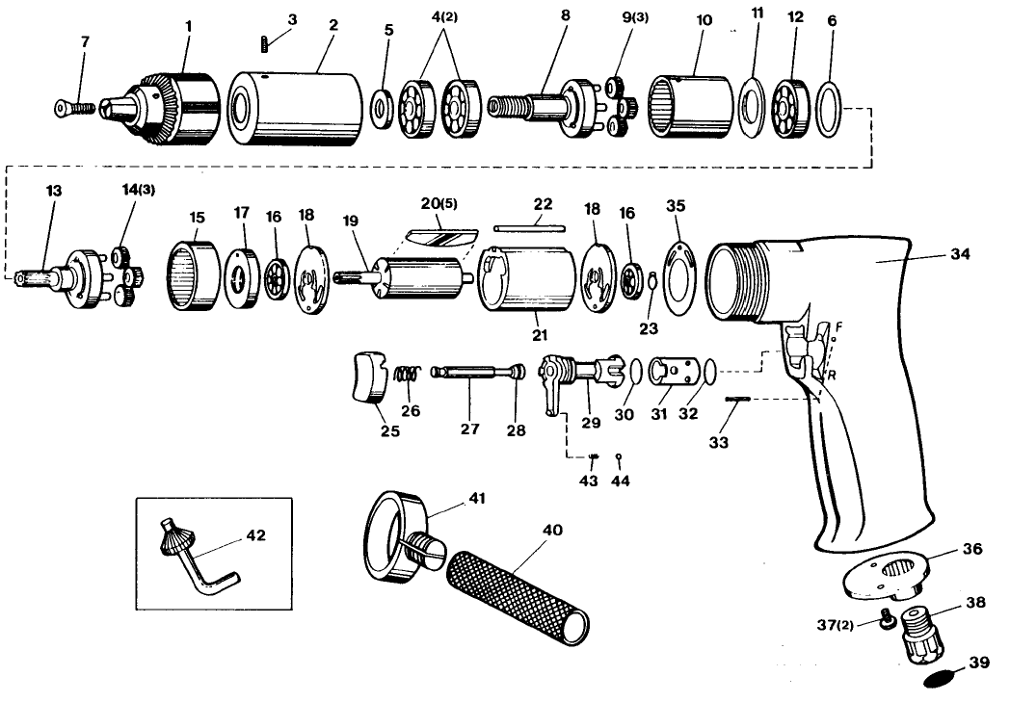

Rep | Ref | Désignation | Qté | Rep | Ref | Désignation | Qté
1 | GPS2055B | Mandrin auto serrant | 1 | 22 | GP2140-22 | Goupille | 1
1 | GPS2049 | Mandrin à clé | 1 | 23 | GP2140-23 | Circlips | 1
2 | GP2140-2 | Carter avant | 1 | 25 | GP2140-25 | Gâchette | 1
3 | GP2140-3 | Vis | 1 | 26 | GP2140-26 | Ressort | 1
4 | 6201-2RS | Roulement 6201 | 2 | 27 | GP2140-27 | Axe | 1
5 | GP2140-5 | Rondelle | 1 | 28 | GP2140-28 | Joint | 1
6 | GP2140-6 | Entretoise | 1 | 29 | GP2140-29 | Inverseur | 1
7 | GP2140-7 | Vis | 1 | 30 | GP2140-30 | Joint | 1
8 | GP2140-8 | Porte satellites | 1 | 31 | GP2140-31 | Chemise gâchette | 1
9 | GP2140-9 | Satellite | 3 | 32 | GP2140-32 | Joint | 1
10 | GP2140-10 | Couronne | 1 | 33 | GP2140-33 | Goupille | 1
11 | GP2140-11 | Rondelle | 1 | 34 | GP2140-34 | Corp | 1
12 | 6200-2RS | Roulement 6200 | 1 | 35 | GP2140-35 | Joint | 1
13 | GP2140-13 | Porte satellite | 1 | 36 | GP2140-36 | Echappement | 1
14 | GP2140-14 | Satellite | 3 | 37 | GP2140-37 | Vis | 2
15 | GP2140-15 | Couronne | 1 | 38 | GP2140-38 | Raccord | 1
16 | 626-2RS | Roulement 626 | 1 | 39 | GP2140-39 | Grille | 1
17 | GP2140-17 | Protection flasque | 1 | 40 | GP2140-40 | Poignée | 1
18 | GP2140-18 | Flasque | 1 | 41 | GP2140-41 | Collier poignée | 1
19 | GP2140-19 | Rotor | 1 | 42 | GP2140-42 | Clé | 1
20 | GP2140-20 | Palette | 5 | 43 | GP2140-43 | Ressort | 1
21 | GP2140-21 | Chemise | 1 | 44 | GP2140-44 | Bille | 1

