**GP2120**

**Perceuse 10mm**

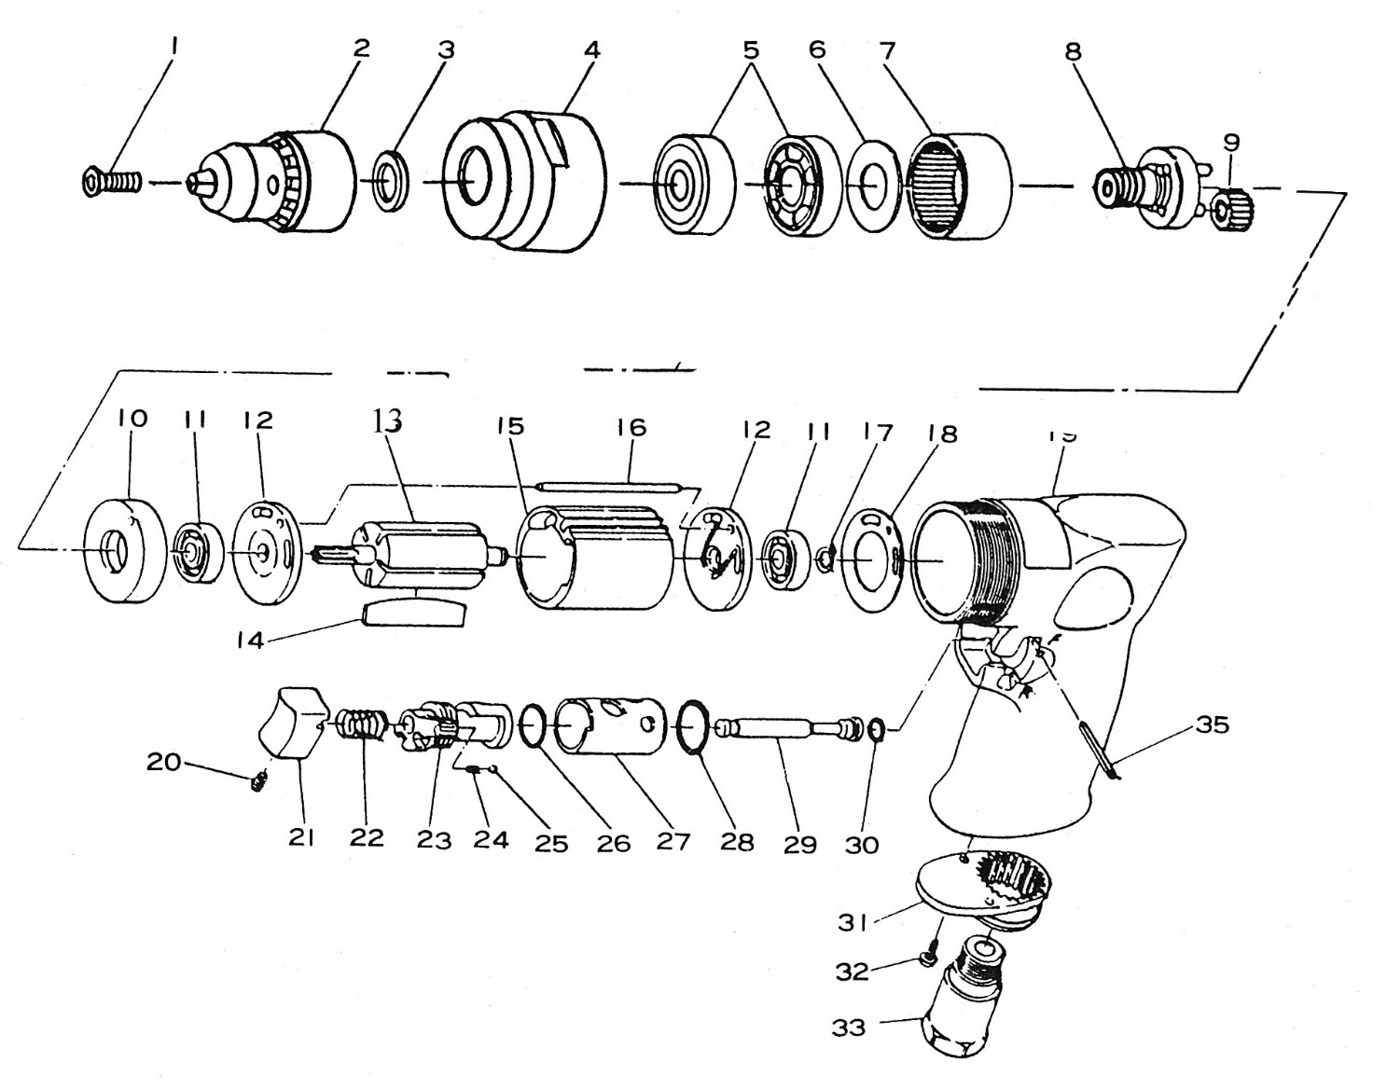

|  |  |  |  |  |  |  |  |
| --- | --- | --- | --- | --- | --- | --- | --- |
| Rep | INDEX No. | DESCRIPTION | QTE | Rep | INDEX No. | DESCRIPTION | QTE |
| 1 | GP2120-1 | Vis | 1 | 18 | GP2120-18 | Joint | 1 |
| 2 | GP2120-2 | Mandrin | 1 | 19 | GP2120-19 | Corps | 1 |
| 3 | GP2120-3 | Rondelle | 1 | 20 | GP2120-20 | Vis | 1 |
| 4 | GP2120-4 | Carter | 1 | 21 | GP2120-21 | Gâchette | 1 |
| 5 | 6201-2RS | Roulement 6201 | 2 | 22 | GP2120-22 | Ressort | 1 |
| 6 | GP2120-6 | Rondelle | 1 | 23 | GP2120-23 | Inverseur | 1 |
| 7 | GP2120-7 | Couronne | 1 | 24 | GP2120-24 | Joint | 1 |
| 8 | GP2120-8 | Porte satellite | 1 | 25 | GP2120-25 | Bille | 1 |
| 9 | GP2120-9 | Satellite | 3 | 26 | GP2120-26 | Joint | 1 |
| 10 | GP2120-10 | Entretoise de protection roulement | 1 | 27 | GP2120-27 | Chemise inverseur | 1 |
| 11 | 626-2RS | Roulement 626 | 2 | 28 | GP2120-28 | Joint | 1 |
| 12 | GP2120-12 | Flasque | 2 | 29 | GP2120-29 | Axe gâchette | 1 |
| 13 | GP2120-13 | Rotor | 1 | 30 | GP2120-30 | Joint | 1 |
| 14 | GP2120-14 | Palette | 5 | 31 | GP2120-31 | Silencieux | 1 |
| 15 | GP2120-15 | Chemise | 1 | 32 | GP2120-32 | Vis | 2 |
| 16 | GP2120-16 | Axe | 1 | 33 | GP2120-33 | Raccord | 1 |
| 17 | GP2120-17 | Circlips | 1 |  |  |  |  |
|  |  |  |  |  |  |  |  |