**GP2100**

**Perceuse rapide**

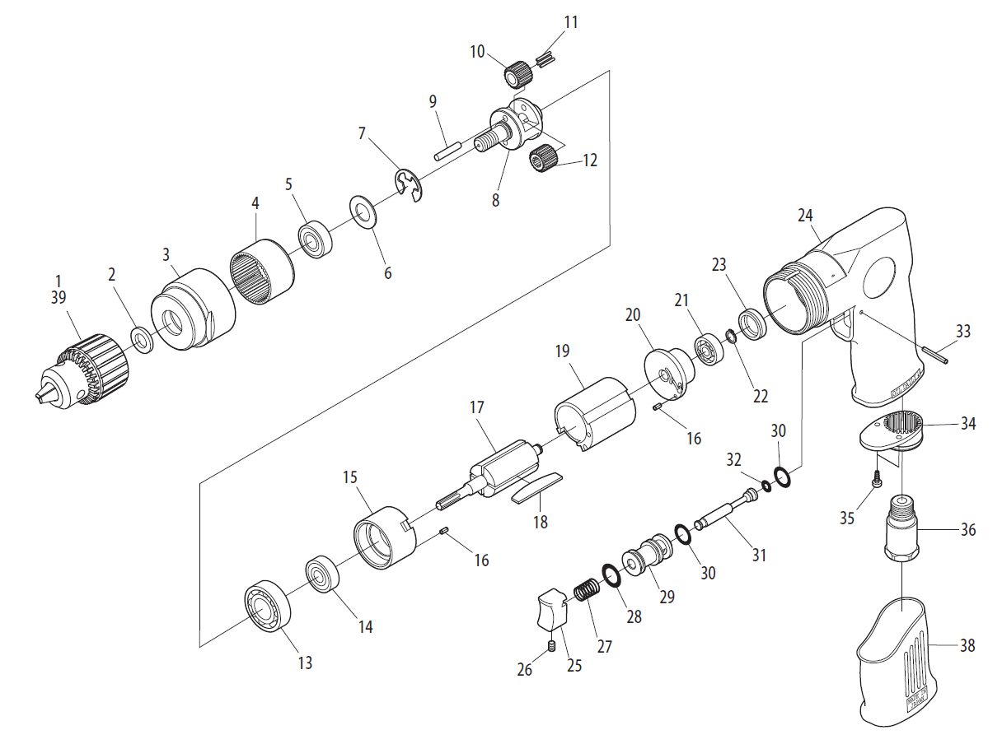

|  |  |  |  |  |  |  |  |
| --- | --- | --- | --- | --- | --- | --- | --- |
| Rep | INDEX No. | DESCRIPTION | QTE | Rep | INDEX No. | DESCRIPTION | QTE |
| 1 | GPS2048 | Mandrin | 1 | 20 | GP2100-20 | Flasque arr | 1 |
| 2 | GP2100-2 | Rondelle | 1 | 21 | 626-2RS | Roulement 626 | 1 |
| 3 | GP2100-3 | Carter | 1 | 22 | GP2100-22 | Clips | 1 |
| 4 | GP2100-4 | Couronne | 1 | 23 | GP2100-23 | Cache roulement | 1 |
| 5 | EE3 | Roulement EE3 | 1 | 24 | GP2100-24 | Corps | 1 |
| 6 | GP2100-6 | Rondelle | 1 | 25 | GP2100-25 | Gâchette | 1 |
| 7 | GP2100-7 | Clips | 1 | 26 | GP2100-26 | Vis | 1 |
| 8 | GP2100-8 | Porte satellite | 1 | 27 | GP2100-27 | Ressort | 1 |
| 9 | GP2100-9 | Axe | 2 | 28 | GP2100-28 | Joint | 1 |
| 10 | GP2100-10 | Satellite | 2 | 29 | GP2100-29 | Chemise | 1 |
| 11 | GP2100-11 | Aiguille | 22 | 30 | GP2100-30 | Joint | 2 |
| 12 | GP2100-12 | Pignon | 1 | 31 | GP2100-31 | Axe gâchette | 1 |
| 13 | 6001-2RS | Roulement 6001 | 1 | 32 | GP2100-32 | Joint | 1 |
| 14 | 608-2RS | Roulement 608 | 1 | 33 | GP2100-33 | Goupille | 1 |
| 15 | GP2100-15 | Flasque avt | 1 | 34 | GP2100-34 | Silencieux | 1 |
| 16 | GP2100-16 | Goupille | 2 | 35 | GP2100-35 | Vis | 2 |
| 17 | GP2100-17 | Rotor | 1 | 36 | GP2100-36 | Raccord | 1 |
| 18 | GP2100-18 | Palette | 4 | 38 | GP3100-38 | Grip | 1 |
| 19 | GP2100-19 | Cylindre | 1 |  |  |  |  |