

**GP2024A**

**Perceuse réversible**

**13mm**

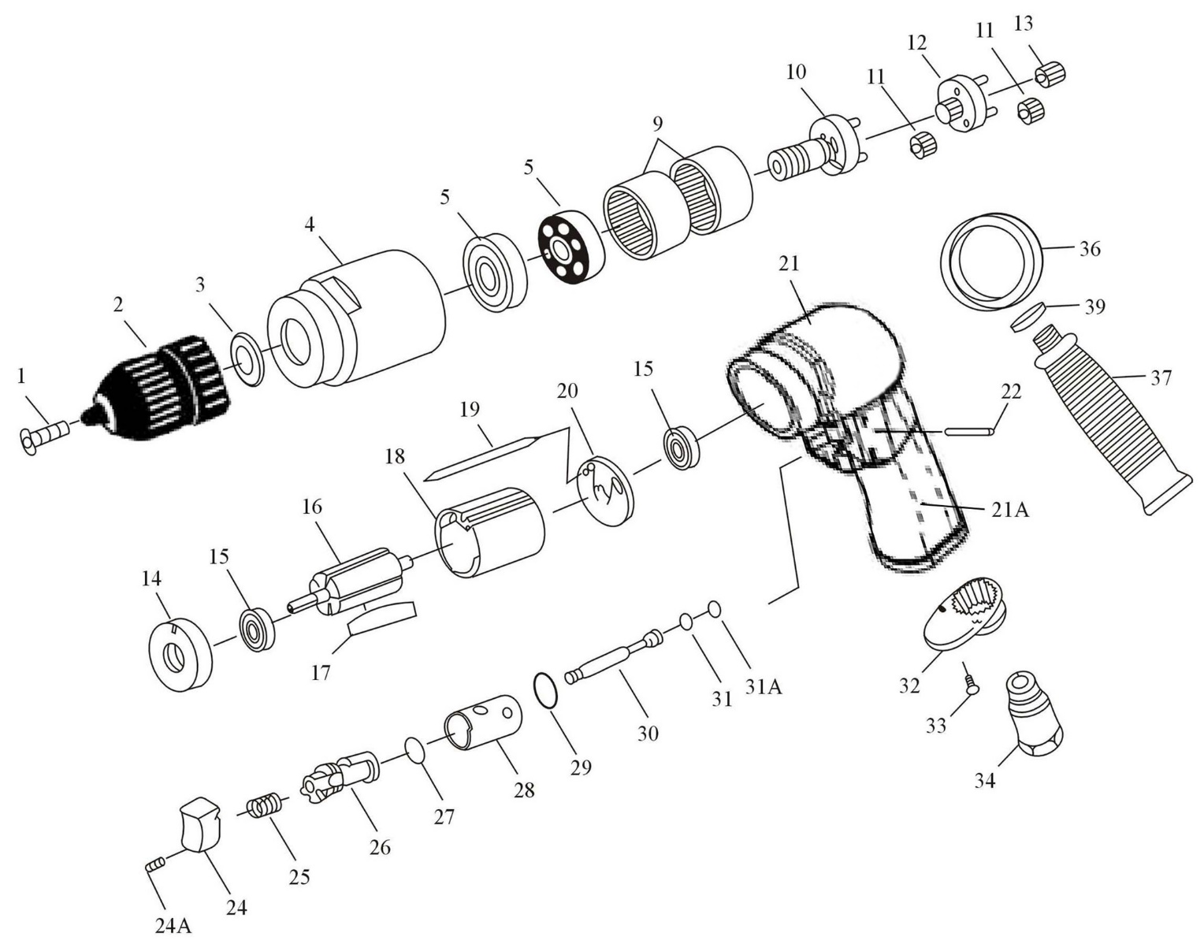

|  |  |  |  |  |  |  |  |
| --- | --- | --- | --- | --- | --- | --- | --- |
| Rep | REF. NO. | DESCRIPTION | QTE | Rep. | REF. NO. | DESCRIPTION | QTE |
| 1 | GP2024-01 | Vis (5x25) | 1 | 21A | GP2024-21A | Gaine de protection corps | 1 |
| 2 | GP2024-02 | Mandrin | 1 | 22 | GP2024-22 | Goupille (2.5x22) | 1 |
| 3 | GP2024-03 | Rondelle | 1 | 24 | GP2024-24 | Gâchette | 1 |
| 4 | GP2024-04 | Carter pignon | 1 | 24A | GP2024-24A | Vis (M4x6) | 1 |
| 5 | 6201-2RS | Roulement (6201zz) | 2 | 25 | GP2024-25 | Ressort | 1 |
| 9 | GP2024-09 | Couronne | 2 | 26 | GP2024-26 | Inverseur | 1 |
| 10 | GP2024-10ASS | Porte satellite +satellite (4x13.8) | 1 | 27 | GP2024-27 | Joint (P9) | 2 |
| 11 | GP2024-11 | Satellite (312S) | 6 | 28 | GP2024-28 | Chambre d'inversion | 1 |
| 12 | GP2024-12ASS | Porte satellite réduction + satellite | 1 | 29 | GP2024-29 | Joint (P14) | 1 |
| 13 | GP2024-13 | Pignon | 1 | 30 | GP2024-30 | Axe gâchette | 1 |
| 14 | GP2024-14 | Flasque avt | 1 | 31 | GP2024-31 | Joint (3.5x1.5) | 1 |
| 15 | 626-2RS | Roulement (626zz) | 2 | 31A | GP2024-31A | Joint (3.9x2.25x2) | 1 |
| 16 | GP2024-16 | Rotor | 1 | 32 | GP2024-32 | Silencieux | 1 |
| 17 | GP2024-17 | Palette | 5 | 33 | GP2024-33 | Vis (M3x8) | 2 |
| 18 | GP2024-18 | Chemise | 1 | 34 | GP2024-34 | Raccord | 1 |
| 19 | GP2024-19 | Goupille (2x55) | 1 | 36 | GP2024-36 | Anneau de poignée | 1 |
| 20 | GP2024-20 | Flasque arr | 1 | 37 | GP2024-37 | Poignée | 1 |
| 21 | GP2024-21 | Corps | 1 | 39 | GP2024-39 | Joint | 1 |

