

**GP2006A**

**Perceuse réversible**

**10mm**

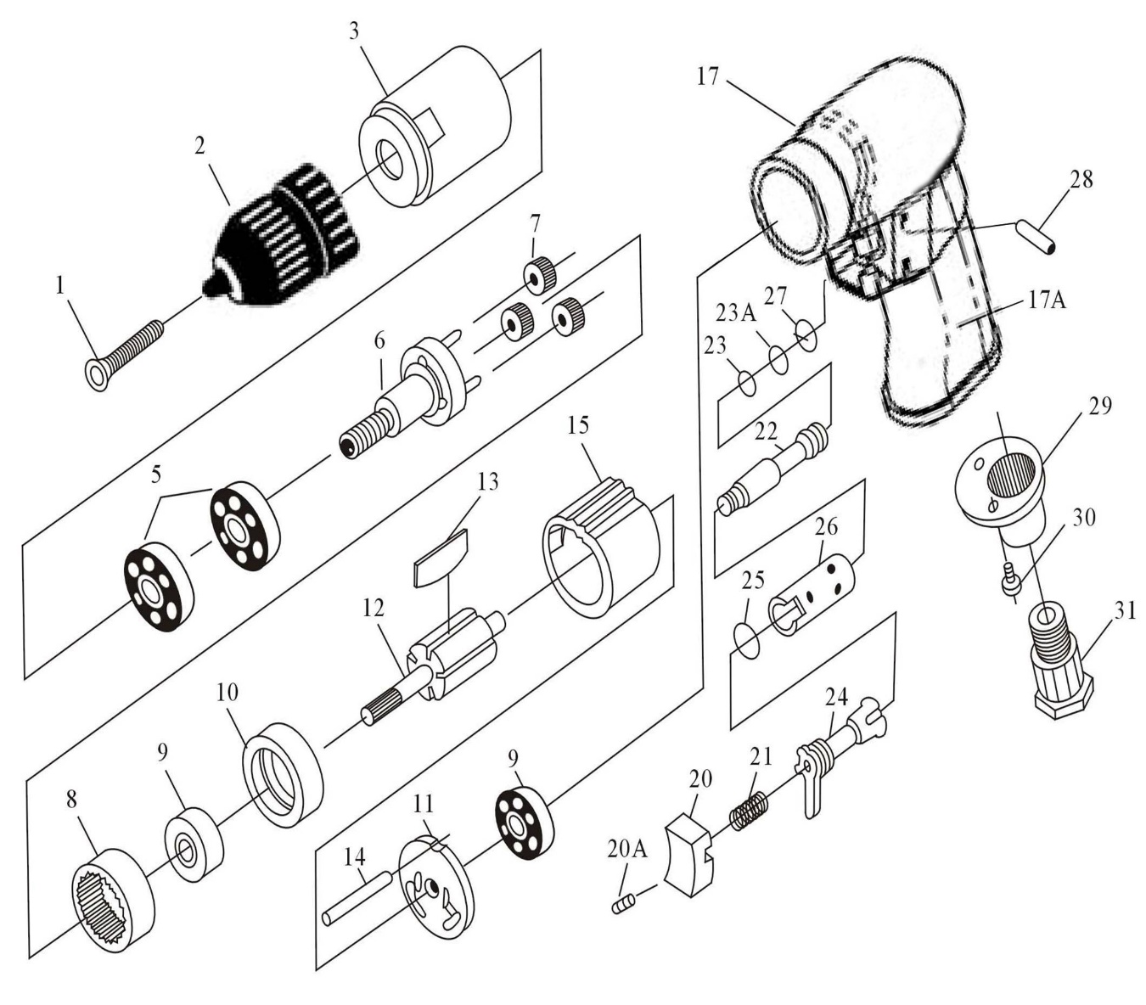

|  |  |  |  |  |  |  |  |
| --- | --- | --- | --- | --- | --- | --- | --- |
| Rep | Réf Art | DESCRIPTION | Qté | Rep | Réf Art | DESCRIPTION | Qté |
| 1 | GP2006-01 | Vis (M5X20) | 1 | 17A | GP2006-17A | Gaine de protection corps | 1 |
| 2 | GP2006-02 | Mandrin | 1 | 20 | GP2006-20 | Gâchette | 1 |
| 3 | GP2006-03 | Carter pignon | 1 | 20A | GP2006-20A | Vis (M4X6) | 1 |
| 5 | 6201-2RS | Roulement (6201ZZ) | 2 | 21 | GP2006-21 | Ressort | 1 |
| 6 | GP2006-06ASS | Porte satellite + axe satellite (φ4X13.8) | 1 | 22 | GP2006-22 | Axe gâchette | 1 |
| 7 | GP2006-07A | Satellite (305S) | 3 | 23 | GP2006-23 | Joint (φ3.5X1.5) | 1 |
| 8 | GP2006-08 | Couronne | 1 | 23A | GP2006-23A | Joint (3.9X2.25X2) | 1 |
| 9 | 626-2RS | Roulement (626ZZ) | 2 | 24 | GP2006-24 | Inverseur | 1 |
| 10 | GP2006-10 | Flasque avt | 1 | 25 | GP2006-25 | Joint (P9) | 1 |
| 11 | GP2006-11 | Flasque arr. | 1 | 26 | GP2006-26 | Corps de l’axe gâchette | 1 |
| 12 | GP2006-12 | Rotor | 1 | 27 | GP2006-27 | Joint (P14) | 1 |
| 13 | GP2006-13 | Palette | 5 | 28 | GP2006-28 | Goupille (φ2.5X22) | 1 |
| 14 | GP2006-14 | Goupille (φ2x55) | 1 | 29 | GP2006-29 | Silencieux | 1 |
| 15 | GP2006-15 | Chemise | 1 | 30 | GP2006-30 | Vis (M3X8) (2) | 2 |
| 17 | GP2006-17 | Corps | 1 | 31 | GP2006-31 | Raccord | 1 |
|  |  |  |  |  |  |  |  |

