

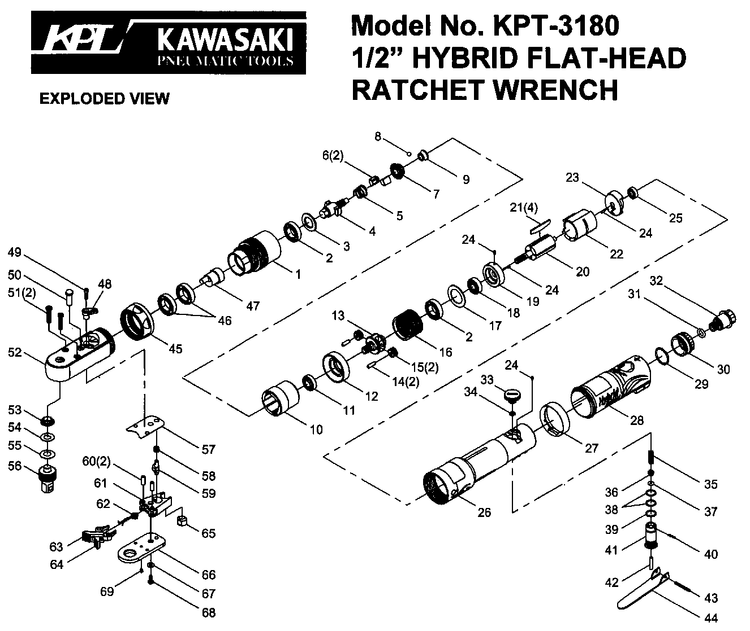

**GP1971**

**Clé à rochet ½ à chocs**

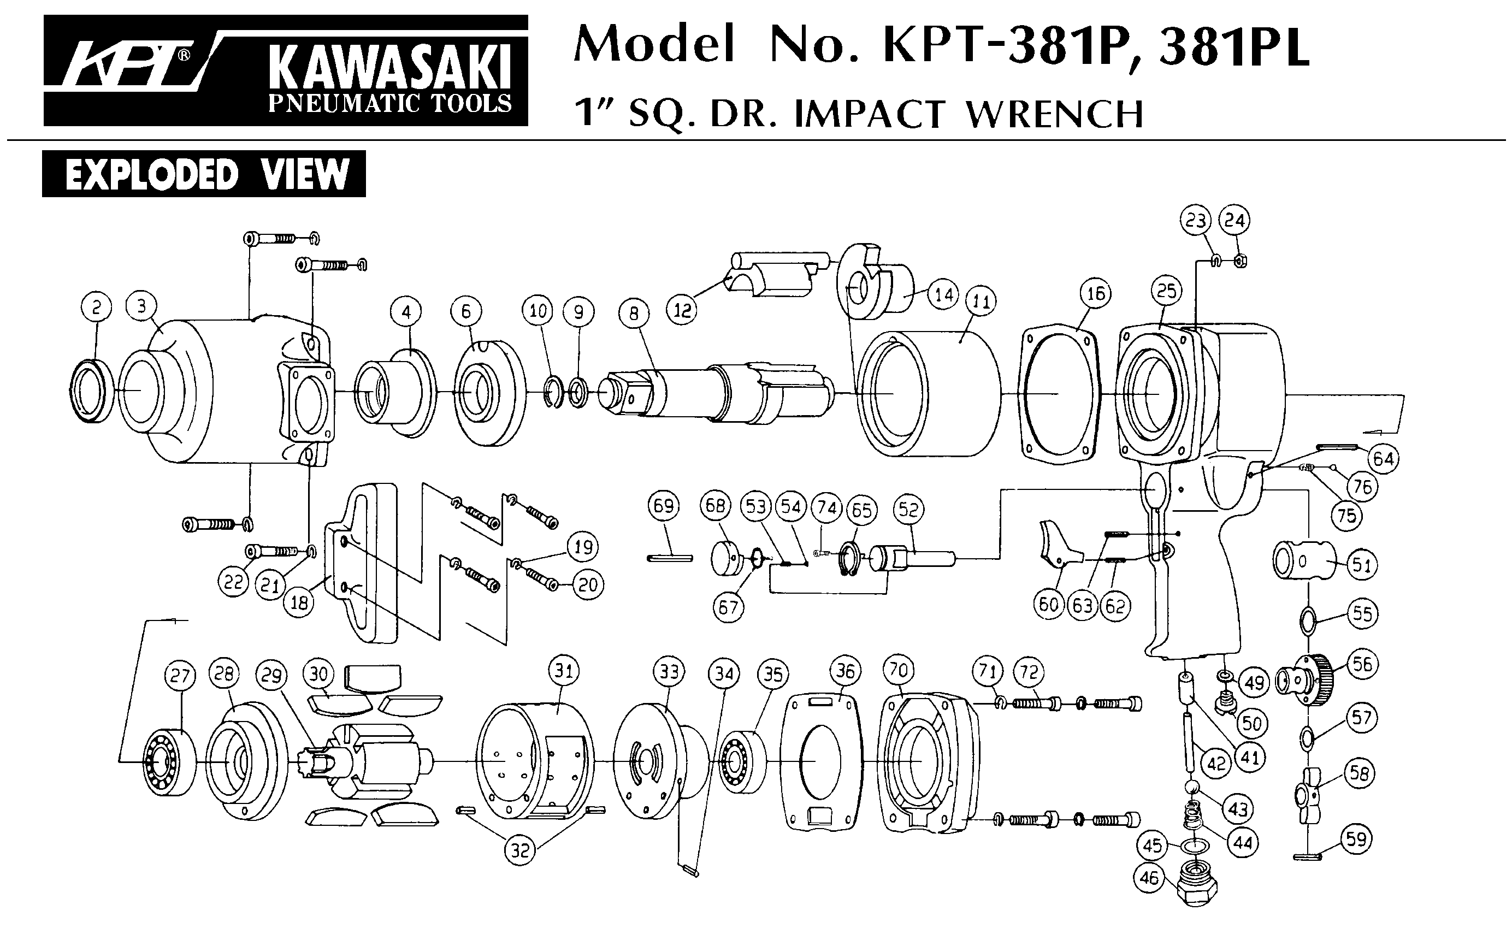





|  |  |  |  |  |  |  |  |
| --- | --- | --- | --- | --- | --- | --- | --- |
| Rep | ref | DESCRIPTION | QTE | Rep | Ref . | DESCRIPTION | QTE |
| 1 | GP1971-1 | Carter cage de frappe | 1 | 36 | GP1971-36 | Valve | 1 |
| 2 | 6902-2RS | Roulement 6902 | 2 | 37 | GP1971-37 | Joint | 1 |
| 3 | GP1971-3 | Rondelle | 1 | 38 | GP1971-38 | Joint | 2 |
| 4 | GP1971-4 | Axe de frappe | 1 | 39 | GP1971-39 | Joint | 1 |
| 5 | GP1971-5 | Ressort | 1 | 40 | GP1971-40 | Goupille | 1 |
| 6 | GP1971-6 | Marteau | 2 | 41 | GP1971-41 | Régulateur | 1 |
| 7 | GP1971-7 | Came | 1 | 42 | GP1971-42 | Axe | 1 |
| 8 | GP1971-8 | Bille | 1 | 43 | GP1971-43 | Goupille | 1 |
| 9 | GP1971-9 | Cuvette bille | 1 | 44 | GP1971-44 | Gâchette | 1 |
| 10 | GP1971-10 | Cage de frappe | 1 | 45 | GP1971-45 | Écrou serrage tète | 1 |
| 11 | 6900-2RS | Roulement 6900 | 1 | 46 | 6903-2RS | Roulement 6903 | 2 |
| 12 | GP1971-12 | Entretoise | 1 | 47 | GP1971-47 | Adaptateur | 1 |
| 13 | GP1971-13 | Porte satellite | 1 | 48 | GP1971-48 | Bouton inverseur | 1 |
| 14 | GP1971-14 | Axe | 2 | 49 | GP1971-49 | Vis | 1 |
| 15 | GP1971-15 | Satellite | 2 | 50 | GP1971-50 | Axe pivot | 1 |
| 16 | GP1971-16 | Couronne satellite | 1 | 51 | GP1971-51 | Vis | 2 |
| 17 | GP1971-17 | Rondelle | 1 | 52 | GP1971-52 | Tête | 1 |
| 18 | 608-2RS | Roulement 608 | 1 | 53 | GP1971-53 | Entretoise | 1 |
| 19 | GP1971-19 | Flasque avt | 1 | 54 | GP1971-54 | Rondelle | 1 |
| 20 | GP1971-20 | Rotor | 1 | 55 | GP1971-55 | Rondelle | 1 |
| 21 | GP1971-21 | Palette | 4 | 56 | GP1971-56 | Carre | 1 |
| 22 | GP1971-22 | Chemise | 1 | 57 | GP1971-57 | Plaque de tête | 1 |
| 23 | GP1971-23 | Flasque arr | 1 | 58 | GP1971-58 | Ressort | 1 |
| 24 | GP1971-24 | Goupille | 1 | 59 | GP1971-59 | Came d'inversion | 1 |
| 25 | 696-2RS | Roulement | 1 | 60 | GP1971-60 | Axe | 2 |
| 26 | GP1971-26 | Corps | 1 | 61 | GP1971-61 | Drive Link | 1 |
| 27 | GP1971-27 | Rondelle | 1 | 62 | GP1971-62 | Ressort détorsion | 1 |
| 28 | GP1971-28 | Capot protection | 1 | 63 | GP1971-63 | Engrenage | 1 |
| 29 | GP1971-29 | Joint | 1 | 64 | GP1971-64 | Engrenage | 1 |
| 30 | GP1971-30 | Silencieux orientable | 1 | 65 | GP1971-65 | Rochet | 1 |
| 31 | GP1971-31 | Joint | 1 | 66 | GP1971-66 | Carter | 1 |
| 32 | GP1971-32 | Raccord | 1 | 67 | GP1971-67 | Rondelle | 1 |
| 33 | GP1971-33 | Bouton régulateur | 1 | 68 | GP1971-68 | Vis | 1 |
| 34 | GP1971-34 | Joint | 1 | 69 | GP1971-69 | Graisseur | 1 |
| 35 | GP1971-35 | Ressort | 1 |  |  |  |  |

**Manche Atlantique Equipements** -27 parc d’activité du Chalet - 22250 BroonsTél 02 96 84 65 59 - Fax 02 96 84 77 75

**WWW.MAE-FR.COM**