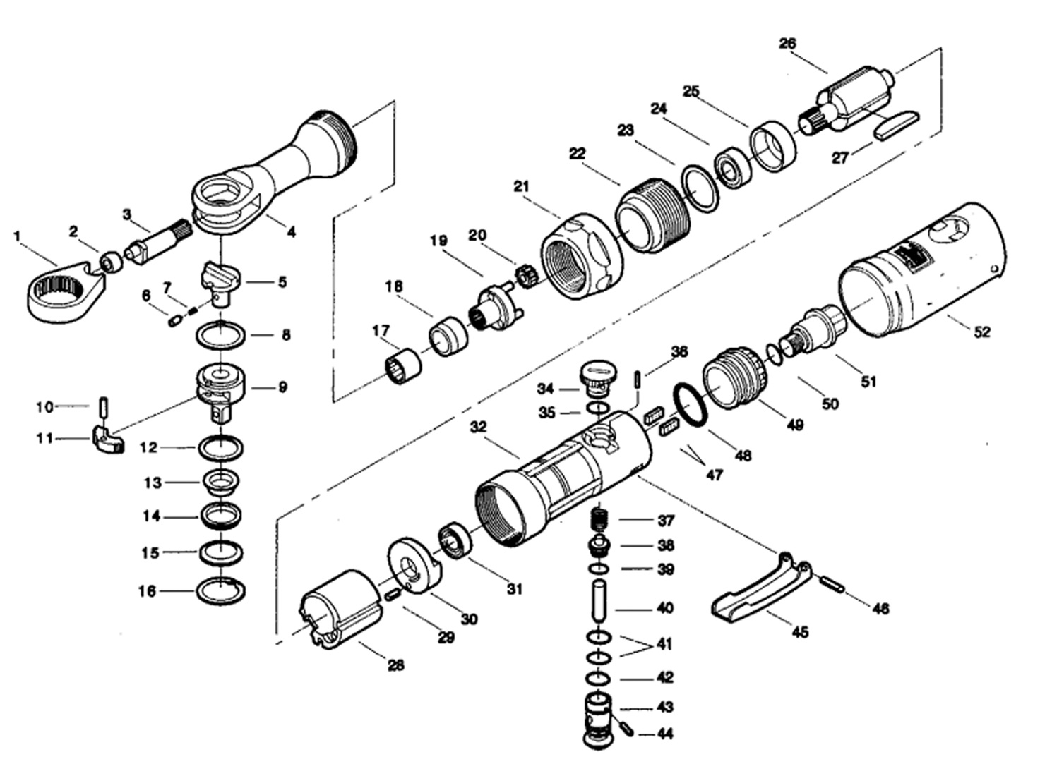

**GP1913**

**Clé à rochet 3/8**

|  |  |  |  |  |  |  |  |
| --- | --- | --- | --- | --- | --- | --- | --- |
| Rep | REF. NO. | DESCRIPTION | QTE | Rep. | REF. NO. | DESCRIPTION | QTE |
| 1 | GP1913-01 | Engrenage tête | 1 | 27 | GP1913-27 | Palette | 4 |
| 2 | GP1913-02 | Rochet | 1 | 28 | GP1913-28 | Chemise | 1 |
| 3 | GP1913-03 | Axe rochet | 1 | 29 | GP1913-29 | Goupille | 1 |
| 4 | GP1913-04 | Carter tête | 1 | 30 | GP1913-30 | Flasque arrière | 1 |
| 5 | GP1913-05 | Bouton inverseur | 1 | 31 | 696-2RS | Roulement 696 | 1 |
| 6 | GP1913-06 | Axe | 1 | 32 | GP1913-32 | Corps | 1 |
| 7 | GP1913-07 | Ressort | 1 | 34 | GP1913-34 | Joint | 1 |
| 8 | GP1913-08 | Rondelle | 1 | 35 | GP1913-35 | Inverseur | 1 |
| 9 | GP1913-09 | Carré 3/8 | 1 | 36 | GP1913-36 | Goupille | 1 |
| 10 | GP1913-10 | Axe | 1 | 37 | GP1913-37 | Ressort | 1 |
| 11 | GP1913-11 | Pignon | 1 | 38 | GP1913-38 | Valve | 1 |
| 12 | GP1913-12 | Rondelle | 1 | 39 | GP1913-39 | Joint | 1 |
| 13 | GP1913-13 | Entretoise | 1 | 40 | GP1913-40 | Axe | 1 |
| 14 | GP1913-14 | Rondelle | 1 | 41 | GP1913-41 | Joint | 2 |
| 15 | GP1913-15 | Rondelle | 1 | 42 | GP1913-42 | Joint | 1 |
| 16 | GP1913-16 | Circlips | 1 | 43 | GP1913-43 | Régulateur | 1 |
| 17 | GP1913-17 | Roulement aiguille | 1 | 44 | GP1913-44 | Axe | 1 |
| 18 | GP1913-18 | Entretoise | 1 | 45 | GP1913-45 | Gâchette | 1 |
| 19 | GP1913-19 | Porte satellite | 1 | 46 | GP1913-46 | Axe | 1 |
| 20 | GP1913-20 | Satellite | 3 | 47 | GP1913-47 | Mousse | 2 |
| 21 | GP1913-21 | Ecrou serrage | 1 | 48 | GP1913-48 | Joint | 2 |
| 22 | GP1913-22 | Bague | 1 | 49 | GP1913-49 | Echappement | 1 |
| 23 | GP1913-23 | Rondelle | 1 | 50 | GP1913-50 | Joint | 1 |
| 24 | 608-2RS | Roulement 608 | 1 | 51 | GP1913-51 | Raccord | 1 |
| 25 | GP1913-25 | Flasque avant | 1 | 52 | GP1913-52 | Gaine plastique | 1 |
| 26 | GP1913-26 | Rotor | 1 |  |  |  |  |